Speaking notes for 3-hour session: Module 2
(full version)

Contents
Welcome & opening 2
Setting the scene and a brief re-cap on natural capital 12
The business case for integrating biodiversity in natural capital assessments 22
Identifying your natural capital impacts & dependencies 29
Scoping an assessment 43
Materiality 57
Practicalities & useful tools 65
Wrap up & next steps 73

Welcome & opening

Slide 1
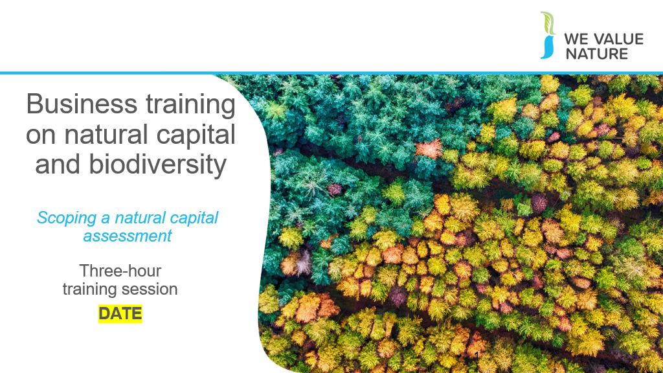
Presenter to welcome the group to the business training on natural capital

Slide 2
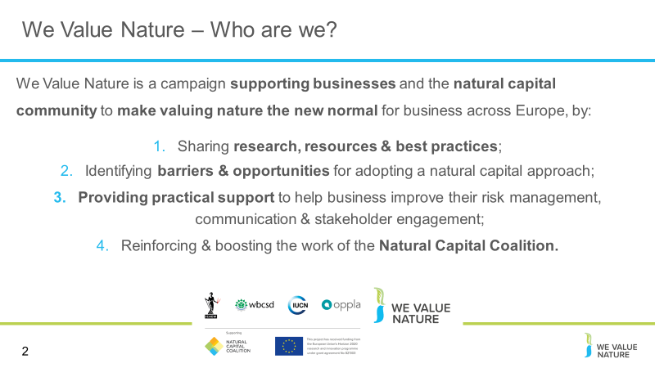
Before starting the training, presenter should introduce that this training is being given as part of the We Value Nature Campaign and explain what it is, its purpose, objectives and partners involved:

The We Value Nature Campaign is a €2 million EU-funded campaign supporting businesses and the natural capital community across Europe with the aim of making valuing nature the new normal for business. As we will have a chance to explore during today’s training, by valuing nature, businesses can make smarter decisions that benefit themselves, society and the planet as a whole.

The campaign is coordinated by the Institute of Chartered Accountants in England and Wales (ICAEW), World Business Council for Sustainable Development (WBCSD), The International Union for Conservation of Nature (IUCN) and Oppla. And it is supporting the Natural Capital Coalition, which has recently merged with the Social & Human Capital Coalition to become now the ‘Capitals Coalition’.

The campaign will aim to increase the uptake of the natural capital approach (including: natural capital assessment, natural capital accounting, nature-based solutions and green infrastructure) by identifying barriers and opportunities, providing practical support to business through activities (such as webinars, helpdesk calls, etc.) and training such as this one, as well as by inspiring businesses to adopt the NCP.

Presenter to take this opportunity to thank the different stakeholders that support the training (if relevant).

Slide 3
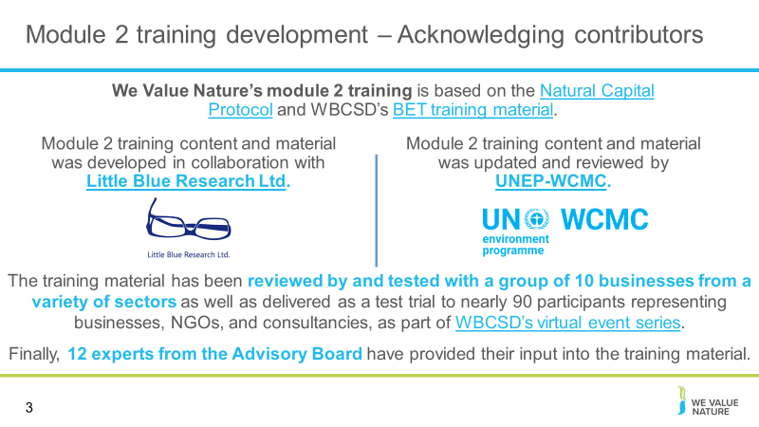
Include an acknowledgement slide for the training: presenter to read through the slide

Slide 4
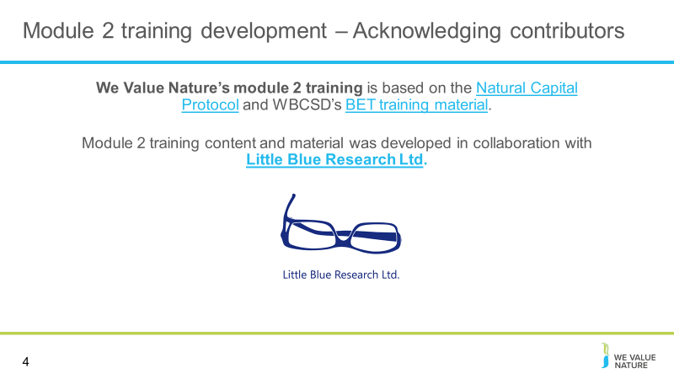 Include an acknowledgement slide for the training: presenter to read through the slide

Slide 5
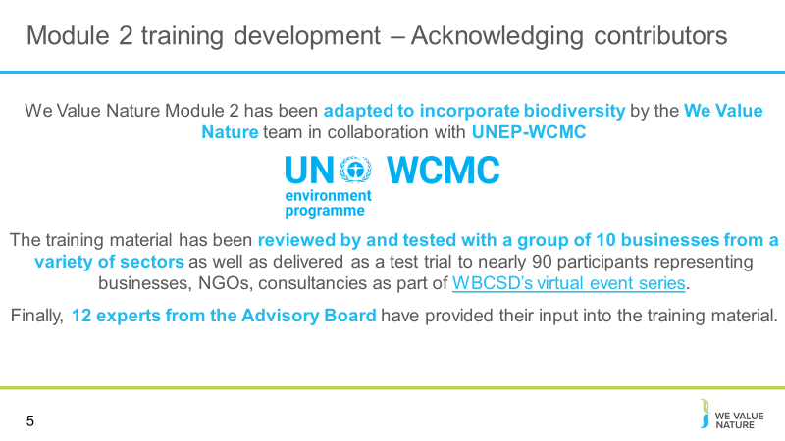
Include an acknowledgement slide for the training: presenter to read through the slide

Slide 6
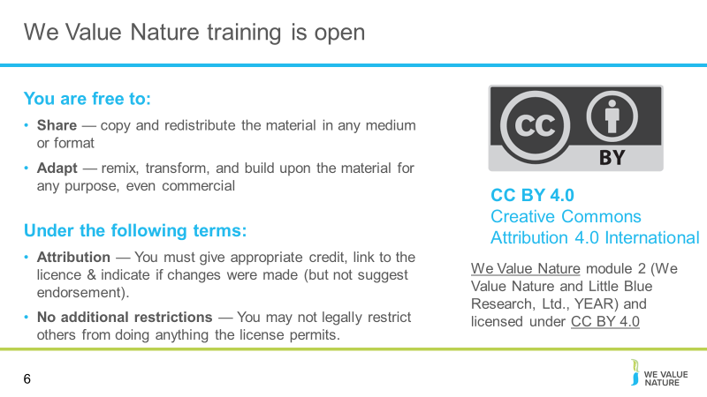
Presenter to read through the slide stating that the training is free to use under a creative commons license.

Slide 7
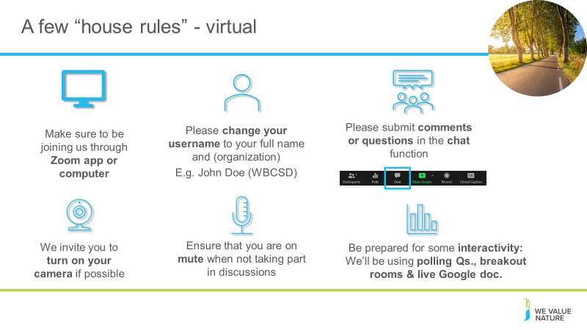
Presenter to explain the house rules on the screen, also using the notes below for a virtual session:

Point 1: Explain that for now are all muted but will unmute when open floor for Qs & discussion – will be flexible with time
Point 2: Encourage to participate – the more discussions, the more beneficial the VO
Point 3: Make sure to explain that will be able to write down their Qs directly in the google document

If using: presenter mention that there is a live document is available for update during the training (this will depend on whether the presenter wishes to use a live document during the session)

Slide 8
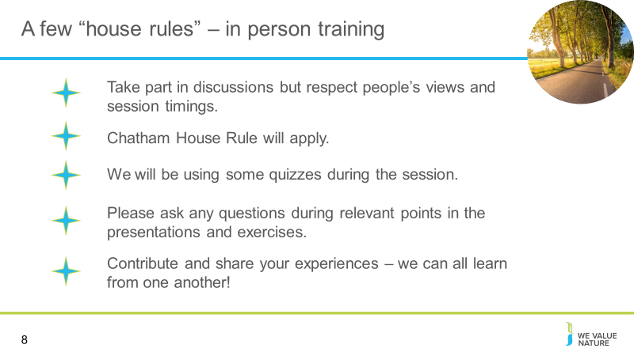
Optional depending on session type: Presenter to explain the house rules on the screen, also using the notes below for an in-person training:

Point 1: Encourage to participate – the more discussions, the more beneficial the VO
Point 2: Explain that we will be following the Chatham House Rule – “When a meeting, or part thereof, is held under the Chatham House Rule, participants are free to use the information received, but neither the identity nor the affiliation of the speaker(s), nor that of any other participant, may be revealed.”
Point 3: Option of using a parking lot for questions that cannot be answered during the training

If using, presenter to mention that there is a workbook available for the session

Slide 9
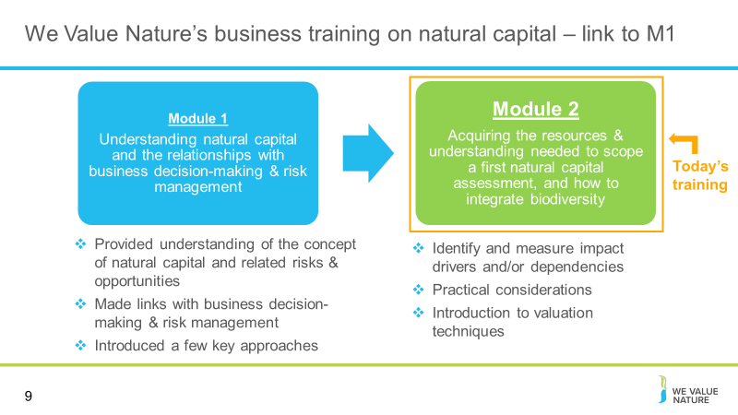
Presenter to elaborate on the content of Module 2 further, using the notes below:

- In M1, we were familiarized with the basic concepts of natural capital, how biodiversity is part of natural capital and how these can be applied to a business context. This helped us to understand why one would conduct a natural capital assessment.
- In M2, we will introduce measuring and assessing impacts and dependencies between ecosystems and services.
- This module is a primer to help delegates understand how impact/dependency assessment can aid business decision making
- More specifically, in M2, we will learn how to scope a first biodiversity-inclusive natural capital assessment:
- We will acquire the tools to determine the appropriate scope to meet our objective
- In doing this we will learn how to identify which impact drivers and dependencies are material
- We will also be introduced to practical considerations to take when pursuing a natural capital assessment, including the timeframe of the assessment, the budget and the human resources and data available

In order to commence with M2, it is important to have a grasp of a of couple of key definitions from the M2 pre-reading, including natural capital, biodiversity, and minimum ecosystem services.

Slide 10
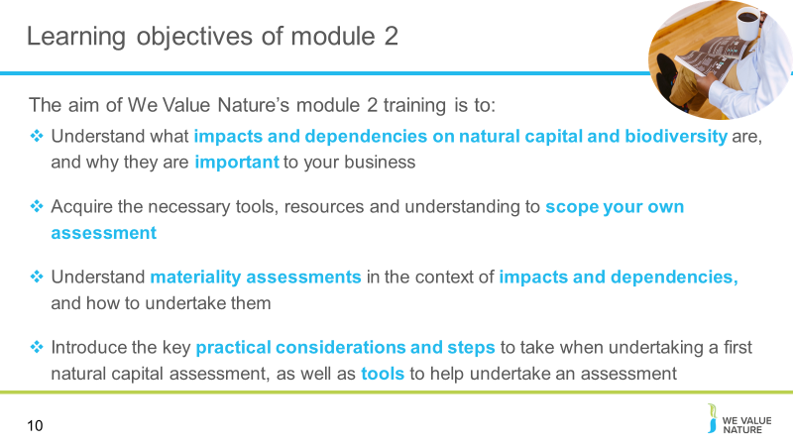 Presenter to explain the learning objectives of Module 2 from the slides.

Slide 11
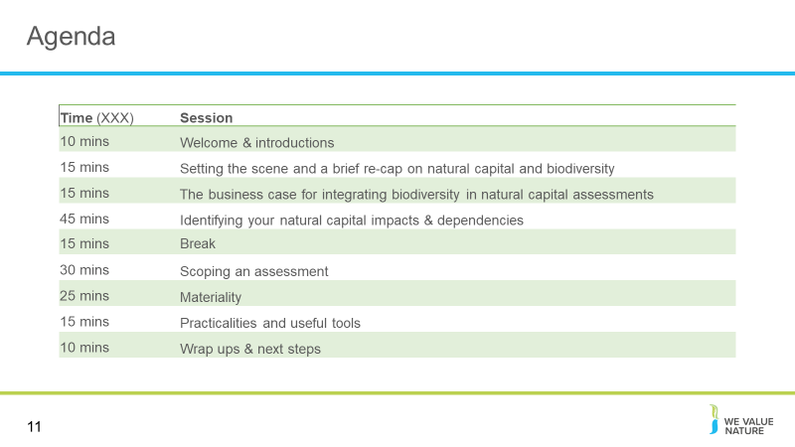 Presenter to run through the agenda for the session.

Slide 12
Presenter to say we will now undertake quick introductions.

Slide 13
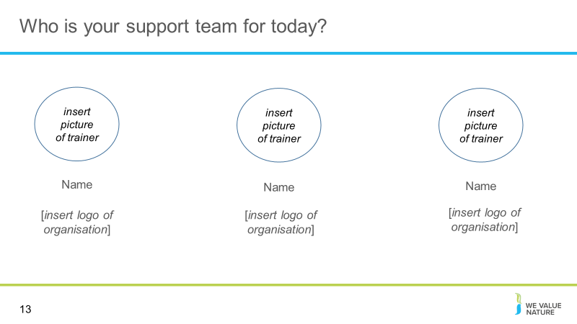NOTE: slide is optional – please adapt to your context
Introductions for those who are presenting the session (virtual or in person)

Slide 14
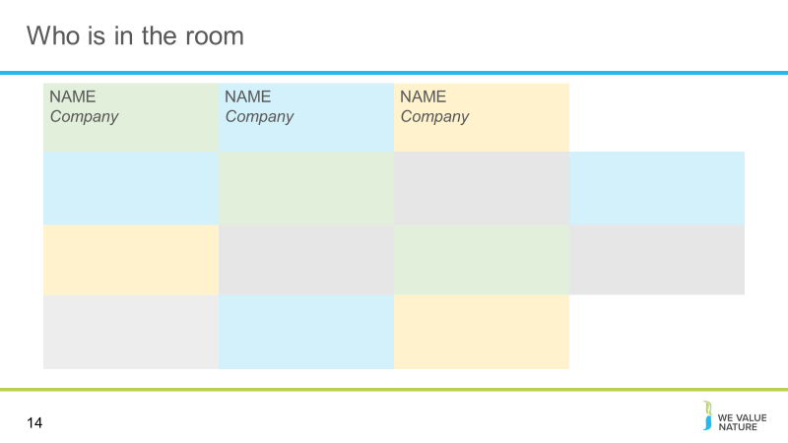
NOTE: slide is optional – please adapt to your context
Either use this slide or following slides to introduce delegates – this is dependent on the number of participants in the training and whether it is virtual
For the virtual session, presenter should add all participants to the slide names and place of work

Slide 15
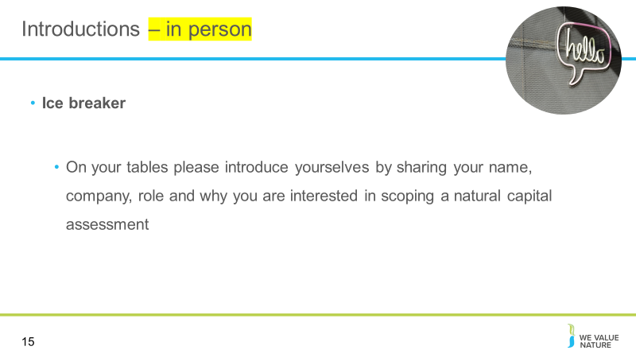
NOTE: slide is optional – please adapt to your context
Either use this slide or previous to introduce delegates – this is dependent on the number of participants in the training and whether it is virtual

Presenter should ask the delegates if they have any specific expectations from the session or things that they would like to discuss.
Slide 16
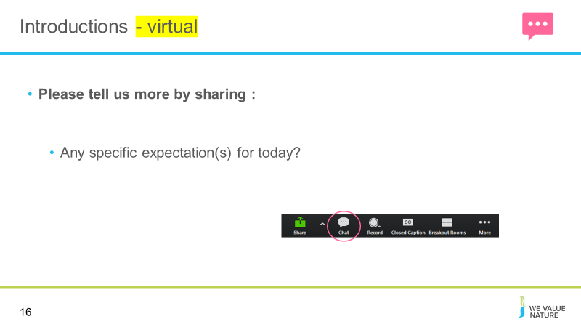
NOTE: slide is optional – please adapt to your context
Either use this slide or previous to introduce delegates – this is dependent on the number of participants in the training depends if this is virtual.

Presenter should ask the delegates if they have any specific expectations from the session or things that they would like to discuss. On the virtual session, the presenter can direct them towards the chat feature on Zoom to share these thoughts.

Setting the scene and a brief re-cap on natural capital

Slide 17
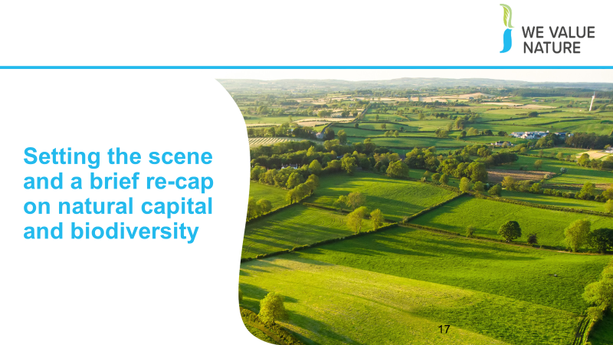
Presenter to introduce the section on ‘setting the scene and a brief re-cap on natural capital’

Slide 18
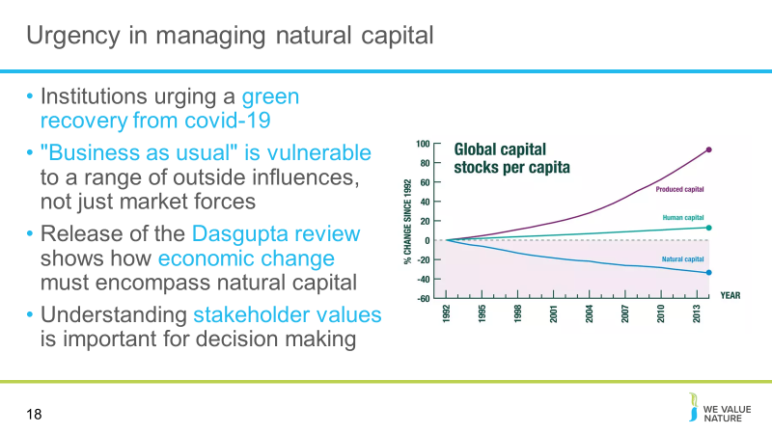 Presenter to give a re-cap on natural capital in relation to the current context on covid-19, using the notes below – this slide should be adapted to the specific country in which training is being given and as the global context changes.
- Number of organisations have considered the impact and how to ensure sustainability remains on the agenda
- The crisis may help senior managers to realize that "business as usual" is vulnerable to a range of outside influences, not just market forces.
- The crisis has highlighted more than ever, the need for business to take into consideration all capitals
- [Explain graph]: Natural capital has been being depleted for many years, as human and produced capital has increased. Nature has been used, and exploited, to support economic growth, and the Dasgupta review has highlighted how this needs to change to secure long-term and sustainable development of economics and human wellbeing.
- The crisis has also further emphasized the need for business to shift from shareholder value to stakeholder focused business models – Stakeholder Capitalism
- The crisis shows why understanding stakeholder values into account for decision making is important i.e. understanding the wider implications of decisions

Presenter to give an example of institutions action on the environment currently the slide is focused on responses to COVID 19 and those urging a green recovery from the crisis, this will need to be updated by presenters as the context changes. An example of this is Christine Lagarde's introductory statement at the Hearing at the Committee on Economic and Monetary Affairs of the European Parliament:
- Christine Lagarde is pushing to include climate change considerations in a review the central bank is due to hold into the way it conducts monetary policy:
- "The transition towards a greener economy is a crucial part of economic recovery. We have the opportunity to step up the EU’s efforts to achieve its sustainability objectives by including climate change and sustainability considerations in the financial response to the COVID-19 pandemic:
- Sustainable finance will be key to the transition to a carbon neutral economy. Today, we published our reply to the Commission’s public consultation and reaffirmed our readiness, in line with our mandate, to support the efforts of governments, public institutions and the private sector
- Moreover, our forthcoming report on the international role of the euro finds that the euro was the main currency of denomination for the issuance of green bonds in 2019"
- This move comes alongside moves by the European Parliament to declare a climate emergency and moves from the European Commission, to promise an imminent "green new deal" in their strategy

Potential VO outputs from these moves:
- Forces people to think differently and be more creative (boost innovation, not just resilience).
- Switching to digital meetings has opened up possibilities for (more) colleagues joining in without cost-increases otherwise related to travelling.
- More motivated than ever before to energise the inclusion of the nature agenda in restarting.
- Take the crisis as an opportunity to communicate on the links health/biodiversity
- The crisis may get senior managers realize that "business as usual" is vulnerable to a range of outside influences, not just market forces.
- The crisis has opened up access to technology and free training materials (new opportunities).
Sources: https://www.ecb.europa.eu/press/key/date/2020/html/ecb.sp200608~4225ba8a1b.en.html

Slide 19
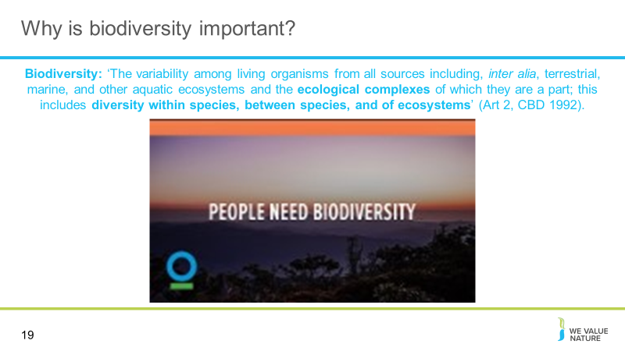
Presenter to remind participants about the importance of biodiversity, showing the video (optional, if time allows)

Biodiversity can be defined as ‘The variability among living organisms from all sources including, inter alia, terrestrial, marine, and other aquatic ecosystems and the ecological complexes of which they are a part; this includes diversity within species, between species, and of ecosystems’ (Art 2, CBD 1992).
This definition is used in the Biodiversity Guidance, and can be found on page 10.

Slide 20
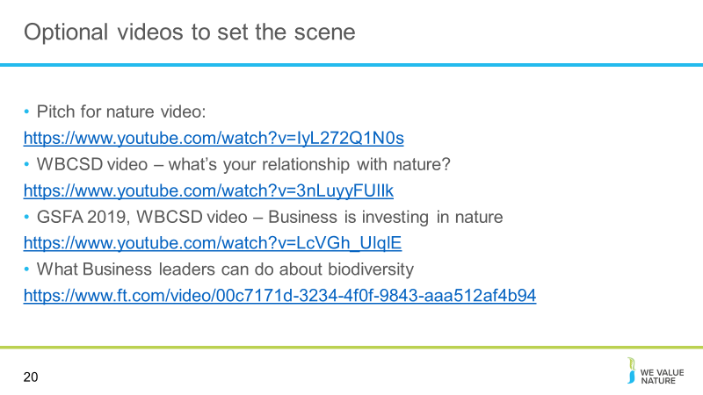
Optional videos

Slide 21
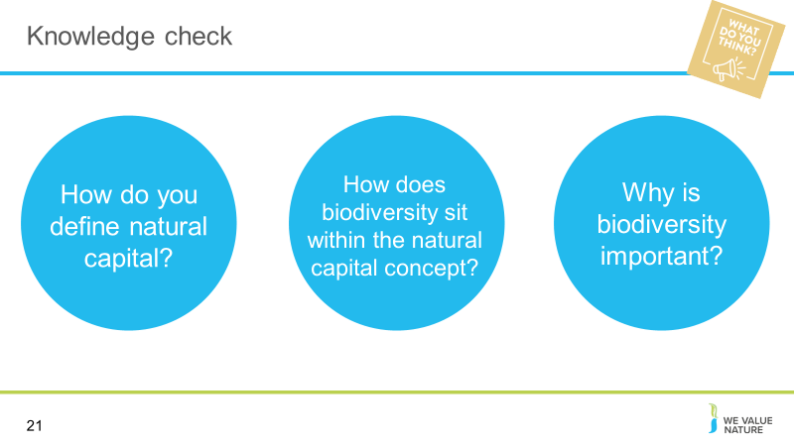NOTE: knowledge check exercise is optional
Presenter to read the question out on the slide.
Once the poll is complete, presenter should use the notes below to explain that there are different definitions. Go through what has been shared by participants.
Virtual session- https://zoom.us/
Add question & answers to a live poll in zoom as per instructions
To enable Polling: Sign into the Zoom web portal. In the navigation menu, click Account Management then Account Settings (if you are an account administrator) or Settings (if you are an account member). Navigate to the Polling option on the Meeting tab and verify that the setting is enabled. If the setting is disabled, click the toggle to enable it. If a verification dialog displays, choose Turn On to verify the change. Note: If the option is greyed out, it has been locked at either the Group or Account level, and you will need to contact your Zoom administrator.

Creating a poll: Go to the Meetings page and click on your scheduled meeting. If you do not have a scheduled meeting, schedule a meeting now. From the meeting management page, scroll to the bottom to find the Poll option. Click Add to begin creating the poll. Enter a title and your first question. (Optional) Check the box to make the poll anonymous, which will keep the participant's polling information anonymous in the meeting and in the reports. Select whether you want the question to be single choice (participants can only choose one answer) or multiple-choice question (participants can choose multiple answers). Type in the answers to your question and click Save at the bottom. If you would like to add a new question, click Add a Question to create a new question for that particular poll.
You can launch a poll by clicking on the live polling icon in the meeting controls and selecting the poll you want to launch. The participants in the meeting will now be prompted to answer the polling questions. The host will be able to see the results live. Once you would like to stop the poll, click End Poll. If you would like to share the results to the participants in the meeting, click Share Results. The results can be downloaded once the meeting has ended.
In person session – https://www.mentimeter.com/
Mentimeter is an interactive presentation software. The host can create a presentation once signing up to Mentimenter. Questions and activities can be added to each slide of the presentation. Participants can answer the questions and interact with the presentation by typing a 6-digit code found at the top of the presentation into Menti.com. The host can either create a new share on Zoom to display the Mentimeter slides or download the Mentimeter plug-in for PowerPoint.
To run this question, select the Multiple-Choice question type when creating your presentation, and fill in the question and answers as directed.

Slide 22
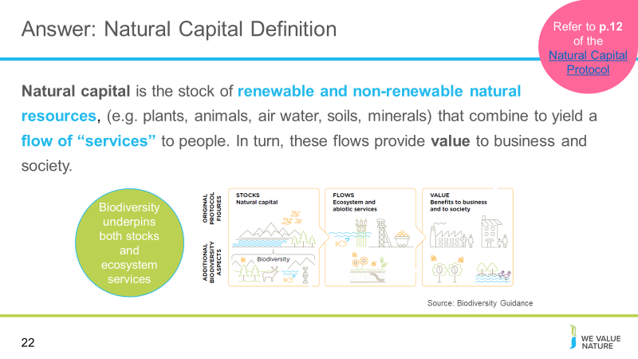

Discussion session based on the outcomes of the poll on slide 21
We have started thinking about natural resources an agricultural producer relies and impacts on but what do we mean when we talk about natural capital?
Well in fact, everything you have discussed through the previous example is natural capital is some form or another. Whether it is the assets/resources it represents (such as water and soil you have identified as needed for the farm) or the services it brings (e.g. pollination, etc.).
From climate adaptation to ecosystem services, the environmental jargon is everywhere. What is important, is not to remember all the terminology used, but rather that these are all connected to the value of nature and that people have different entry points and priorities and will use one or another terminology based on that. But fundamentally, we are all speaking about the same things, just in different ways.
This is the definition according to the Natural Capital Protocol.

Presenter to read out the definition of natural capital on the slide, referring to pg. 12 of the Natural Capital Protocol. Presenter to then explain natural capital stocks using the notes below:

The stocks refer to the natural resources available to us while the flows refer to the different benefits people receive from ecosystems such as:
timber, fiber, pollination, water regulation, climate regulation, recreation, etc.
Abiotic services are benefits to people that do not depend on ecological processes but arise from fundamental geological processes e.g. – supply of minerals, metals and oil and gas, as well as geothermal heat, wind, tides, etc.

Slide 23
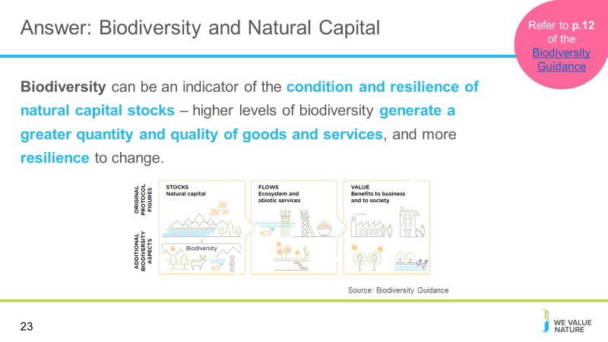
Discussion session based on the answers to the poll on slide 21
Presenter to address biodiversity; what CAN and CANNOT be covered in the training session, referring to pg. 14/15 of the Natural Capital Protocol
- In this training, we will demonstrate ways in which biodiversity underpins stocks and ecosystem services
- In the Protocol, biodiversity (part of stocks) is considered critical to the health and the stability of natural capital in so much that it provides resilience to shocks like floods and droughts…
- As well as supporting fundamental processes such as carbon and water cycles and soil formation
- Since biodiversity underpins stocks and ecosystem services, business impacts and dependencies on biodiversity are often hard to measure, remaining hidden in many cases. To truly measure and value business impacts on biodiversity, you need to understand the causal relationships between your business activities, the changes in biodiversity and the associated changes in ecosystem services.
- There are different for valuing biodiversity for example using total economic value techniques in which is the value that people place on the continued existence of species or ecosystems, regardless of whether they ever encounter the species or ecosystem is sought. Others try to attach intrinsic value to biodiversity which is linked to concepts like “duty of care” and “stewardship of nature”, these are beyond the current scope of the training.
NOTE: a further definition on the natural capital approach is included below. Presenter has the option to use this depending on the audience and context of the training.

Source: https://www.iisd.org/pdf/2008/natural_capital_approach.pdf

The Natural Capital Approach (NCA) is a means for identifying and quantifying natural resources and associated ecosystem goods and services that can help integrate ecosystem-oriented management with economic decision-making and development (this includes abiotic services as well as ecosystem services). By integrating economic and environmental imperatives, NCA operationalizes the ecosystem approach and facilitates policymaking for sustainable development.

Slide 24
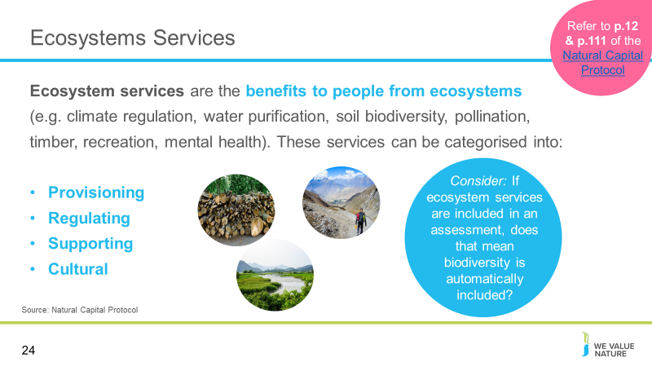 Presenter to explain ecosystem services using the notes below and referring to pg. 12 and 111 of the Natural Capital Protocol:
- Ecosystems services are the benefits to people from ecosystems, where an ecosystem is defined as the interaction between complex plants, animals and microorganisms and their non-living environment
- Examples of ecosystem services include timber, fiber, pollination, water regulation, climate regulation, recreation, fostering wellbeing and others
- Ecosystem services can be classified into provisioning, regulating, cultural and supporting services
- Provisioning: material outputs from nature (e.g. fiber, timber, etc.)
- Regulating: indirect benefits from nature generated through regulation of ecosystem processes (e.g. mitigation of climate change through carbon sequestration)
- Cultural: non-material benefits from nature (e.g. recreational, spiritual, aesthetic). It is much harder to measure these kinds of services in quantifiable terms so often have to use qualitative approaches
- Supporting: fundamental ecosystem processes that support the delivery of other ecosystem services (e.g. nutrient cycling)
- There are many classification schemes for ecosystem services including the CICES and the FEGS-CS which measure ecosystem outputs that are directly consumed or used by beneficiaries:
- The Common International Classification of Ecosystem Services aims to classify the contributions that ecosystems make to human well-being that arise from living processes – the classification has been broadened in this tool to cover abiotic outputs (https://cices.eu/)
- The Final Ecosystem Goods and Services Classification System provides a foundation for measuring, quantifying, mapping, modelling and valuing ecosystem services. The FEGS-CS can serve as the basis for valuation (https://www.epa.gov/eco-research/final-ecosystem-goods-and-services-classification-system-fegs-cs)
Bring in biodiversity element by recognizing the links between ecosystem services and biodiversity, and how biodiversity is important for the provision of the ecosystem services.

Slide 25
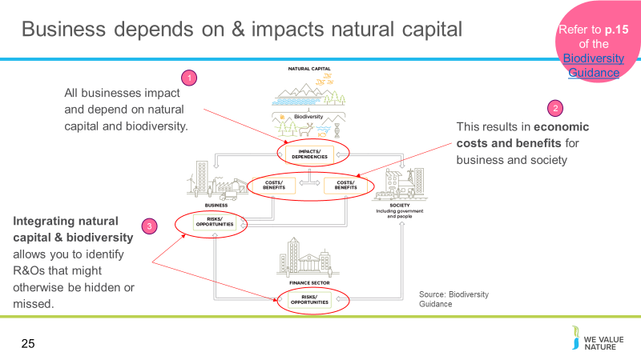
Presenter to discuss the business case for a natural capital assessment: showing how all businesses impact and depend upon natural capital and biodiversity.

Natural capital and the benefits that flow from it sustain us all: individuals, families, companies, and society as a whole. At the same time, our individual or collective actions can build or degrade natural capital, depending on how we use it. Every business impacts and depends on natural capital to some degree and will experience risks and/or opportunities associated with those impacts and/or dependencies.

Biodiversity describes the variety of life and is the living component of what can be thought of as natural capital stocks. It plays an important role in the provision of the services we receive from nature. The terms “capital” and “stocks” are used as metaphors to help describe the role of nature within the economy. The presence of, and interactions between, natural capital stocks generate a flow of goods and services; these goods and services create value through the benefits they provide to business and society. Biodiversity is an integral part of natural capital and underpins the goods and services that natural capital generates. It is important to note that biodiversity is not an asset, rather a descriptive feature of assets we call natural capital.

The figure shown on the slides highlights biodiversity impacts and dependencies. It is a conceptual model for business, the finance sector and society.
- Natural, social and economic issues are fundamentally interconnected and cannot be separated from one another. Natural capital underpins all the other capitals and without it we would not have social and human or financial capital.
- Natural resources encompass a range of materials occurring in nature that can be used for production and/or consumption.
- Renewable resources: These may be exploited indefinitely, provided the rate of exploitation does not exceed the rate of replacement, allowing stocks to rebuild (assuming no other significant disturbances). Renewable resources exploited faster than they can renew themselves may effectively become non-renewable, such as when over-harvesting drives species extinct (UN 1997).
- Non-renewable resources: These will not regenerate after exploitation within any useful time period. Non-renewable resources are sub-divided into reusable (e.g., most metals) and non-reusable (e.g., thermal coal).
- It is important for businesses to understand their impacts and dependencies on natural capital stocks, and the ecosystem services they provide. Because the current economic system assumes infinite availability of these resources, use and extraction are currently unsustainable, and provide a systemic risk to your business, and society as a whole.

Slide 26
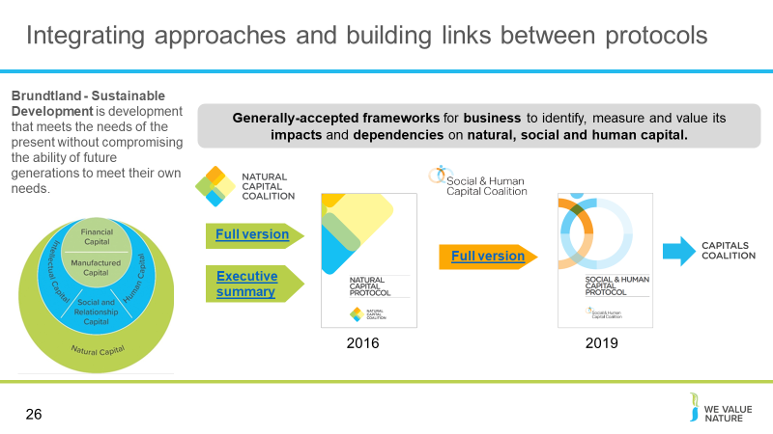
Presenter to first introduce the Brundtland Sustainable Development definition, using the notes on the slide and the notes below:

It contains within it two key concepts: the concept of 'needs', in particular the essential needs of the world's poor, to which overriding priority should be given; and the idea of limitations imposed by the state of technology and social organization on the environment's ability to meet present and future needs – WCED, 1987. Adapted from BET module 1 (WBCSD, 2012)

Presenter to then provide an explanation of the development of different protocols:
- NC – The Natural Capital Protocol is a decision-making framework that enables organizations to identify, measure and value their direct and indirect impacts and dependencies on natural capital. It was developed in 2016 by the Natural Capital Coalition (now the Capitals Coalition). Three sector guides (Apparel; Food and Beverage; Forest Products) and a Finance sector supplement have since been released to accompany the Protocol.
- SC – The Social and Human Capital Protocol is a decision-making framework that enables organizations to identify, measure and value their direct and indirect impacts and dependencies on social and human capital. The Protocol is the result of four years of collaborative development – involving input from over 50 businesses and a public consultation. The Protocol was released in 2019 by the Social & Human Capital Coalition (now the Capitals Coalition).
- The Capitals Coalition unites the Natural Capital Coalition and the Social & Human Capital Coalition to accelerate momentum, leverage success, connect powerful and engaged communities, and identify the areas, projects and partnerships where we can collectively deliver benefits for nature, people and the economy. The Coalition is a collaboration of over 370 of the world’s leading organizations from business, accountancy, science and academia, membership organizations, standard setting, finance, policy and civil society, who have united in a pre-competitive space because they believe that the Coalition is a vehicle that can drive the global conversation and deliver desperately needed systemic change by bringing nature and people into the heart of decision making.

Link to The Capitals Coalition website: https://capitalscoalition.org/

Slide 27
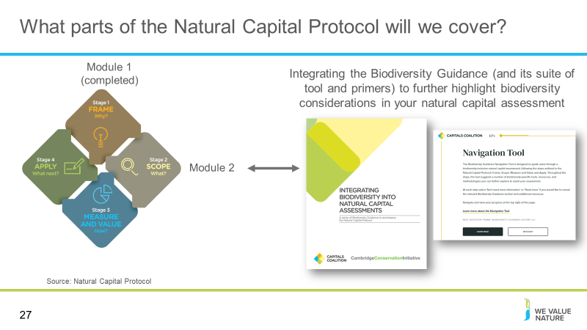
Presenter to explain the parts of the Natural Capital Protocol that will be covered in this training, using the notes below:
Scope the assessment - What is an appropriate scope to meet your objective?
Determine the impacts and/or dependencies - Which impacts and/or dependencies are material?
Measure impact drivers and/or dependencies - How can your impact drivers and/or dependencies be measured?

The business case for integrating biodiversity in natural capital assessments

Slide 28
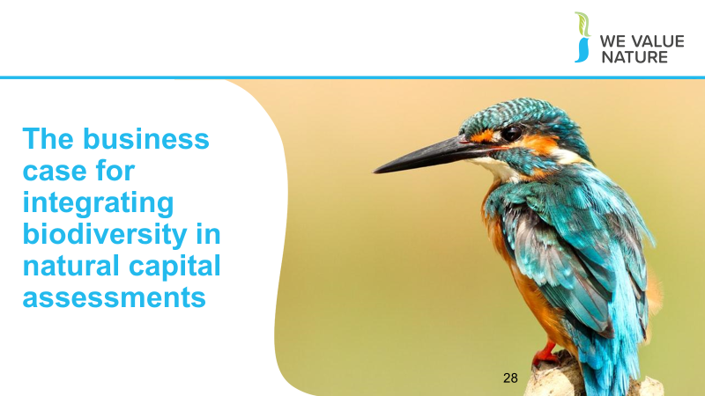
Presenter to introduce the section on the business case for integrating biodiversity in natural capital assessments

Slide 29
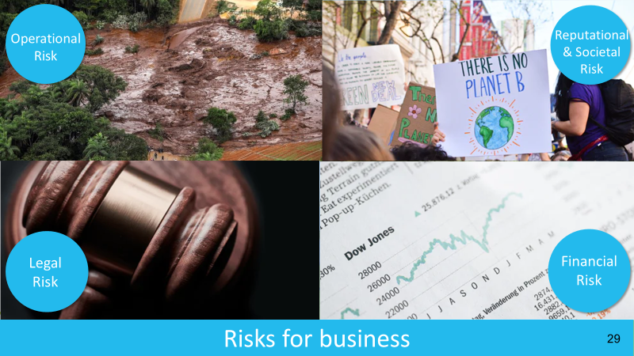
Presenter to talk through risks and opportunities for businesses and why it’s important to assess impacts and dependencies in the context of risks and opportunities. Presenter to highlight that we will be going into more detail in the following slides as to what some examples of impacts and dependencies are, but before, it is important to highlight typical risks and opportunities that businesses face.

Source: WVN training module 1
Operational risk – Vale damn collapse
Reputation risk – increased public & consumer awareness of environmental and social damages + consumers are increasingly demanding assurance that the products they buy are produced in way that protect our environment and respect human rights – link with SOCIETAL risks – health impacts on local communities, social license to operate
Legal risk – Texas oil company, Anadarko Petroleum, has agreed to pay $5.1 billion for a vast environmental clean-up - aimed at restoring thousands of sites polluted by toxins and compensating thousands of people with personal injury claims. https://www.nytimes.com/2014/04/04/business/energy-environment/anadarko-petroleum-to-pay-5-1-billion-to-settle-pollution-case.html
Financial risk – Underlying all of these risks & opportunities are financial ones! As we have seen, these risks imply important financial costs. Canadian gold mining company, Infinito Gold, lost over 50% of its share value as a result of the withdrawal of a mining concession in Costa Rica due to concerns about the potential impacts on agriculture, endangered species and forests. This led to a reference in the audit accounts to material uncertainties regarding the company’s ability to continue as a going concern
Source: KPMG, Flora and Fauna International, Acca, Is natural capital a material issue (2012)

Sitting under all these different types of risk are the risks due to biodiversity loss.

Biodiversity loss risk: Biodiversity loss comes at the nexus of many other business risks. E.g. through decreasing food security (which itself has economic ramifications) or increasing the likelihood of coastal flooding. Biodiversity loss can be felt through physical risks (increased cost of resources, disruption of operations due to natural disasters unmitigated by appropriate ecosystems), associated regulatory and legal risk, market risk from changing consumer preference as consumers become more aware & discerning RE biodiversity, and supply chain risks. Examples: “Deforestation in the Agno River basin in the Philippines has led to such extensive river and reservoir siltation that the 100-megawatt Binga hydroelectric facility can only operate intermittently”, Studies have shown that the total economic impact of Hurricane Katrina (approximately US$150 billion), was significantly higher than would have been the case if coastal wetlands in the region had been preserved, In 2008, the Norwegian Pension Fund withdrew its £500 million stake in the mining giant Rio Tinto and excluded the company from its funds. The decision to withdraw was based on the activities of Rio Tinto’s mining operations in Indonesia.

https://www.pwc.co.uk/assets/pdf/wef-biodiversity-and-business-risk.pdf

But the good news is that, where there is risk, there is opportunity to:
- Secure natural resources
- Save costs
- Manage future risks
- Engage stakeholders

Operational opportunity – EDF rainwater harvesting to manage water scarcity risks leading to reduction in water consumption, economical & energy savings https://www.wbcsd.org/Programs/Food-Land-Water/Water/Circular-water-management/Resources/Case-studies/Rainwater-harvesting-for-water-reduction

Reputation opportunity – IKEA to use only renewable and recycled materials by 2030 https://www.reuters.com/article/us-ikea-sustainability/ikea-to-use-only-renewable-and-recycled-materials-by-2030-idUSKCN1J31CD

Legal opportunity – Union Carbide Corporation, subsidiary of The Dow Chemical Company: Seadrift, TX Wetlands for Wastewater Treatment Project description: 110-acre engineered wetland in lieu of an industrial wastewater treatment plant In 1995, the Seadrift water treatment facility was seeking a solution to consistently meet regulatory requirements for water discharge. An innovative GI solution consisting of a constructed wetland was installed and has been successfully operating upon startup and for the last 15 years. https://www.naturalinfrastructureforbusiness.org/wp-content/uploads/2015/11/DowUCC_NI4BizCaseStudy_ConstructedWetlands.pdf

Financial opportunity – But when these risks are taken into account, we saw how it can also lead to reduced financial costs, or improve access to finance. Companies like those you can see here have managed to secure substantial billion dollar loan facilities where the interest rate of repayments is linked to ESG performance. That is to say if the company has string environmental and social performance they pay back less on the loan.

Slide 30
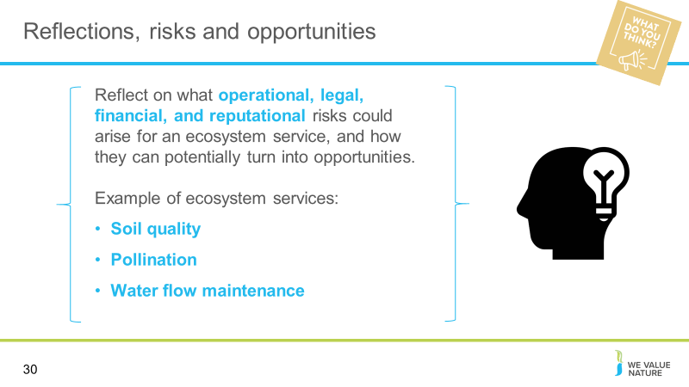
Optional exercise depending on time: presenter to read the question out on the slide, using the notes below to clarify:

Soil quality
- Soil regulation is considered as an ecosystem characteristic or process for regulating soil quality and health rather than soil creation in this example
- More details regarding the ecosystem service functions relating to soil are given in different ecosystem service classification systems including:
- The Common International Classification of Ecosystem Services (CICES): https://cices.eu/
- The National Ecosystem Services Classifications System (NESCS): https://www.epa.gov/sites/production/files/2015-12/documents/110915_nescs_final_report_-_compliant_1.pdf

Pollination
- Wild animal pollination (for farmers, gardeners, foresters)
- Pollination could be interpreted as rented pollinators or wind

Water flow maintenance
- Freshwater (for utilities, farmers)
- Water extraction can be easily mixed up with the labour and capital (pipes, pumps) needed for extraction rather that the freshwater getting to the user

Once reflection is complete and feedback has been received (either virtually or in person; see below), presenter should use the notes below to explain that there are different answers:

Generally, it is difficult to tell whether natural capital will pose more of a risk or an opportunity without knowing the specific context
Different forms of natural capital can pose more of a risk or more of an opportunity depending on the timescale, the sector of the company, who is impacted, the size of the population, the significance of different values, how big the change is from the baseline, the type of ecosystem service or stock in question etc.

Virtual
Presenter should ask each delegate to share their thoughts in the chat

In person
Each table will be asked to reflect on these points as a group and feedback

Slide 31
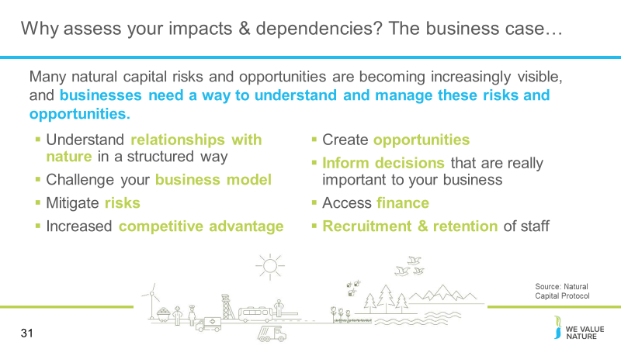
Presenter to provide the business case for assessing natural capital, using the notes below and the information on the slide:

There are evidently a lot of pertinent risks around nature and the environment facing businesses today. Where does natural capital come into this - how can it help you manage these risks?

- To assess natural capital is to assess your company’s impacts and dependencies on nature.
- It provides information that will help you to understand your relationship with nature. By focusing on impacts and dependencies, natural capital provides structure to this understanding.
- Once you have a better understanding of your relationship with nature, you can use this to challenge your business model, mitigate risks and create opportunities. Natural capital can also be a valuable tool for broadening the conversation to include all parts of your business, including the finance team.

Slide 32
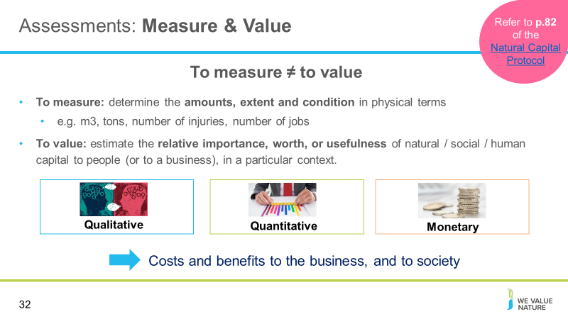
Presenter to explain the difference between measuring and valuing, using the notes below:
- There are different ways of valuing – could be qualitative, quantitative, and monetary
- Important to note that monetary values without any context (i.e. accompanying quantification) are less meaningful!
- The method you chose depends on which natural capital impact drivers or dependencies you wish to assess, the chosen value perspective (e.g. business, societal, or both), the ultimate objective of your assessment, and the time and resources available
- Monetary valuation: some find it difficult to accept or interpret monetary valuation of certain benefits (e.g. spiritual values). In such situations, special efforts may be required to explain the advantages and also to acknowledge the limitations of monetary valuation.
- Advocates of natural capital are sometimes accused of ‘putting a price on nature’ or ‘pricing the priceless’, but the core assertion of this approach is that prices have failed to reflect the ‘true value’ of the natural world, and that the economic systems are broken.
- In this training the common definitions of price and value are used, i.e. where price is ‘the quantity of one thing that is exchanged or demanded in barter or sale for another/the amount of money given or set as consideration for the sale of a specified thing’ and value as ‘the regard that something is held to deserve; the importance, worth, or usefulness of something e.g. “your support is of great value”. If something is not for sale, we do not describe it as having a ‘price’, but we may nevertheless recognize the value that it holds and make decisions on this basis.

Slide 33

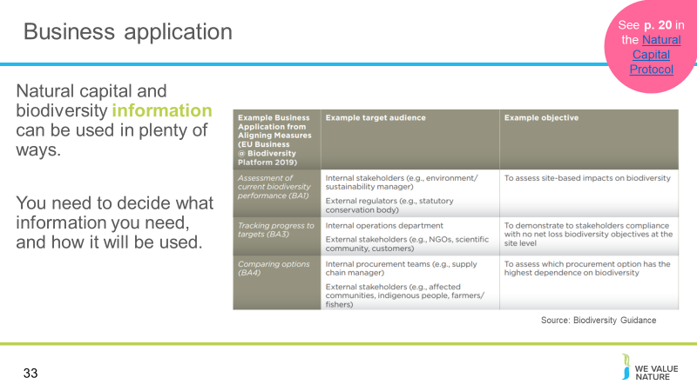Presenter to explain business applications of natural capital assessments, using the notes below:
A natural capital assessment provides information. Whilst this can be valuable in its own right, there are also numerous ways to use this information.
The NCP focuses on using natural capital assessment for decision-making, measurement and valuation, but it can also be used for disclosure and communication, or to help formulate strategy.
The best way for your company to use natural capital information is highly individual – think back to the challenges and risks you identified earlier in the training and consider how more information could help you meet these challenges.

Presenter to highlight some examples of business applications using the table provided, e.g.
- Assessing risks and opportunities: e.g. assess risks and opportunities of capital expenditure when deciding which flood solution to choose
- Assessing impacts on stakeholders: e.g. assess how a company's dependency on a local water supply affects local communities
- Estimating the total value and/or net impact of the company: e.g. estimating the total impact of a manufacturing company across the entire value chain (upstream, direct operations, downstream)

Slide 34
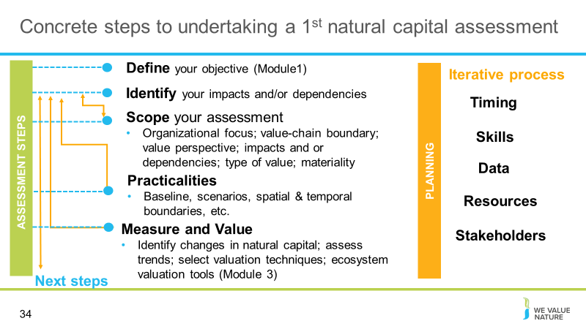Presenter to explain the steps to undertaking a 1st natural capital assessment using the diagram on the slide. Presenter to explain that defining the objective can be quite difficult but this is a necessary step to have completed before beginning to scope an assessment

Slide 35
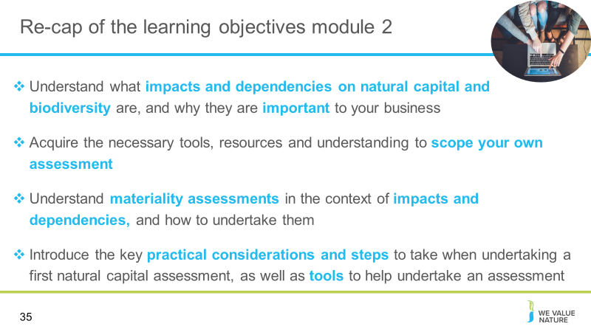Presenter to quickly re-cap the learning objectives of this training session, referring to the points on the slide

Identifying your natural capital impacts & dependencies

Slide 36
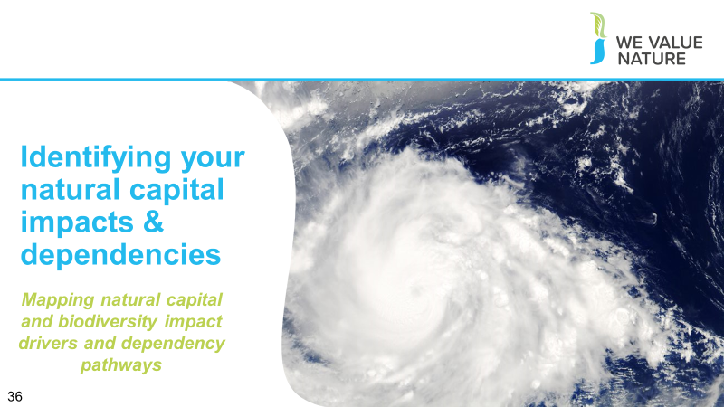
Presenter to introduce the section on understanding business activities and the impact/dependencies that they have on different stakeholders/areas of natural capital

Slide 37
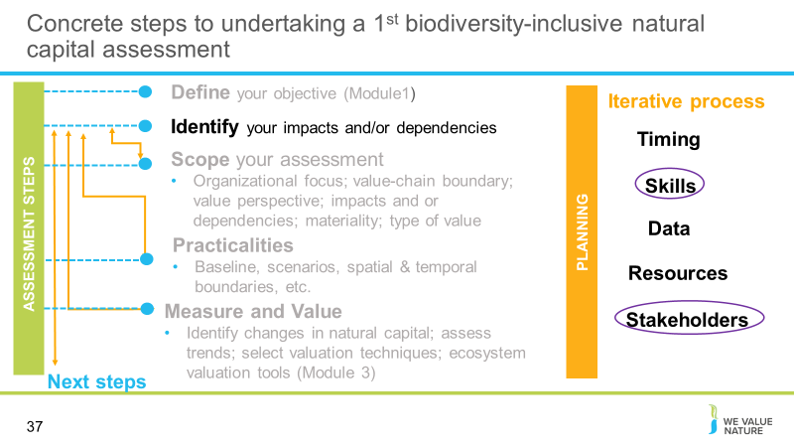Presenter to provide initial view of impacts and dependencies. This can be set out in more detail during the project and a materiality assessment can be undertaken

Slide 38
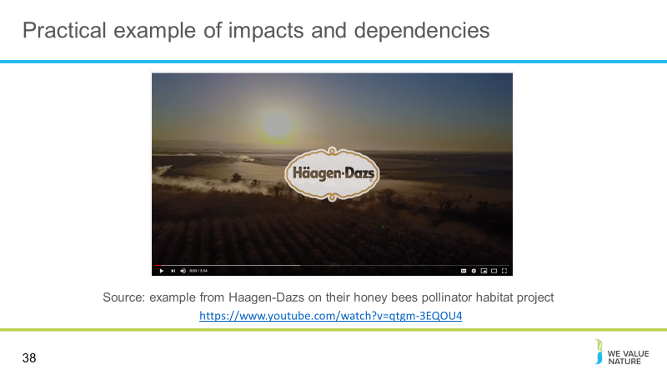Optional video

Slide 39
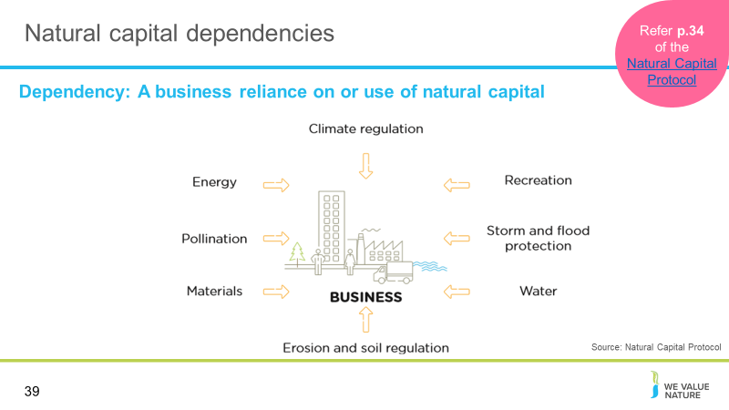
Presenter to provide detail on natural capital dependencies using the notes below and referring to p. 34 of the Natural Capital Protocol:
The protocol defines natural capital dependency as: A business reliance on or use of natural capital. This can occur in your direct operations or somewhere else in your value chain.

Presenter to link natural capital dependencies with the risks and opportunities material covered in M1, using the notes below. Presenter to elaborate on the business impact diagram, using some examples:

- Again, thinking back to some of the content in M1, we can see how natural capital dependencies can pose different risks and opportunities for businesses. This is useful in establishing the value of natural capital dependencies in relation to other inputs and services that you rely on.
- Pollination e.g. regulating service critical in agriculture
  - This may pose an operational risk for agricultural sectors if pollinator populations decline
  - Land use change may lead to a decrease in local pollinator-supporting habitats. This could reduce yield and create unpredictable changes in supply. Pollination of surrounding habitats could also decrease, leading to a reputational risk to your business and a societal risk to the local community (through a decrease in livelihoods).
  - Materials e.g. reliance on timber
  - This may pose a societal risk if timber sourcing begins to impact on access to forests for local communities in sourcing regions
  - This may pose a societal opportunity if local communities start to benefit from good forestry management
  - The creation of timber based products could be affected by climate change, leading to unpredictable growth rates. Climate change is a driver of biodiversity loss

Slide 40
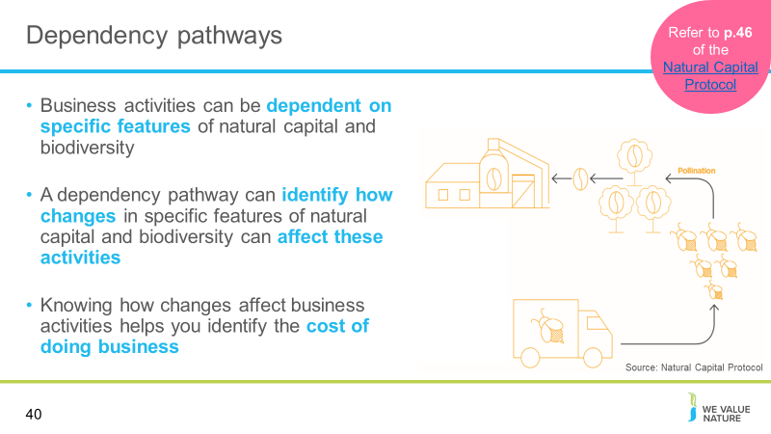
Presenter to discuss dependencies and outline the relevance of the figure on the slides
- Business activities can be dependent on specific features of natural capital and biodiversity
- A dependency pathway shows how a particular business activity depends upon specific features of natural capital. It identifies how observed or potential changes in natural capital affect the costs and/or benefits of doing business.
- The figure illustrates a dependency pathway using the pollination of coffee plants as an example. In this situation, a decline in the populations of wild pollinators (due to deforestation) results in lower yields and/or additional costs to coffee producers, who may be forced to rely on commercial pollinating services.
- A materiality assessment in this example would consider whether the yield loss or extra cost of commercial pollination is likely to have a significant impact on the business, compared to other potential relevant dependencies.

Additional information:
Presenter to then walk through the coffee production/pollination example using the notes below and referring to p. 46 of the Natural Capital Protocol:
Business activities at a coffee production plant have a dependency on the pollination of coffee plants, and are dependent on habitats rich in biodiversity to provide the pollinator supporting habitats.

Changes in natural capital cause the bee population to decline due to:
The business itself, e.g. overuse of pesticides
Natural changes e.g. extreme weather events
Human-induced changes, including due to the activity of other businesses, e.g. habitat change
Changes in natural capital affect business dependency, so pollination services are important

Presenter to walk through the t-shirt manufacture example below, using the notes below and referring to pg. 24 of the Natural Capital Protocol:

At the agricultural level, water is needed to irrigate cotton plants, creating a dependency on water.
Changes in the natural capital, in this case water availability, can change due to both external factors (e.g. climate change, other agriculture dependent on the same water source, other upstream water usage) and internal factors (e.g. over-abstraction of water for irrigation, water extraction to clean machinery).
Because of these changes in natural capital, the company has to chose whether to accept a decreased cotton yield, adapt to a more resilient form of agriculture, or pay more for an alternative water supply.

Presenter to link this content to risk, reading an example from module 1:

Reputation risk – increased public & consumer awareness of environmental and social damages + consumers are increasingly demanding assurance that the products they buy are produced in way that protect our environment (link to pollution)

Legal risk – giant Texas oil company, Anadarko Petroleum, has agreed to pay $5.1 billion for a vast environmental clean-up - aimed at restoring thousands of sites polluted by toxins and compensating thousands of people with personal injury claims.(link to pollution) https://www.nytimes.com/2014/04/04/business/energy-environment/anadarko-petroleum-to-pay-5-1-billion-to-settle-pollution-case.html

Financial risk – Underlying all of these risks & opportunities are financial ones! As we have seen, these risks imply important financial costs. Canadian gold mining company, Infinito Gold, lost over 50% of its share value as a result of the withdrawal of a mining concession in Costa Rica due to concerns about the potential impacts on agriculture, endangered species and forests. This led to a reference in the audit accounts to material uncertainties regarding the company’s ability to continue as a going concern (Link to land management and pollution). Source: KPMG, Flora and Fauna International, Acca, Is natural capital a material issue? (2012)

Biodiversity loss risk: Biodiversity loss comes at the nexus of many other business risks. E.g. through decreasing food security (which itself has economic ramifications), or increasing the likelihood of coastal flooding. Biodiversity loss can be felt through physical risks (increased cost of resources, disruption of operations due to natural disasters unmitigated by appropriate ecosystems), associated regulatory and legal risk, market risk from changing consumer preference as consumers become more aware & discerning RE biodiversity, and supply chain risks. Examples: “Deforestation in the Agno River basin in the Philippines has led to such extensive river and reservoir siltation that the 100-megawatt Binga hydroelectric facility can only operate intermittently”, Studies have shown that the total economic impact of Hurricane Katrina (approximately US$150 billion), was significantly higher than would have been the case if coastal wetlands in the region had been preserved, In 2008, the Norwegian Pension Fund withdrew its £500 million stake in the mining giant Rio Tinto and excluded the company from its funds. The decision to withdraw was based on the activities of Rio Tinto’s mining operations in Indonesia. https://www.pwc.co.uk/assets/pdf/wef-biodiversity-and-business-risk.pdf

But good news is that, where there is risk, there is opportunity to:
- Secure natural resources
- Save costs
- Manage future risks
- Engage stakeholders

Presenter to link this content to opportunities, using an example from module 1 and the risk and opportunities slide in earlier sessions:
- Operational opportunity – EDF rainwater harvesting to manage water scarcity risks leading to reduction in water consumption, economical & energy savings https://www.wbcsd.org/Programs/Food-Land-Water/Water/Circular-water-management/Resources/Case-studies/Rainwater-harvesting-for-water-reduction
- Reputation opportunity – IKEA to use only renewable and recycled materials by 2030 https://www.reuters.com/article/us-ikea-sustainability/ikea-to-use-only-renewable-and-recycled-materials-by-2030-idUSKCN1J31CD
- Legal opportunity – Union Carbide Corporation, subsidiary of The Dow Chemical Company: Seadrift, TX Wetlands for Wastewater Treatment Project description: 110-acre engineered wetland in lieu of an industrial wastewater treatment plant In 1995, the Seadrift water treatment facility was seeking a solution to consistently meet regulatory requirements for water discharge. An innovative GI solution consisting of a constructed wetland was installed and has been successfully operating upon startup and for the last 15 years. HTTPs://www.naturalinfrastructureforbusiness.org/wp-content/uploads/2015/11/DowUCC_NI4BizCaseStudy_ConstructedWetlands.pdf
- Financial opportunity – But when these risks are taken into account, we saw how it can also lead to reduced financial costs or improve access to finance. Companies like those you can see here have managed to secure substantial billion-dollar loan facilities where the interest rate of repayments is linked to ESG performance.

Slide 41
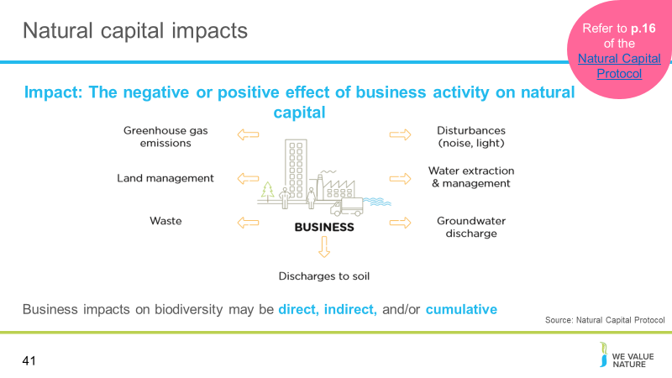
Presenter to provide detail on natural capital impacts using the notes below and referring to p. 16 of the Natural Capital Protocol:

The Protocol defines a natural capital impact as: The negative or positive effect of business activity on natural capital. They can arise directly from business operations or indirectly from the use of products and services. As a result of your impact on natural capital you can generate impacts on your business as well as impacts on society.

Your business impacts on biodiversity may be direct, indirect, and/or cumulative. Indirect impacts are triggered in response to the presence of your business projects or operations, rather than being directly caused by them. Cumulative impacts arise from the combined impacts of your operations, those of other organizations (including other businesses, governments, and local communities), and other background pressures and trends (BBOP 2012a). Similarly, impacts can accumulate over time, so that relatively small impacts of each subsequent activity can add up to a large overall impact. Your business impacts on biodiversity, particularly your indirect and cumulative impacts, may often be non-linear and difficult to predict.

Presenter to link natural capital impacts with the risks and opportunities material covered in M1, using the notes below. Presenter to elaborate on the business impact diagram, using some examples:
- Thinking back to some of the content in M1, we can see how natural capital impacts can pose different risks and opportunities for businesses:

Presenter to discuss examples from below:
- Land management e.g. forest management
  - This may pose an operational risk by reducing resilience to natural hazards through degradation of natural ecosystems
  - This may also pose an operational opportunity if businesses invest in sustainable land management, hence reducing costs by protecting against natural hazards
  - Waste/Site based impacts (e.g. development of an open cast mine may lead to a reduction in total vegetation cover and complexity).
    - This could pose a risk to the structural integrity of the mine due to an increased likelihood of flood (from the loss of provisioning services provided by the local habitat) and it would pose a reputational risk depending on the location of the mine
    - Uncontrolled leakage from tailing ponds (e.g. selenium) could lead to acute and chronic impacts on surrounding flora and fauna, which could affect local livelihoods and cause trophic cascades/decrease in population of local species
    - This may pose a reputational risk if there is negative publicity about the business’ impacts on natural capital

  - Groundwater discharge e.g. wastewater
  - Thinking of the example above, groundwater discharge may pose risks to biodiversity
  - This may pose financial risks if social conflict over polluted water adds to security costs
  - This may also pose societal opportunities if businesses use managed water catchments to improve water quality for local communities

Slide 42
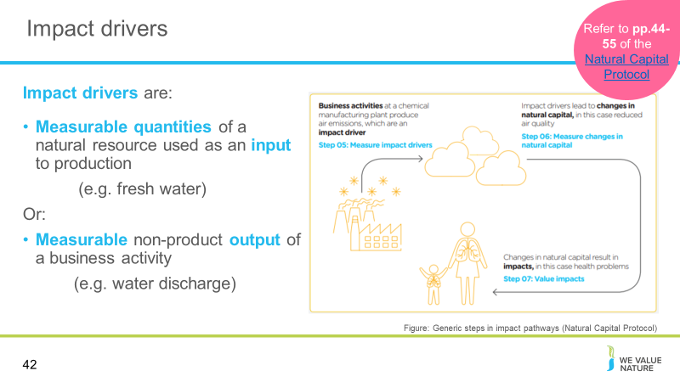
Presenter to define impact drivers and discuss impact pathways figure

Impact Driver – In the Protocol, an impact driver is a measurable quantity of a natural resource that is used as an input to production (e.g., volume of sand and gravel used in construction) or a measurable non-product output of business activity (e.g., a kilogram of NOx emissions released into the atmosphere by a manufacturing facility).
Impact drivers are generally expressed in quantitative units (e.g., kilograms, m3, hectares) and may already be included in company non-financial reporting or generated through life-cycle assessments.

Generally you can think of impact drivers as verbs – water use, land use, soil use – input. It is an impact diver because you can measure it, leading to measurement and valuation, which we will discuss shortly. The output is a quantifiable, measurable product e.g. GHG emissions

The figure on the slides illustrates the impact pathway for air pollution, a classic non-product output of industry. In this example, the business activity is the manufacture of industrial chemicals, which results in the emission of certain pollutants (the impact driver, measured in Step 5). These emissions lead in turn to a reduction in air quality (the change in natural capital, measured in Step 6), which may have significant impacts on various people depending on the local environment (the impact, valued in Step 7). Note that changes in natural capital that result from your business activity are sometimes called “outcomes”. In this example, a materiality assessment would be needed to determine whether air pollution was a material impact and, if so, which specific pollutants and resulting impacts are most relevant.

Slide 43
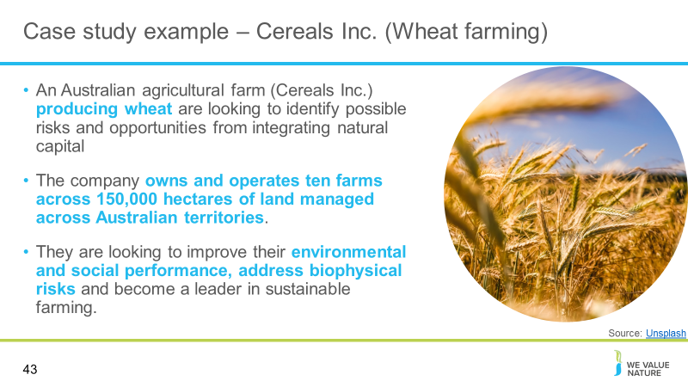

Slide 44
Presenter to read the points on the slide, explaining how the breakout rooms will work, for the virtual session.

Presenter to clarify that in this example they are looking for negative impacts
If time is short the exercise can be limited to either impacts or dependencies rather than both

Note: Limit this exercise to considering the company’s Australian operations. However, any option can be chosen by the presenter and the relevant results updated to accommodate this change. Additional information relating to the local country context may also be provided by the presenter as needed.

Presenter to clarify that in this example they are looking for negative impacts.
The breakout rooms should be based on Cereals Inc.

Slide 45
Presenter to read the points on the slide for the in-person session

Note: Limit this exercise to considering the company’s Colombian operations. However, any option can be chosen by the presenter and the relevant results updated to accommodate this change. Additional information relating to the local country context may also be provided by the presenter as needed.

Presenter to clarify that in this example they are looking for negative impacts.
The breakout rooms should be based on Cereals Inc.

Slide 46
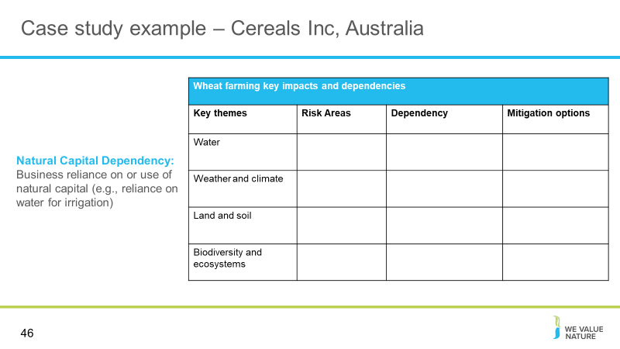
Presenter to ask participants to discuss in breakout sessions/at their tables, how relevant each of the thematic areas are to the dependencies of the wheat farm. Presenter to explain that the list of thematic areas on the slide are not exhaustive but rather an example list that has been cut down from those ecosystem services described in earlier slides.

We will tackle impacts and dependencies separately. This is because it is important to be aware that impacts and dependencies do not exist in a loop. Impacts don't cause dependencies, as dependencies don't cause impacts. Whilst sometimes the two are related, this is the case in the minority, rather than the majority.

Presenter to read out the definitions of a dependency:
Natural capital dependencies are defined as a business reliance on or use of natural capital. For example, businesses may be dependent on pollination as a regulating service in agriculture

In the table the participants are asked to identify the ecosystem services linked to each thematic areas, and identify the dependencies that a wheat farm may have on these areas. Lastly, the participants are asked to identify the overall risk associated with the ecosystem services, ranking them from low to high.

Slide 47
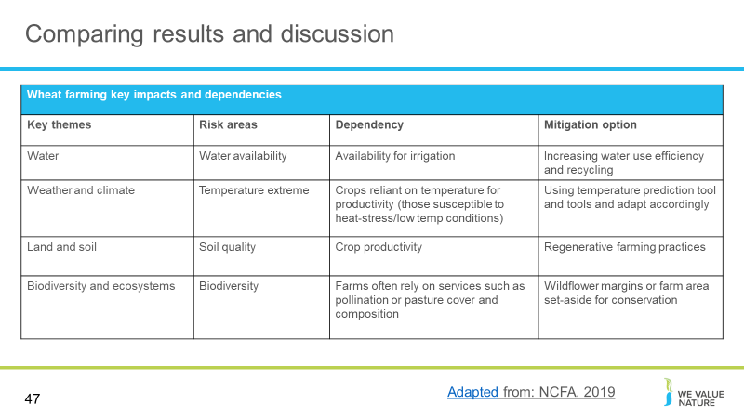
Presenter to discuss answers and compare results from breakout group discussions

Slide 48
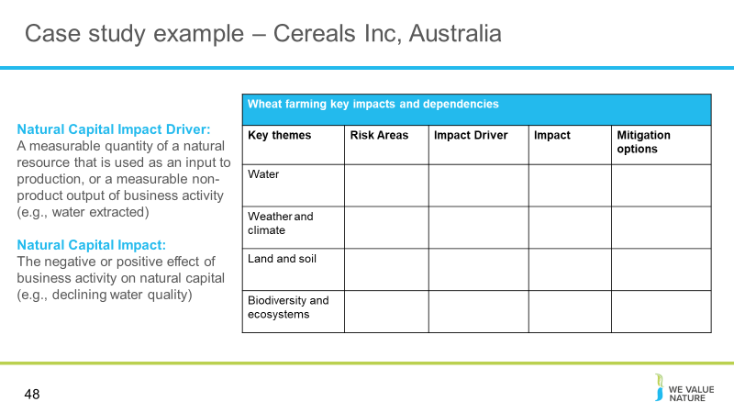
Presenter to ask participants to discuss in breakout sessions/at their tables, how relevant each of the thematic areas are to the impacts and impact drivers of the wheat farm. Presenter to explain that the list of thematic areas on the slide are not exhaustive but rather an example list that has been cut down from those ecosystem services described in earlier slides.

Presenter to read out the definitions of impact and impact drivers:
Natural capital impact drivers are defined as a measurable quantity of a natural resource that is used as an input to production, or a measurable non-product output of business activity (e.g. water extracted)
Natural capital impacts are defined as the negative or positive effect of business activity on natural capital. For example, businesses may extract a lot of water, depleting natural reserves

Presenter to clarify that in this example they are looking for negative impacts

In the table the participants are asked to identify the ecosystem services linked to each thematic areas, and identify the dependencies and impacts that a wheat farm may have on these areas. Lastly, the participants are asked to identify the overall risk associated with the ecosystem services, ranking them from low to high.

Slide 49
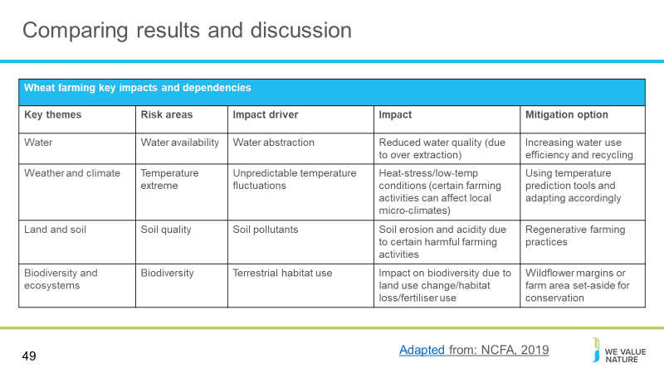
Presenter to discuss answers and compare results from breakout group discussions.

Slide 50
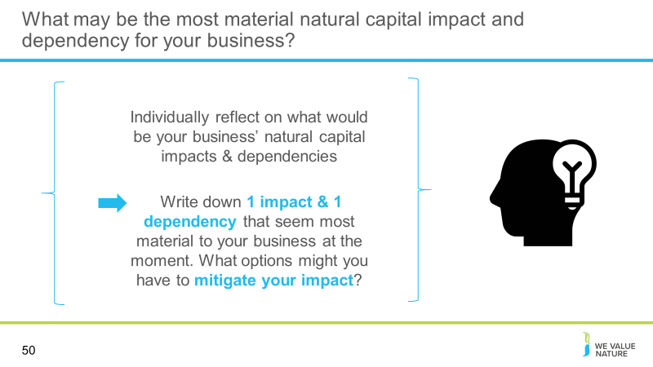
NOTE: reflection is optional
Presenter to read the question out on the slide

Virtual
Presenter should read through the slide, allow the participants some time for reflection and ask each delegate to share their thoughts in the chat
In person
Presenter should read through the slide, each table will be asked to reflect on these points as a group and feedback

Slide 51
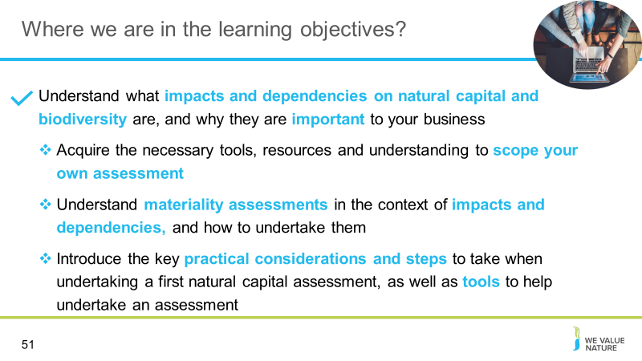
Presenter to highlight that learning objective 1 has now been covered and that the training will proceed to the next learning objective

Slide 52
Presenter to give participants a 15-minute coffee break

Scoping an assessment

Slide 53
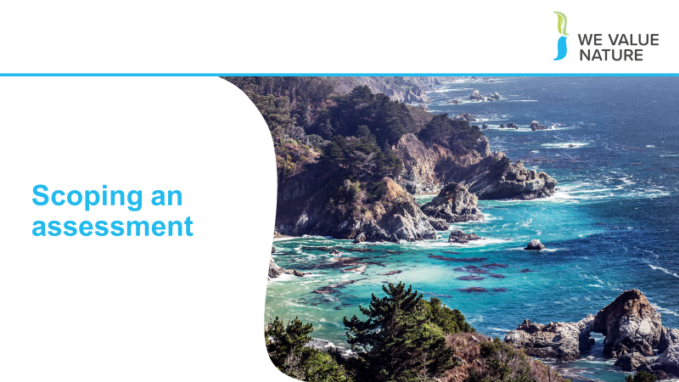
Presenter to introduce the section on ‘scoping an assessment’

Slide 54
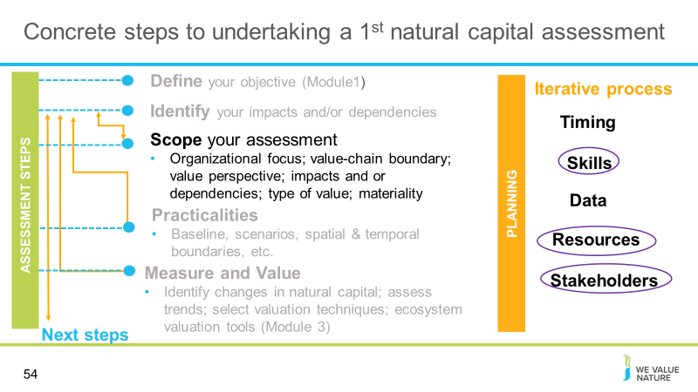
Presenter to explain this session will concentrate on concrete steps to undertake a 1st natural capital assessment in relation to scoping and practicalities

Slide 55
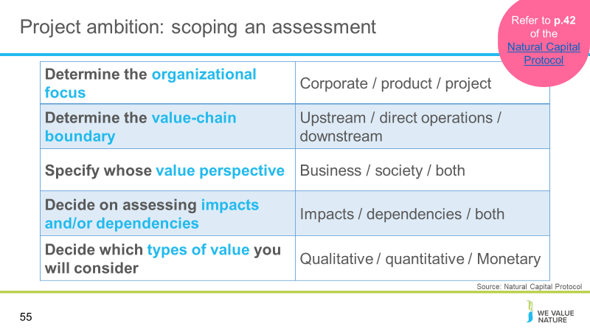
Presenter to walk through the steps to scope an assessment using the table on the slide, the notes below and referring to p.42 of the Natural Capital Protocol. Note: these points represent the ambition for the project and not all of the practicalities – these are covered in the next section in relation to scoping.

The organizational focus is where the assessment will focus, e.g. will the focus be on the corporate level (the whole company), product level (one product or a site), or project level?

Organizational focus: the part or parts of the business to be assessed (e.g., the company as a whole, a business unit, or a product, project, process, site, or incident). For simplicity, these are grouped under three general levels as below:
Corporate: assessment of a corporation or group, including all subsidiaries, business units, divisions, different geographies or markets, etc.
Project: assessment of a planned undertaking or initiative for a specific purpose, and including all related sites, activities, processes, and incidents.
Product: assessment of particular goods and/or services, including the materials and services used in their production.

Presenter to explain that to determine the value-chain boundary, you need to decide where in the value chain the assessment will take place:

For example, a clothing company may decide that the assessment should take place across all upstream operations (e.g. cotton farming and clothes manufacture).

Value-chain boundary: The part or parts of the business value chain to be included in a natural capital assessment. For simplicity, the Protocol identifies three generic parts of the value chain: upstream, direct operations and downstream. An assessment of the full lifecycle of a product would encompass all three parts.
Upstream (cradle-to-gate): covers the activities of suppliers, including purchased energy.
Direct operations (gate-to-gate): covers activities over which the business has direct operational control, including majority owned subsidiaries.
Downstream (gate-to-grave): covers activities linked to the purchase, use, re-use, recovery, recycling, and final disposal of the business’ products and services.

Presenter to explain that the value perspective identifies the potential values that the assessor wishes to be measured as part of the assessment i.e. the value to business, the value to society, or both:

Value perspectives: the perspective or point of view from which value is assessed; this determines which costs or benefits are included in an assessment.
Business value: The costs and benefits to the business, also referred to as internal, private, financial, or shareholder value.
Societal values: The costs and benefits to wider society, also referred to as external, public, or stakeholder value (or externalities).

The types of value to be considered include qualitative, quantitative and monetary (see slide in introduction section).

In addition to these considerations there are further questions that a potential assessor should ask including: the time and budget available, and the decision for which the assessment will help to inform – refer to the scoping section that comes next.
If there is time, the presenter can ask participants to complete a Mentimeter poll for one, or each of the scoping areas identified in terms of what would make sense for their own context. For example, what organization focus would be relevant for your company/own situation? Use the Open-Ended question type, instructions for using Mentimeter are provided in slide 12.

Slide 56
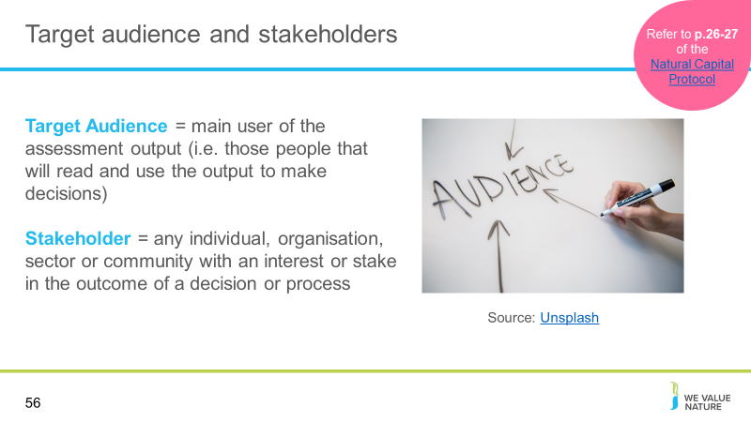
Presenter to discuss the importance of identifying target audience and key stakeholders, providing definitions for these groups

Slide 57
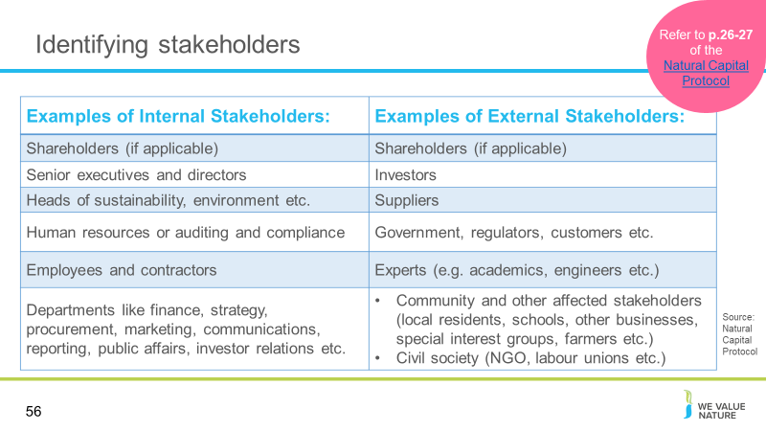
Referring to p. 26-27 of the Natural Capital Protocol, the presenter should explain steps to identify the stakeholder and explain why it is important to identify the stakeholder, using the notes below:
A stakeholder is defined as any individual, organization, sector or community with an interest or stake in the outcome of a decision or process (see p. 124 of the Natural Capital Protocol)
It is important to involve the right stakeholders to ensure that your assessment is reliable, relevant and useful in the long term – stakeholders may need to authorize or fund the assessment at the outset

Often, stakeholders may be the same as the target audience – nonetheless, there are also other stakeholders who may be affected by the results, including people who can provide information, influence or help verify, validate and interpret the assessment

Internal stakeholders are those directly and or financially involved in the operations – they may provide better insight

External stakeholders are entities not within the business itself but who care about or are affected by its performance – they may provide greater robustness and credibility as well as necessary insight into the impact of your business on natural capital When mapping stakeholders, it is important to consider the relative importance of stakeholders and their relative influence as well as their legitimacy, willingness and ability to engage or primary/secondary status

Presenter should provide some examples of internal and external stakeholders using the table on the slide.

Sources:
https://courses.lumenlearning.com/boundless accounting/chapter/overview-of-key-elements-of-the-business/#:~:text=External%20stakeholders%20are%20entities%20not,regulators%2C%20investors%2C%20suppliers

Slide 58
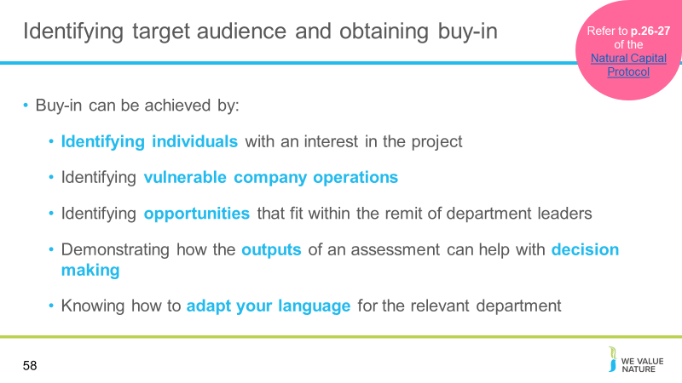
Presenter to explain how buy-in can be achieved, using the notes on the slide

Slide 59
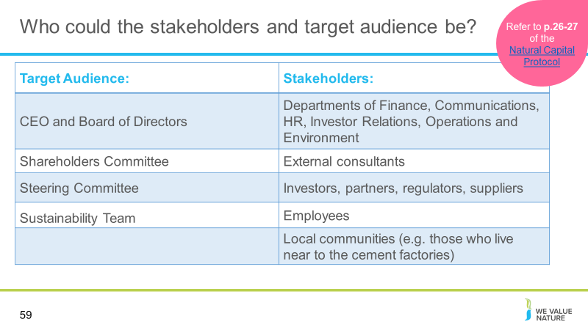
Presenter to provide examples of different target audiences and stakeholders

Slide 60
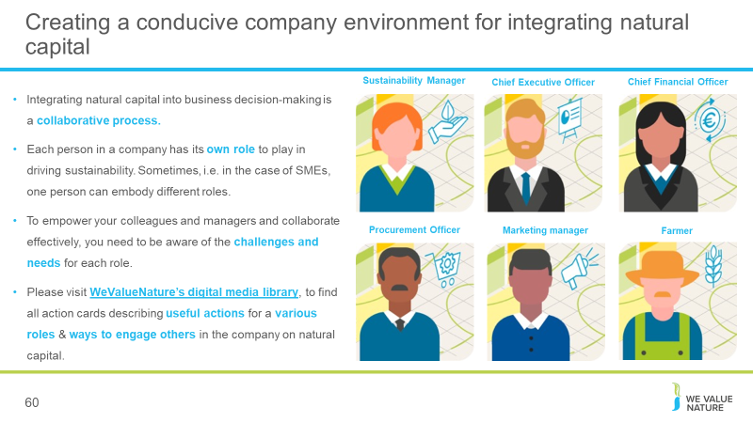
Presenter to dicsuss creating a conducive company environment for integrating natural capital, using notes on the slide

Slide 61
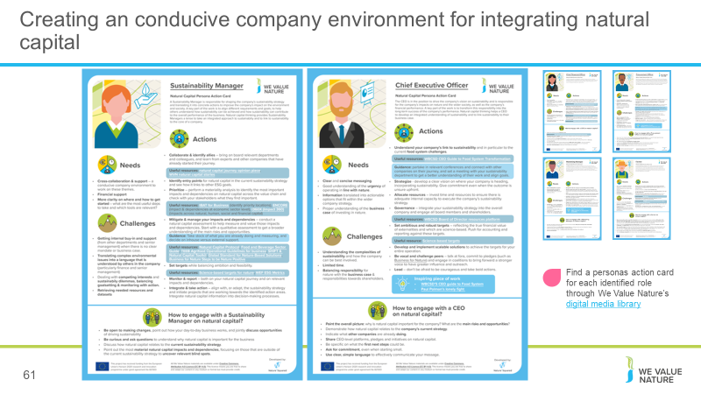
Presenter to discuss the cards available on WVN media library
Cards have been developed for different roles – e.g., sustainability manager, CEO, risk officer, supplier, farmer etc. – each card explains their role in the value chain, their needs, their challenges in engaging with nature, key actions they can take, and practical tips on how best to engage with that actor and obtain buy in.

For example:

Sustainability Manager
Actions
- Collaborate & identify allies
- Identify entry points
- Mitigate & manage your impacts and dependencies
- Set targets
- Monitor & report
- Integrate & take action
Needs
- Cross-collaboration & support
- Financial support
- More clarity on how and where to get started
Barriers
- Getting internal buy-in and support
- Translating complex environmental issues into a language that is understood by others
- Retrieving needed resources and datasets
How to engage?
- Be open to making changes
- Be curious and ask questions
- Discuss how natural capital relates to the current sustainability strategy
- Point out the most material natural capital impacts and dependencies

CEO
Actions
- Understand your company’s link to sustainability
- Strategize and allocate resource
- Governance
- Set ambitious goals and targets
- Develop and implement scalable solutions
- Be vocal and challenge peers
- Lead
Needs
- Clear and concise messaging
- Good understanding of the urgency and business case
- Information translated into actionable options
Barriers
- Understanding the complexities of sustainability
- Limited time
- Balancing responsibility for nature with responsibilities towards shareholders
How to engage?
- Paint the overall picture of why NC is important to the company
- Show how NC related to the current strategy
- Indicate what other companies are already doing
- Ask for commitment, even when starting small

All cards can be retrieved through: LINK FORTHCOMING

Slide 62
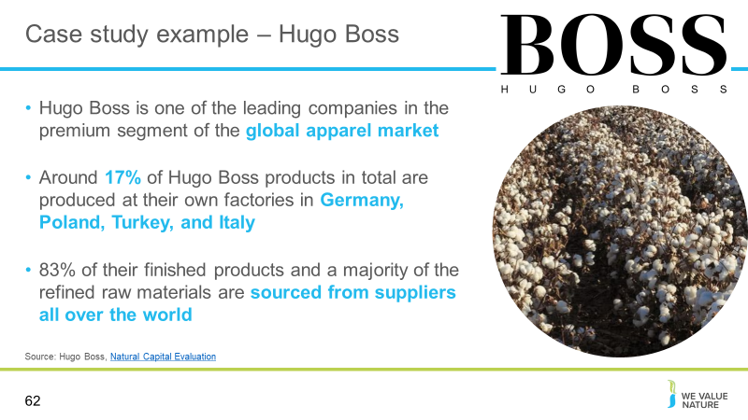
Optional: Presenter to explain the Hugo Boss case study using the notes on the slide
Sources:
https://group.hugoboss.com/en/responsibility/we-vision-strategy/natural-capital-evaluation
https://group.hugoboss.com/fileadmin/media/pdf/sustainability/2018-05-31_3rd_White_Paper_EIV.pdf

Slide 63
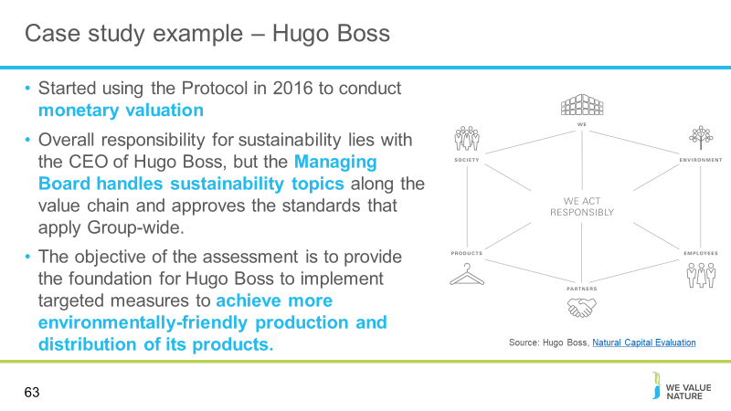
Presenter to explain the Hugo Boss case study using the notes on the slide
Sources:
https://group.hugoboss.com/en/responsibility/we-vision-strategy/natural-capital-evaluation
https://group.hugoboss.com/fileadmin/media/pdf/sustainability/2018-05-31_3rd_White_Paper_EIV.pdf

Slide 64
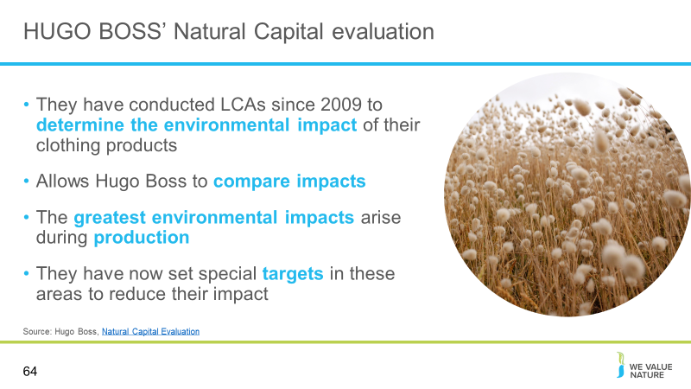
Presenter to explain the Hugo Boss case study using the notes on the slide
- They have conducted LCAs since 2009 to determine the environmental impact of their clothing products
- The assessment allows Hugo Boss to compare impacts and identify which steps in the value chain have the greatest environmental impact
- The greatest weight among the environmental impacts of the value chain arise during the production steps
- They have set special targets in these areas and become involved in relevant initiatives
- They categorized work steps by their corresponding ecological effects to create hot spots where more precise analysis and suitable measures can be employed

Sources:
https://group.hugoboss.com/en/responsibility/we-vision-strategy/natural-capital-evaluation
https://group.hugoboss.com/fileadmin/media/pdf/sustainability/2018-05-31_3rd_White_Paper_EIV.pdf

Slide 65
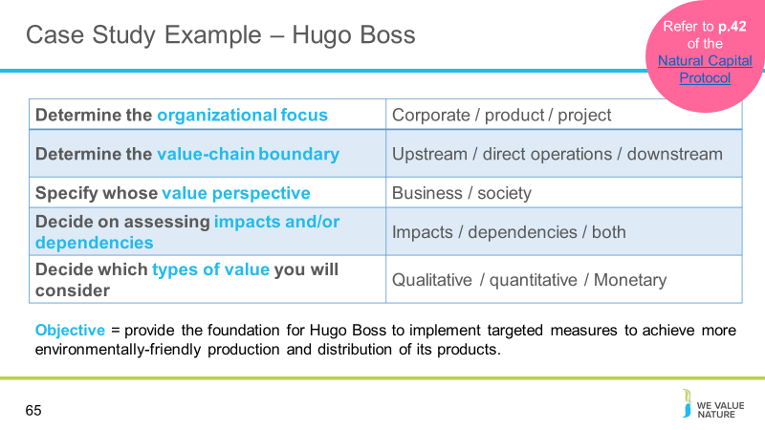
Presenter will now explain the scoping assessment exercise for the delegates, to determine the target audience and key stakeholders for Hugo Boss. The exercise can be modified to focus on just one question using polling if conducting a shorter training course

Depending on whether the presentation is being given virtually or in person, the group will be split into tables or breakout rooms. They will be asked to fill out this table for Hugo Boss.

Presenter to remind them what the categories in the table mean, using the notes below:

The organizational focus is where in the company the assessment will focus, e.g. will the focus be on the corporate level, product level, or project level?

Value-chain boundary: The part or parts of the business value chain to be included in a natural capital assessment. For simplicity, the Protocol identifies three generic parts of the value chain: upstream, direct operations and downstream. An assessment of the full lifecycle of a product would encompass all three parts.

The types of value to be considered include: qualitative, quantitative and monetary.
Value perspectives: the perspective or point of view from which value is assessed; this determines which costs or benefits are included in an assessment.

Natural capital impacts are defined as the negative or positive effect of business activity on natural capital. For example, businesses may extract a lot of water, depleting natural reserves and natural capital dependencies are defined as a business reliance on or use of natural capital. For example, businesses may be dependent on pollination as a regulating service in agriculture

Presenter to then read the context below to help the delegates with the scoping exercise:
The objective of the Hugo Boss LCA is to provide the foundation for Hugo Boss to implement targeted measures to achieve more environmentally friendly production and distribution of its products.
They have been conducting LCAs since 2009 to help determine the environmental impact of their clothing products

Slide 66
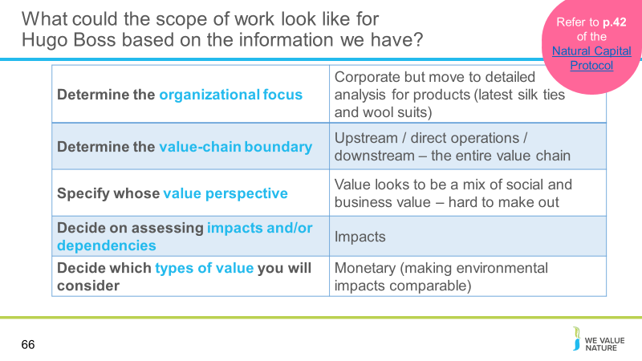
Referring to p. 42 of the Natural Capital Protocol and using the table on the slide, presenter should explain the steps to scope an assessment in reference to the Hugo Boss case study -– this can either be presented or a black table presented initially and this table used as the results for a group exercise

The organizational focus is where in the company the assessment will focus, e.g. will the focus be on the corporate level, product level, or project level?

Organizational focus: the part or parts of the business to be assessed (e.g., the company as a whole, a business unit, or a product, project, process, site, or incident). For simplicity, these are grouped under three general levels as below:
- Corporate: assessment of a corporation or group, including all subsidiaries, business units, divisions, different geographies or markets, etc.
- Project: assessment of a planned undertaking or initiative for a specific purpose, and including all related sites, activities, processes, and incidents.
- Product: assessment of particular goods and/or services, including the materials and services used in their production.

To determine the value-chain boundary, you need to decide where in the value chain the assessment will take place. For a clothing company, the assessment may take place across all upstream operations (e.g. cotton farming and clothes manufacture).

Value-chain boundary: The part or parts of the business value chain to be included in a natural capital assessment. For simplicity, the Protocol identifies three generic parts of the value chain: upstream, direct operations and downstream. An assessment of the full lifecycle of a product would encompass all three parts.

Upstream (cradle-to-gate): covers the activities of suppliers, including purchased energy.
Direct operations (gate-to-gate): covers activities over which the business has direct operational control, including majority owned subsidiaries.

Downstream (gate-to-grave): covers activities linked to the purchase, use, re-use, recovery, recycling, and final disposal of the business’ products and services.

Explain that the value perspective determines that value being measured i.e. the value to business, the value to society, or both.
The types of value to be considered include: qualitative, quantitative and monetary.

- Value perspectives: the perspective or point of view from which value is assessed; this determines which costs or benefits are included in an assessment.
- Business value: The costs and benefits to the business, also referred to as internal, private, financial, or shareholder value.
- Societal values: The costs and benefits to wider society, also referred to as external, public, or stakeholder value (or externalities).

Note: the results shown in the table are assumptions based on the publicly available data and documentation available on the work that Hugo Boss has completed in relation to Natural Capital.

Sources:
https://group.hugoboss.com/en/responsibility/we-vision-strategy/natural-capital-evaluation
https://group.hugoboss.com/fileadmin/media/pdf/sustainability/2018-05-31_3rd_White_Paper_EIV.pdf

Slide 67
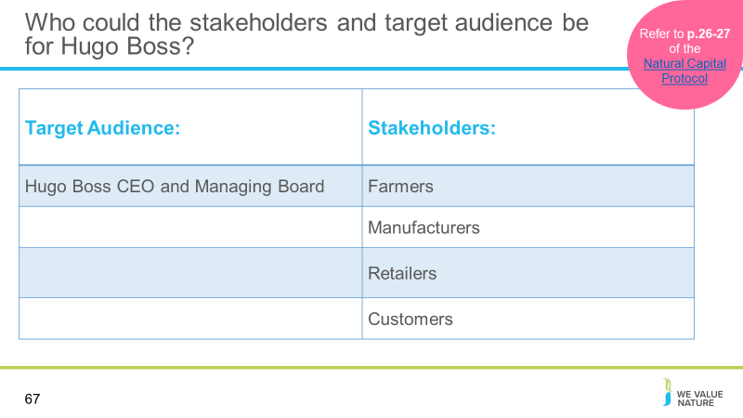
Referring to the table on the slide, the presenter should explain how to identify the stakeholders and target audience specifically for the Hugo Boss case study, giving examples – this can either be presented or used as the results for a group exercise. Refer to p. 26-27 of the Natural Capital Protocol.

As mentioned in the case study overview, the objective of the Hugo Boss LCA is to provide the foundation for Hugo Boss to implement targeted measures to achieve more environmentally friendly production and distribution of its products. It is useful to understand the objective of the LCA when working out who the target audience and stakeholders are:

The target audience is the main user of the assessment output

The Hugo Boss website states that “Overall responsibility for sustainability lies with the Chief Executive Officer of HUGO BOSS. At its meetings, the Managing Board handles sustainability topics along the value chain and approves the standards that apply Group-wide.” Thus, the CEO and Managing Board will be the target audience directly overseeing the production and distribution of environmentally friendly products coming out of this LCA

Stakeholders, on the other hand, are any individuals, organizations, sectors or communities with an interest or stake in the outcome of a decision or process some examples are listed based on the publicly available information for Hugo Boss
Farmers (e.g. cotton farmers/ sheep farmers) will be impacted by the production of environmentally friendly products as they are key in the harvesting of raw materials to use in these products
Manufacturers are also impacted, as they are central in the production of environmentally friendly products

Retailers are key due to their role in the distribution of these products
Customers are key in the purchasing and uptake of these products – without customers creating demand there would be no market and thus no incentive in creating these items

Slide 68
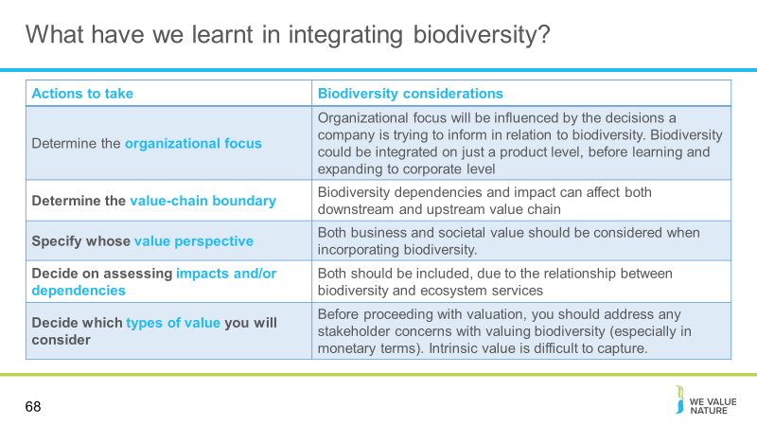
Presenter to discuss the biodiversity considerations for each action, using the notes on slide

Slide 69
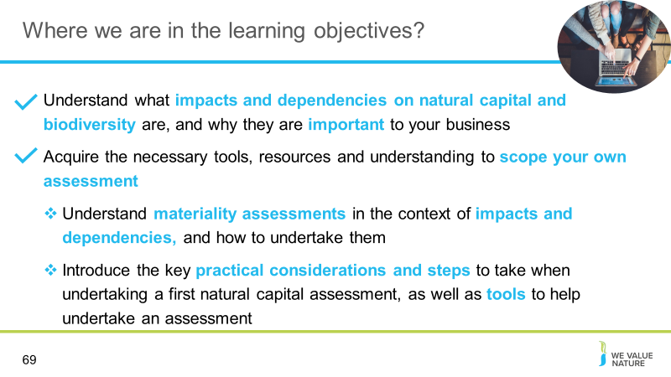
Presenter to highlight that learning objective 2 has now been covered and that the training will proceed to the next learning objective

Materiality

Slide 70
Presenter to introduce section on materiality

Slide 71
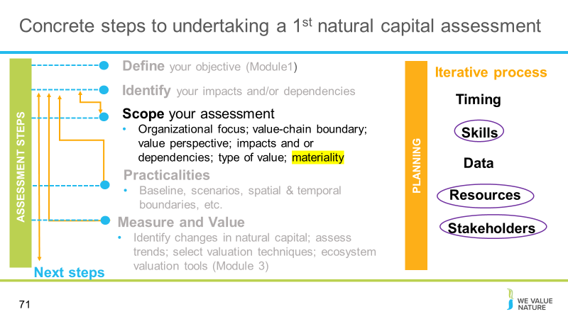
Presenter to explain that materiality sits within the scoping step of an assessment

Slide 72
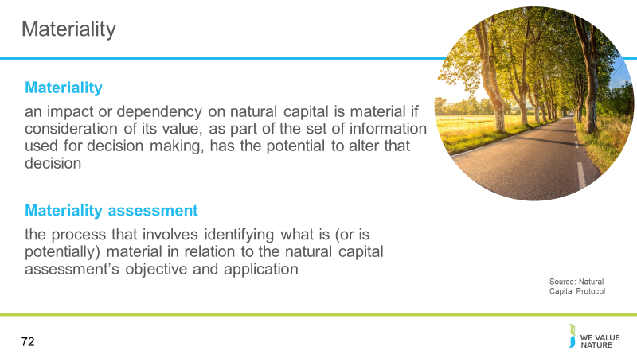
Presenter to read out the definitions of materiality and materiality assessment on the slide. Presenter to then walk through the four stages of conducting a materiality assessment, using the notes below:

- Identifying potentially material impacts and/or dependencies
- Identifying criteria for the materiality assessment
- Gathering relevant information
- Completing the materiality assessment

To carry out a materiality assessment, the assessor must identify a small group of potentially material impacts and/or dependencies.

Information will need to be gathered and criteria set to measure the materiality of the chosen impacts and dependencies.

Note that the information gathering stage of the materiality assessment will involve identifying the potential sources of data.

It is to note that potentially material impacts and dependencies will need to take into account hidden biodiversity values, business impacts that also affect dependencies, and a societal value perspective (impacts may appear more material because of regulation and consumer pressure as concern for biodiversity grows)

The criteria for assessing materiality may vary when including biodiversity (e.g. for operational criteria, particular upstream operations may be specifically dependent on biodiversity; while reputational criteria may have higher materiality weighting due to the intrinsic value of biodiversity to many stakeholders)

Slide 73
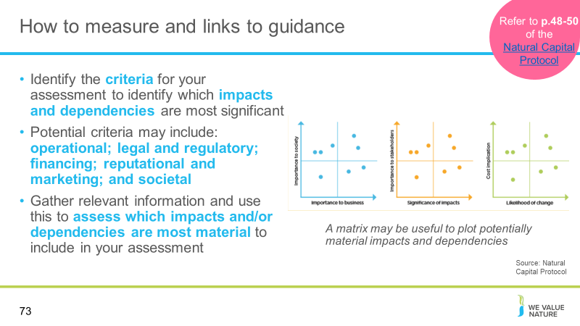
Presenter to explain how to identify criteria for identifying material issues using the notes below.
Presenter can ask the audience how many have undertaken a materiality assessment as part of their current role.

Throughout the measurement phase, the assessment’s objective and purpose should be considered
Identify criteria based on who the impacts are most significant for, and whether you are considering the value to business, society or both

Examples of materiality criteria include (this list is not exhaustive):
- Operational: the extent to which the natural capital impact or dependency may significantly affect business operations, project implementation, or the value of existing or new product(s).
- Legal and regulatory: the extent to which the natural capital impact or dependency may trigger a legal process or liability (e.g., emission fees or extraction quotas, environmental impact mitigation requirements).
- Financing: the extent to which the natural capital impact or dependency may influence “cost of capital” or your access to capital, investor interest, or insurance conditions.
- Reputational and marketing: the extent to which the natural capital impact or dependency may affect the product portfolio, company image, or relationship with customers and other stakeholders (e.g., changing customer preferences).
- Societal: the extent to which the natural capital impact or dependency may generate significant impacts to society

Note that the type of information that may be collected to determine the materiality of an impact or dependency may include:
- Type of impact and/or dependency
- Scale of impact and/or dependency
- Consequence of impact and/or dependency (on business, society, or both)
- Time scale (short, medium, and long-term)

Explain that collecting this information may include stakeholder consultation; seeking expert opinion; compiling available information; conducting a brief assessment of value (e.g. what is the financial value of the asset involved).

To carry out the assessment, establishing a panel of relevant assessors with a broad range of skills is recommended. It is also recommended that relevant thresholds are set for different criteria, with anything exceeding them considered material. It is possible that some impacts or dependencies are uncertain at and may require further information gathering or consultation to resolve.

Presenter can refer to the Cementos Argos materiality matrix as an example (to match the case studies used) or to replace this with reference to another example, available on page 6 of their integrated report:
https://mnisaccp01.blob.core.windows.net/sostenibilidad/Doc/2018/eng/Integrated-report-2018.pdf

Slide 74
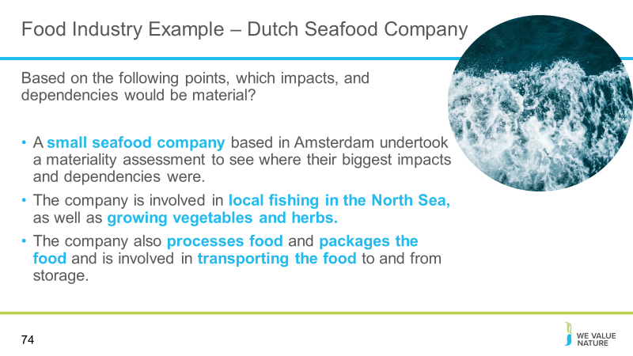
Presenter to walk through the points listed on the slide in relation to the case study.
In this case study, Nature^Squared demonstrates their Natural Capital Accounting framework for Small and Medium-sized Enterprises (SMEs): Accounting For A Better Planet. The technique was used to demonstrate that:
- SMEs can use a materiality assessment along with larger companies.
- The Accounting For A Better Planet framework provides SMEs with a simple and integrated overview of their relation to natural capital, thereby enabling companies to create a positive impact where it is mostly needed. It not only allows companies to have an understanding of their impacts and dependencies on natural capital, it also identifies key areas for change
- The framework has 7 key themes: biodiversity; land-use change; climate; air quality; soil quality; water use; and water quality.

An example of the application of the framework is given below:
A small-sized seafood company based in Amsterdam that:
- source their fish locally from the North Sea.
- considers sustainability as part of their DNA
- their main objective was to create real positive impact through their business operations and to communicate their sustainable journey with their customers.
- that the scope of the analysis would be broad, e.g. measuring both impacts and dependencies and incorporating all supply chain stages

The presenter will then start breakout room sessions for participants to discuss the potentially material impacts and/or dependencies and how to rank these.

Source: file:///Users/sabinagordon/Downloads/case%20study%20-%20accounting%20for%20a%20better%20planet%20(1).pdf

Slide 75
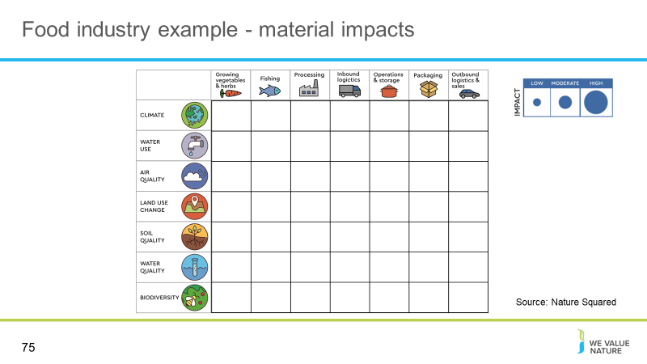
Presenter will explain the framework on the slide, using the notes below. Presenter will split the delegates into breakout rooms/table exercises (see slide 50 and 51 for instructions). Presenter will ask the respondents to consider how they will rank impacts for the fishing company using the key on the screen (criteria high medium and low). The delegates will be asked to feedback after a few minutes, giving their top 3 impacts for the company and giving the reasons for this choice.

See Nature Squared’s ACCOUNTING FOR A BETTER PLANET – AN ACTION-ORIENTED NATURAL CAPITAL ACCOUNTING FRAMEWORK FOR SMES, Case study: Netherlands for more detail.

Source: file:///Users/sabinagordon/Downloads/case%20study%20-%20accounting%20for%20a%20better%20planet%20(1).pdf

Slide 76
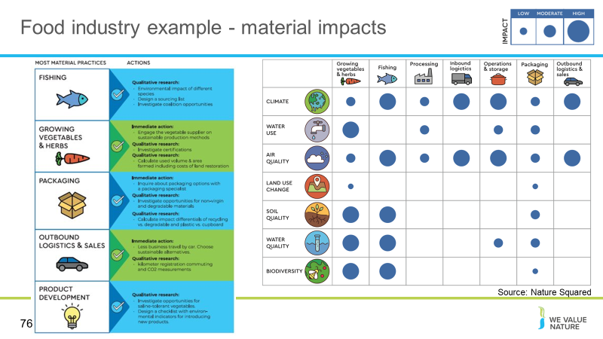
Presenter will run through the impacts and dependencies selected as material by the food industry SME in this example. Presenter to go through the most material impacts shown on the slide (climate, air quality, water quality etc.) and compare them to the impacts suggested by participants. Presenter to ask what criteria were used for high medium and low during the exercise.

The framework has been implemented and extensive feedback was collected by Nature^Squared. Nature^Squared conducted a series of workshops to help the firm through the materiality process. This is a great example of how you can conduct a qualitative assessment of natural capital impacts and dependencies which can already translate into concrete actions to take in response to this. Here are just the impacts, but the same exercise was repeated for dependencies too.

To complete it, they discussed relative importance with different stakeholders and simply provided relative orders of magnitude, based on resources
From this, they were able to identify most material elements of their practices and then prioritise which actions to take.

This exercise can be repeated in consultation with your own employees and stakeholders.
You don’t necessarily need to measure and value your impacts, this type of assessment can already be very informative without a lot of time, expertise or a big budget. Again, it depends on what your objective is.

Based on this analysis and an additional stakeholder analysis, the activities of fishing, growing vegetables, and packaging were identified as most material. Outbound logistics and sales were also prioritized as alternative practices were considered as easy to implement and material for the client

For each of the prioritized business activities, several strategies have been developed to realize sustainable changes. The strategies range from measurements and qualitative research to tangible action plans when alternative practices were readily available.
The following list of activities shows how the client used the results of the materiality assessment to decide on how to further assess their impacts and dependencies on nature

For example:

Fishing:
Qualitative research… environmental impact of different species, design a sourcing list and investigate coalition opportunities
Vegetables and Herbs:
immediate action… engage the vegetable supplier on sustainable production methods…
Qualitative research…. investigate certifications … calculate used volume and area farmed including costs of land restoration
Packaging:
Immediate action … inquire about packing options with a specialist
Qualitative… investigation of non-virgin and degradable materials… calculate impact differentials of recycling vs degradable and plastic vs cupboard
Lastly, the firm decided to integrate a natural capital approach into product development to ensure a sustainable design of new products.

See Nature Squared’s ACCOUNTING FOR A BETTER PLANET – AN ACTION-ORIENTED NATURAL CAPITAL ACCOUNTING FRAMEWORK FOR SMES, Case study: Netherlands for more detail.
Note: further information can be added to the impact categories for example, including initial assessments of data availability and data ownership for all high impacts identified

Slide 77
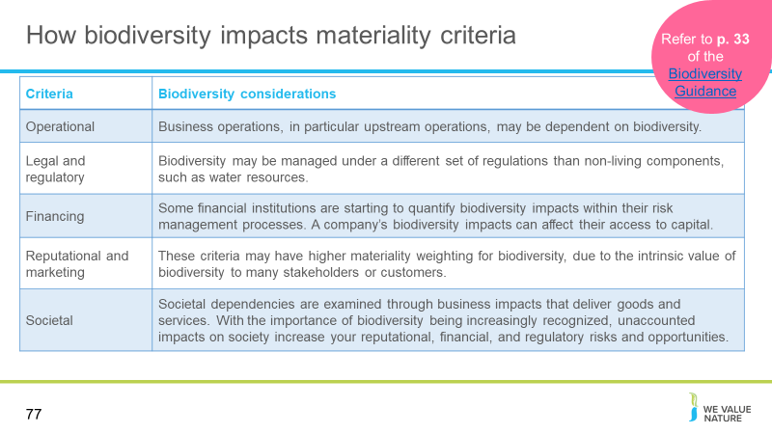
Presenter to discuss the biodiversity considerations for different materiality criteria

Slide 78
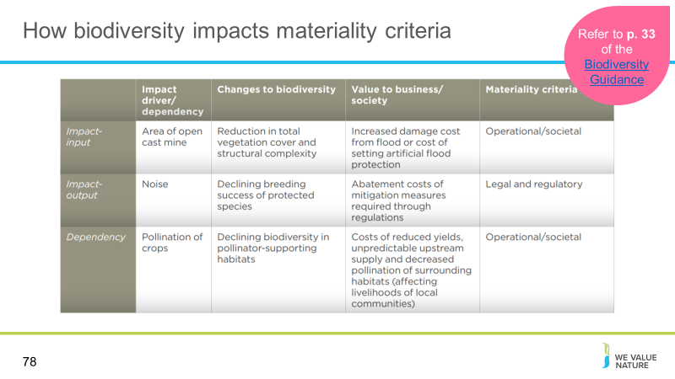
Presenter to further explore how biodiversity impacts materiality criteria by discussing the table on the slide

Slide 79
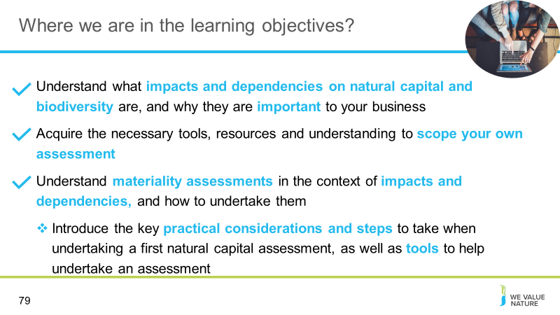
Presenter to highlight that learning objective 3 has now been covered and that the training will proceed to the next learning objective

Practicalities & useful tools

Slide 80
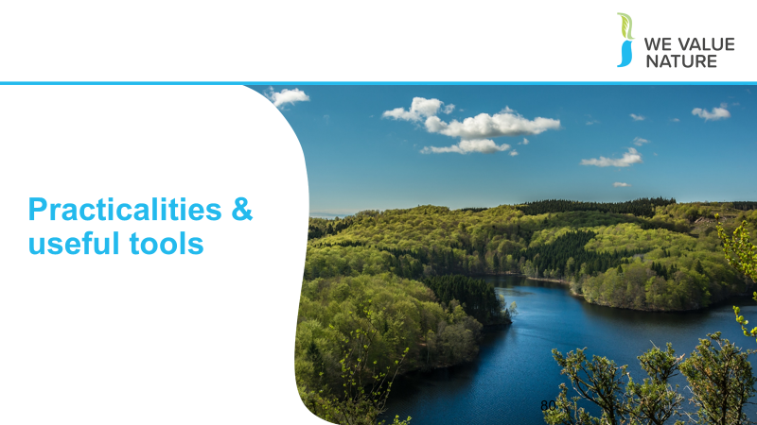
Presenter to explain that the next section will concrete on the practicalities of an assessment

Slide 81
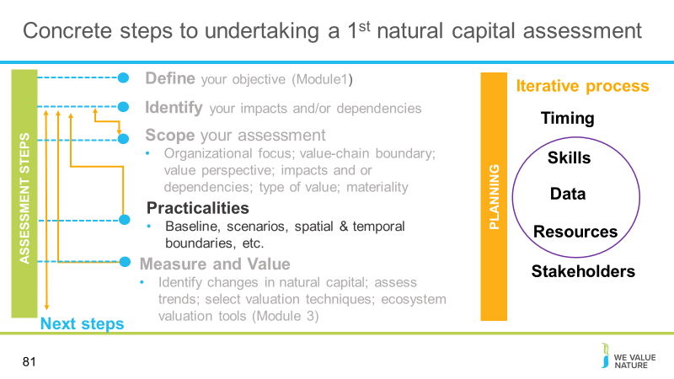
Presenter to explain that we will now look at the next step after scoping: practicalities. This will include consideration of required skills, data, and resources

Slide 82
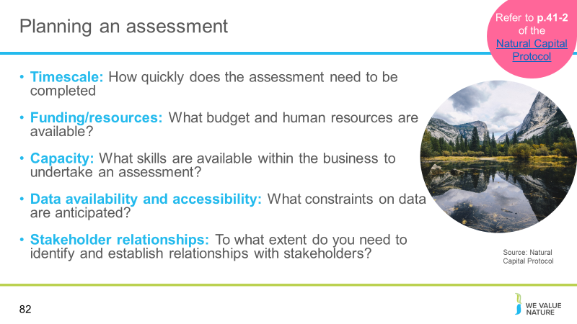
Presenter to walk through the things to consider when planning an assessment using the notes on the slide. Run through examples for each as shown below:

Timescale – An assessment may be needed to input into a decision in 6 months’ time

Funding/resources – The budget may be limited to $50 USD and 20% of an environmental manager’s time

Capacity – The relevant skills may come from the company’s sustainability team, with some assistance from an environmental economist

Data availability and accessibility – The company may only have data available from the past year

Stakeholder relationships – A full stakeholder mapping may need to be carried out, which identifies the need for further stakeholder engagement

See p. 41-42 of the Natural Capital Protocol for more details.

Slide 83
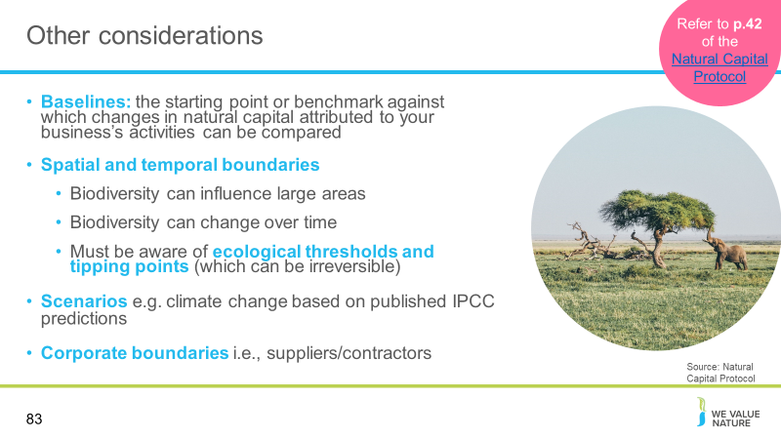
Presenter to go through the other considerations, using the notes on the slide and the notes below:

Baselines: One key consideration for all natural capital assessment is baselines (defined in the Protocol as the starting point or benchmark against which changes in natural capital attributed to your business’s activities can be compared). In addition to those covered in the Protocol, some additional considerations related to biodiversity include:
- Prevailing conditions where impacts in a year are compared to the average over previous years. A prevailing conditions baseline may be particularly appropriate if the objective is reducing the biodiversity impact of the whole business, where comparing to the last financial year could be an appropriate baseline. Using prevailing conditions as a baseline however may make it challenging to take into consideration the impacts of activities already occurring in the land/seascape.
- Pristine baseline where impacts are measured relative to biodiversity in its natural state. Pristine baselines have the advantage of making impacts easy to conceptualize, and encourage restorative actions. Most business activities are likely to be negatively impacting biodiversity when comparing to a pristine state. Some measurement approaches use a pristine, undisturbed state as a baseline. Further guidance on measurement approaches is provided in the Measuring and Valuing Guidance.

Spatial and temporal boundaries: Including biodiversity influences the spatial and temporal boundary of your assessment; it is likely that broader geographical and temporal boundaries will be needed for a biodiversity-inclusive assessment than when focusing on the non-living components of natural capital.

When considering biodiversity, the potential areas of influence can be large, due to, for example, impacts on migratory or wide-ranging species. For financial institutions undertaking portfolio-level assessments or companies with geographically dispersed operations, the potential area of influence may include multiple geographical and temporal boundaries.

The timeframes over which the implications of impacts and dependencies on biodiversity are felt also require further consideration. For example:
- The condition of biodiversity can change over time, influencing the benefits received by business and society in the future. It can be difficult to predict changes in benefits linked to changes in biodiversity, but it is risky to assume that benefits will persist without managing biodiversity. Equally there may be a time-lag between loss of biodiversity and the loss of services, particularly where it is the resilience of the ecosystem that is impacted making it vulnerable to collapse at a later date. Information on trends in biodiversity, and the drivers of its condition, will help you to understand whether it is likely to change.
- Biodiversity management efforts can take time to achieve their desired outcomes. You need go beyond a single snapshot in time, and consider the consequences of changes in the state of biodiversity over time.
- The presence of potential ecological thresholds and tipping points, where minor changes in biodiversity can result in larger changes to the ways ecosystems function. Your timeframe should be appropriate to assess the consequences, and potential irreversibility, of your impacts on biodiversity.

See p. 41-42 of the Natural Capital Protocol for more details

A scenario is a storyline describing a possible future. Scenarios explore aspects of, and choices about, the future that are uncertain, such as alternative project options, business as usual, and alternative visions. Example scenarios for a clothing company may include the baseline agricultural impacts as one scenario and have the impacts of a new agriculturally improved system as the second scenario.
An example corporate boundary for a clothing company may be plantations directly owned by the company (i.e. excluding 3rd party producers).

Including biodiversity will influence your baseline, as well your spatial and temporal boundaries, meaning a broader scope will likely be required.

Slide 84
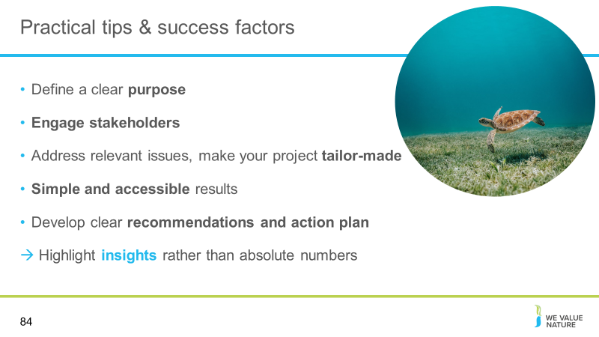
Presenter to elaborate on practical tips and success factors by explaining the points on the slide.

Slide 85
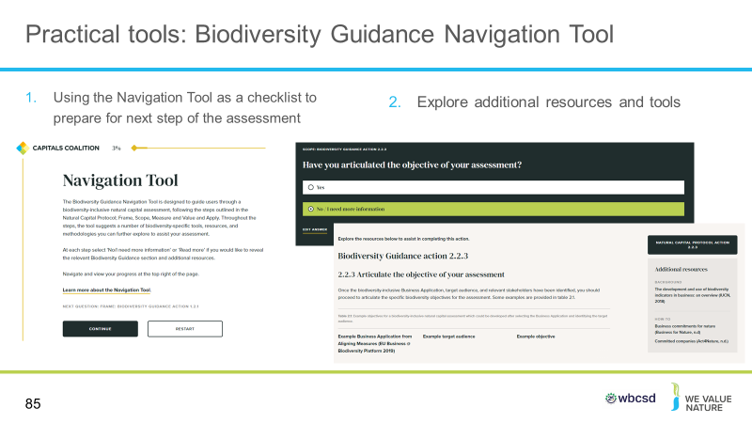
Presenter to outline the biodiversity guidance navigation tool and its role in supporting natural capital assessments.

The navigation tool recognises that you may need to work iteratively through the Protocol e.g. you go to Step 6 to determine the methods to quantify change in state of the natural capital assets, then go back to the impact drivers you have identified as material and determine how these can be measured
- We would recommend doing a first run through the navigation tool to see all the questions and consider how you would answer them. You can then choose an approach to fit the data you already have, or describe the data you need to collect.
- Currently there is no standardised way of measuring biodiversity (but Align project coming)

Slide 86
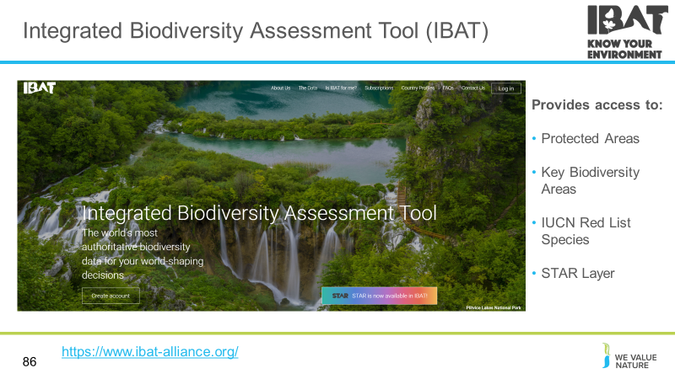
Presenter to consider tools available to help with natural capital assessments: IBAT

Presenter to explain that IBAT could be a useful tool to identify priority sites (i.e. based on proximity to Key Biodiversity Areas and/or red listed species) for a natural capital assessment. This could be completed during the materiality/scoping part of the assessment to prioritise locations for consideration (e.g. those in closet proximity to Key Biodiversity Areas and/or with the most threatened/endangered species).

Another helpful tool is IBAT. As previously mentioned, the Integrated Biodiversity Assessment Tool (IBAT) provides authoritative global biodiversity data. Users can import raw data on locations and create reports and map files. IBAT host and maintain 3 global biodiversity datasets; IUCN Red List of Threatened Species, World Database on Protected Areas, World Database of Key Biodiversity Areas. Additionally, the STAR metric is now available in IBAT.

STAR
As shown in the video. the Species Threat Abatement and Restoration Metric (STAR) is available in IBAT. STAR allows quantification of the potential contributions that species threat abatement and restoration activities offer towards reducing extinction risk across the world. STAR can inform decisions made by businesses, governments, civil society, and other actors towards global goals for halting extinctions. As such, STAR helps identify actions that have the potential to bring benefits for threatened species, and it supports the establishment of science-based targets for species biodiversity, and commitments relevant to the post-2020 biodiversity framework. STAR is calculated from data on the distribution, threats, and extinction risk of threatened species derived from the IUCN Red List of Threatened Species. STAR Scores are disaggregated by 57 different threats from the Red List for both Threat Abatement and Restoration.

STAR is simple to use and interpret as the analysis is carried out automatically in IBAT. STAR insights can be gained by using IBAT site-specific reports, which calculate estimated STAR values for a given Area of Interest, as well as by using IBAT Multi-site Reports to gain a broad understanding at the portfolio/supply chain level. Additionally, the raw raster layer is available to download at the global level and at local scale with 5km granularity.

STAR is standardised across the globe as every grid cell can be directly compared using the same objective criteria. STAR is also scalable as users can sum their potential contributions across sites, regions and countries throughout the world to determine their overall opportunities for nature-positive action. STAR can help businesses identify both opportunities and risks associated with their activities and value-chains. STAR can also provide a basis for setting corporate “science-based targets” for nature that contribute to global conservation goals.

Slide 87
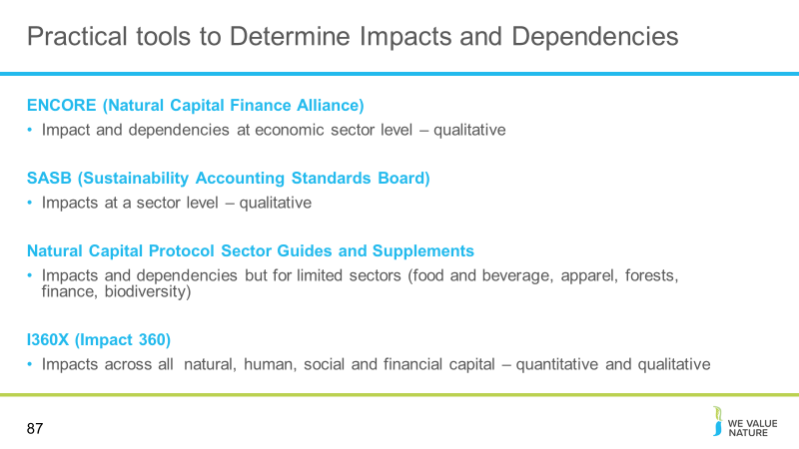
Presenter to provide some information on tools that are useful in determining impacts and dependencies as another example. Presenter to the slide and the notes below:
Some examples of relevant tools for identifying impacts and dependencies include (this list is not exhaustive, presenter can add their own examples):

Encore:
Tool to help users understand and visualize impact of environmental change on the economy
Focuses on goods and services that nature provides to enable economic production
Guides users in understanding how businesses across sectors depend on nature and how these dependencies might represent business risk if environmental degradation disrupts them

SASB:
Connects businesses and investors on the financial impacts of sustainability
SASB has industry specific standards which provide insight on which ESG factors are likely to create or destroy value
Helps to identify priority issues and improve the results of companies

Natural Capital Protocol Sector Guides
Support the protocol by providing additional guidance and sector specific insights
Sector guides do not provide additional methodologies and are not stand-alone documents but should be used to guide organizations from specific sectors through an application of the NCP
Identifies impacts and dependencies relevant to businesses operating in the sector
Offers practical guidance for sector specific protocol application
Practical examples to demonstrate sector specific business applications of protocol

I360X Tool:
Online “software as a service” platform that assesses natural capital, human capital, social capital and financial capital to understand impact
Uses sophisticated algorithms and global databases to measure these externalities
The result is the comprehensive integrated profit and loss report that integrates value added or lost across all four capitals
I360X helps corporations make sustainable decisions, positively impacting nature, society and humans as well as the bottom line
I360X helps to benchmark your impact against peers in your industry and region
Impact measurement is presented in the form of economic value, quantifiable volumes and qualitative ranks

Details on each tool with further links are available on the SHIFT platform:
Encore: https://encore.naturalcapital.finance/en
SASB: https://shift.tools/contributors/313
Natural Capital Protocol Food and Beverage Sector Guide: https://shift.tools/iframe/1794?ssl=true
I360X: https://www.gistimpact.com/

Slide 88
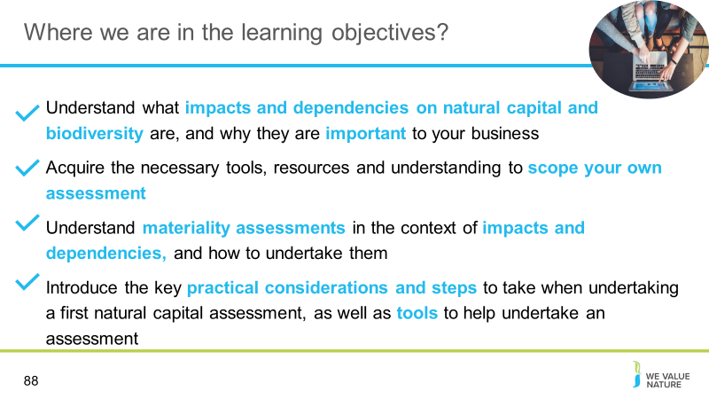
Presenter to highlight that all learning objectives have now been covered, bringing us to the end of the training

Wrap up & next steps
Slide 89
Presenter to begin wrapping up the session, and explaining the next steps

Slide 90
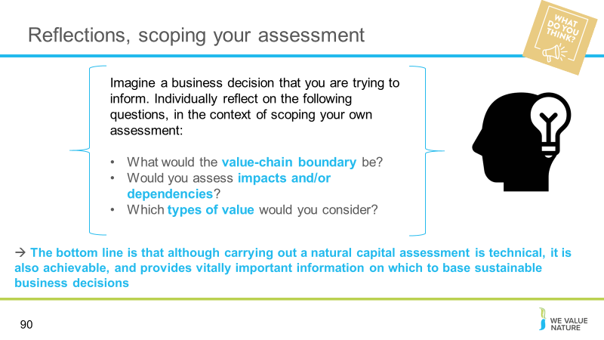
Presenter to read the questions on the slide and ask the delegates to individually reflect on these for a couple of minutes.

Virtual
Using a Zoom poll, the presenter will get participants to answer the 3 questions, as though they were scoping their own assessments.
In person
Using a Mentimeter poll, the presenter will get participants to answer the 3 questions, as though they were scoping their own assessments.

Slide 91
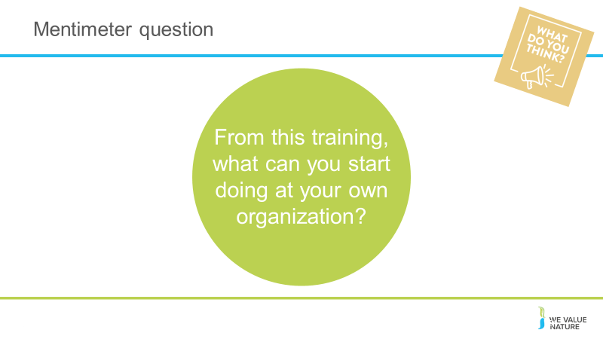
Presenter to read the questions on the slide an use an online poll to gather results.

Virtual
Using a Zoom poll, the presenter will get participants to answer the 3 questions, as though they were scoping their own assessments.
In person
Using a Mentimeter poll, the presenter will get participants to answer the 3 questions, as though they were scoping their own assessments.

Slide 92
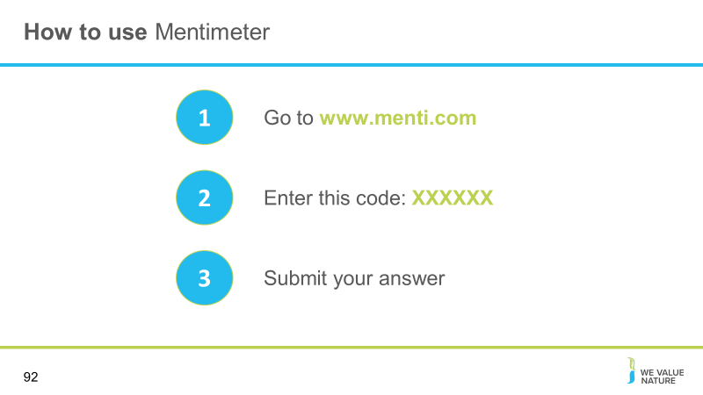
Presenter to direct participants to Menti to answer the question

Slide 93
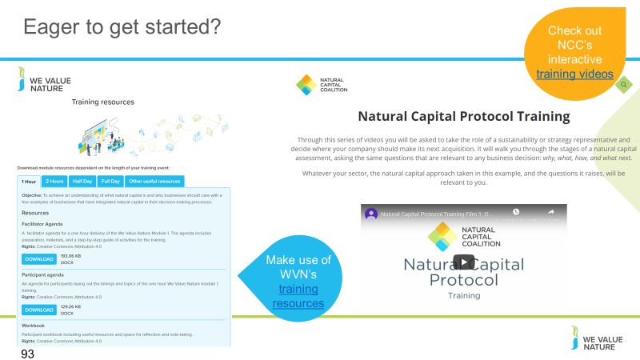
Presenter to explain the NCP training videos, using the notes below:
The Capitals Coalition has recently launched a set of training videos that will guide you in an interactive way through a light natural capital assessment to explore just how much can be achieved with limited resources. Interested to learn more? Check out these videos here: https://naturalcapitalcoalition.org/protocol-training/

Slide 94
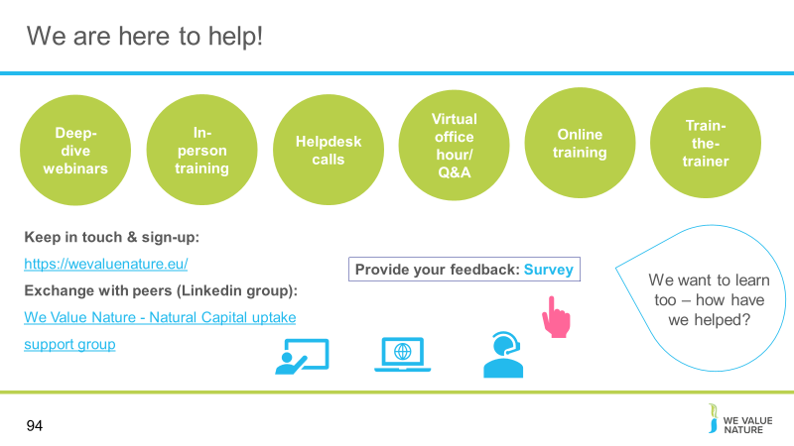
Presenter to point the delegates towards other resources that they can explore. Use the notes below as well as the notes on the slide:
WHAT ELSE would you need? What support would you need?
Sign-up for in-person day training
If want support, need to fill out survey (Google form survey)
Refining training further, keen to know how have used this training and catch-up via call (if don’t want to, let us know)

Slide 95
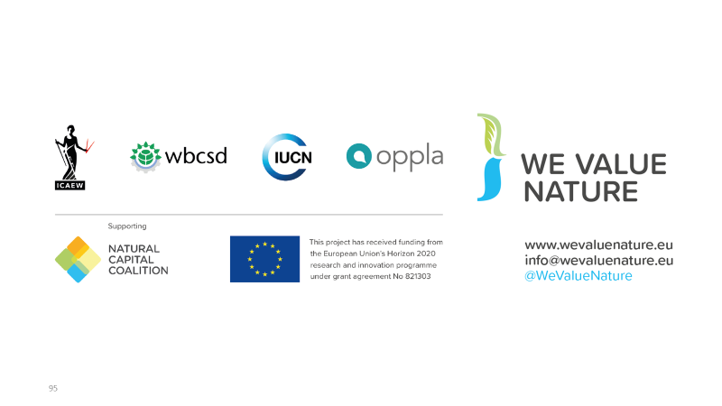
Presenter to conclude the presentation and thank everyone for their participation

Disclaimer: The information contained in this report is based on a review of Natural Capital training material in May 2020. The information contained herein is of a general nature and is not intended to address the circumstances of any particular individual or entity. Although we endeavour to provide accurate and timely information, there can be no guarantee that such information is accurate as of the date it is received or that it will continue to be accurate in the future. No one should act on such information without appropriate professional advice after a thorough examination of the particular situation.
The We Value Nature Network hereby expressly disclaim all warranties of originality, accuracy, completeness, merchantability or fitness for a particular purpose with respect to any of this information and in no event shall the parties have any liability for any damages of any kind.
The citing of trade names, reports, websites does not constitute endorsement. The We Value Nature Network and Little Blue Research Ltd. do not accept any liability for damage arising from the use of these speakers notes and make no representation regarding the advisability or suitability of this to specific business or training needs.

Slide 96
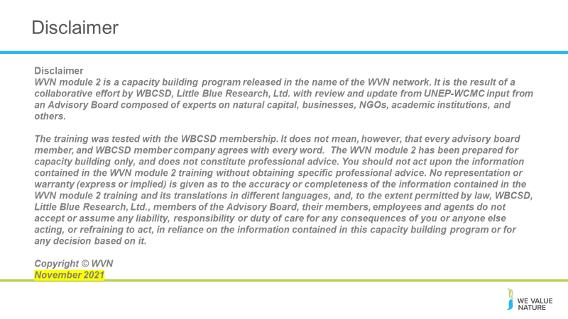
Presenter to make all aware of the disclaimer

