Speaking notes: Module 1 (full version)

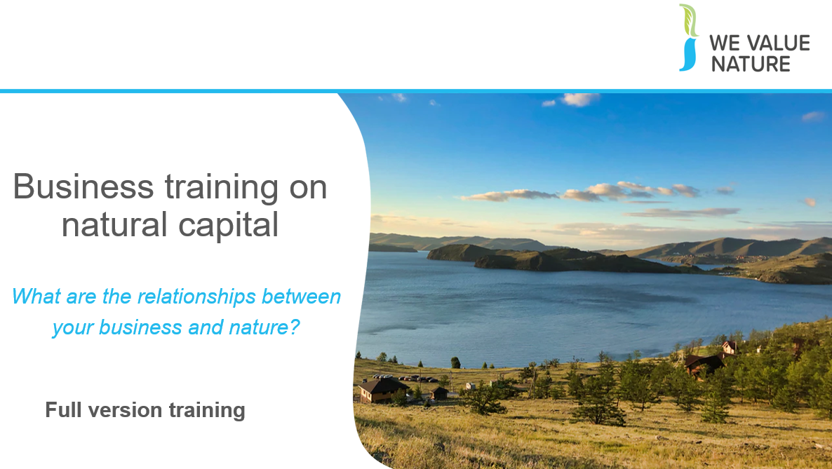

Welcome all participants – Refer to facilitator’s agenda.

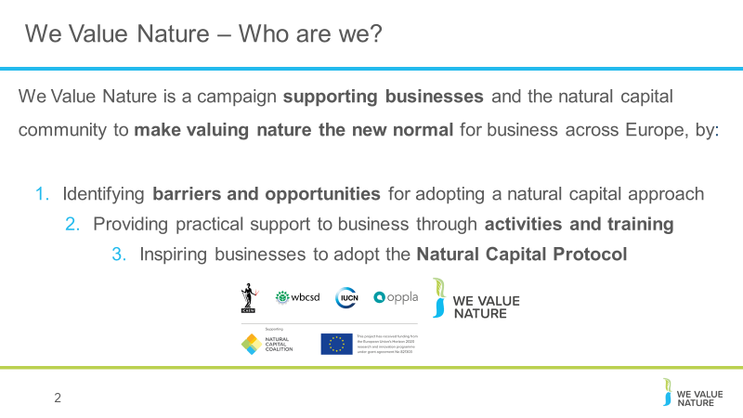
Introductions

Before kicking-off the training, introduce that this training is being given as part of the We Value Nature Campaign and explain what it is, its purpose, objectives and partners involved.

The We Value Nature Campaign is a €2 million EU-funded campaign supporting businesses and the natural capital community across Europe with the aim of making valuing nature the new normal for business. As we will have a chance to explore during today’s training, by valuing nature, businesses can make smarter decisions that benefit themselves, society and the planet as a whole.

The campaign is coordinated by the Institute of Chartered Accountants in England and Wales (ICAEW), World Business Council for Sustainable Development (WBCSD), The International Union for Conservation of Nature (IUCN) and Oppla. And it is supporting the Natural Capital Coalition, which has recently merged with the Social & Human Capital Coalition to become now the ‘Capitals Coalition’.

The campaign will aim to increase the uptake of the natural capital approach (including: natural capital assessment, natural capital accounting, nature-based solutions and green infrastructure) by identifying barriers and opportunities, providing practical support to business through activities (such as webinars, helpdesk calls, etc.) and training such as this one, as well as by inspiring businesses to adopt the NCP.

Take this opportunity to also thank the different stakeholders that supported the training

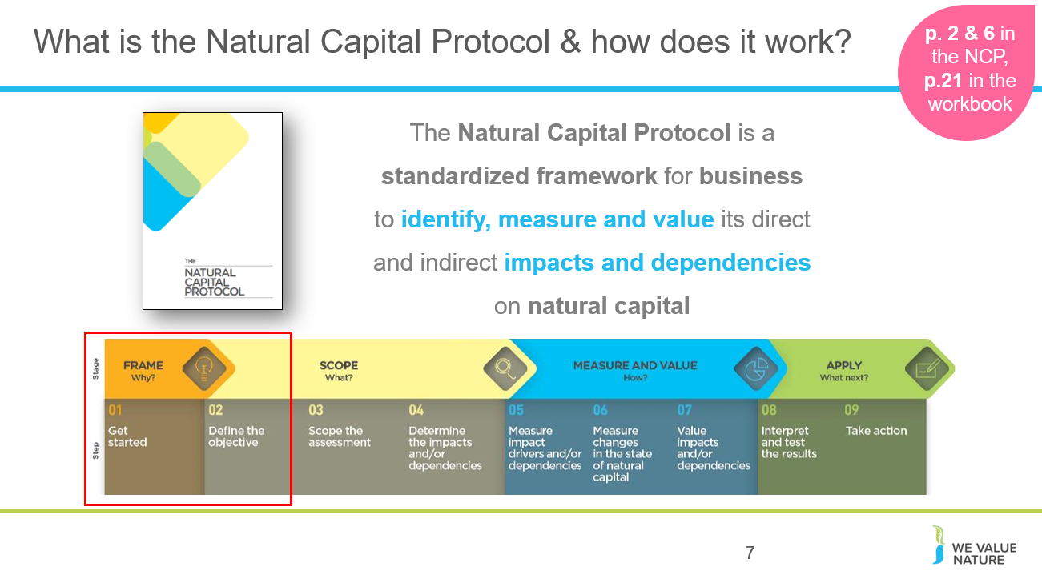
The Natural Capital Coalition is a collaborative space to harmonize approaches to natural capital
The network represents over 300 organizations across all parts of society and around the world
Purpose: To mainstream the inclusion of natural capital in decision making, harmonizing approaches and getting them to scale, quickly
The Protocol aims to support better decisions by taking into account how business interacts with natural capital in decision making. Until now, natural capital has for the most part and still is, being excluded from decisions.
So it is to be understood as a Framework that was really designed to help generate trusted, credible and actionable information that business managers need to inform decisions by identifying, measuring and valuing impacts and dependencies on natural capital.
The Protocol builds upon many approaches already used within business.
It acts as an overarching globally accepted framework to build and expand this information into robust natural capital assessments.
STRUCTURE of the Protocol:
4 overarching stages of frame (why), scope (what), measure and value (how) and apply (so what) and 09 logical steps. It should be easy to follow and should be suitable for any business across any sector or geography.
The stages and steps are iterative so expect that you may need to revisit a previous step.
Important to note that the NCP as an overarching framework, won’t give you actual results and need to therefore use the Nat Cap toolkit to get tools.
Highlight that while we will briefly cover tools and approaches for stages of ‘Measure & Value’ – the aim of the training will mainly focus on first two stages of the Protocol and that going into measurement and valuation technical details, requires a separate training.
There are many supplementary guidances to the Protocol for different sectors, including a guidance on Biodiversity, which helps guides users through the specifics of undertaking a biodiversity inclusive natural capital assessment.
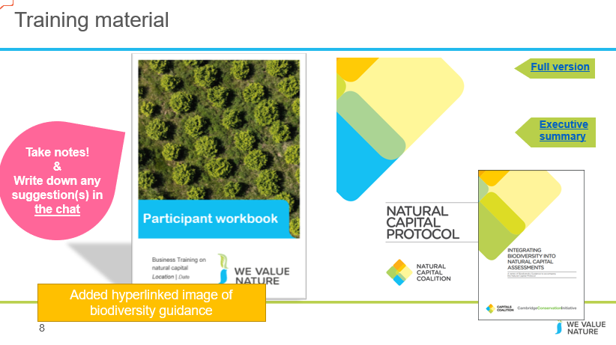
Mention that they should all have a ‘Participant workbook’ and explain that its purpose is to use it throughout the training. We have included in there some of the slides from the training but also additional information. Explain that the Biodiversity Guidance must be used alongside the Natural Capital Protocol, not by itself.

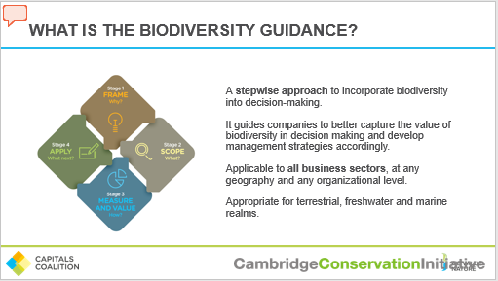
The Biodiversity Guidance offers a stepwise approach to incorporate biodiversity into natural capital assessments. It guides companies to better capture the value of biodiversity in their natural capital assessments and develop management strategies accordingly.
The Guidance is applicable to all business sectors, at any geography and any organizational level.
The Guidance is appropriate for terrestrial, freshwater and marine realms.
It is designed to work in 4 stages:
‘Why’ (Framing Guidance)
‘What’ (Scoping Guidance),
‘How’ (Measure and Value Guidance) and
‘What next’ (Application Guidance).

These stages are broken down into 9 steps, which address a specific question that must be answered when integrating biodiversity into your natural capital assessments.
The Guidance is written for businesses and financial institutions who already recognise the importance of natural capital and wish to ensure their assessments incorporate biodiversity, as well as businesses and financial institutions who are managing their relationship with biodiversity and want to expand those considerations to a broader natural capital perspective.
It can also help civil society, government, multi stakeholder organizations, standard setters, disclosure organizations and science / academia to engage with business and support them in their journey to embed the value of nature in their decision-making.

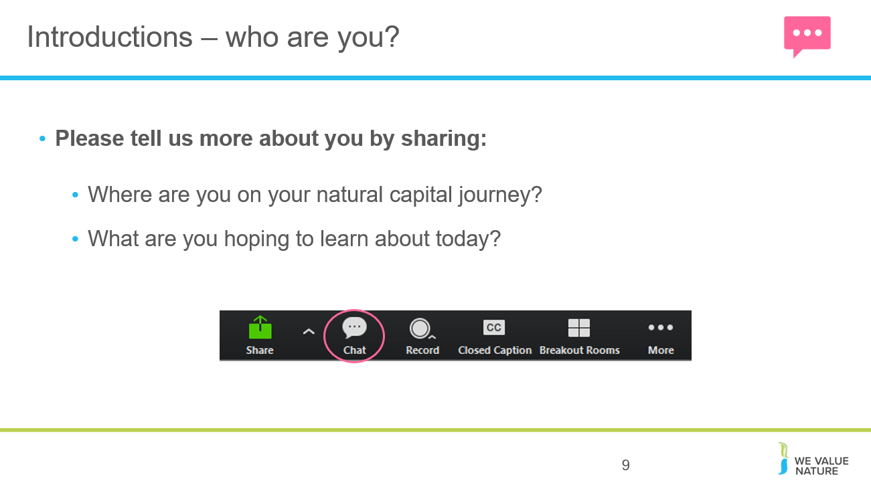

Ask everyone to respond to questions on slide using the chat function.

What is natural capital
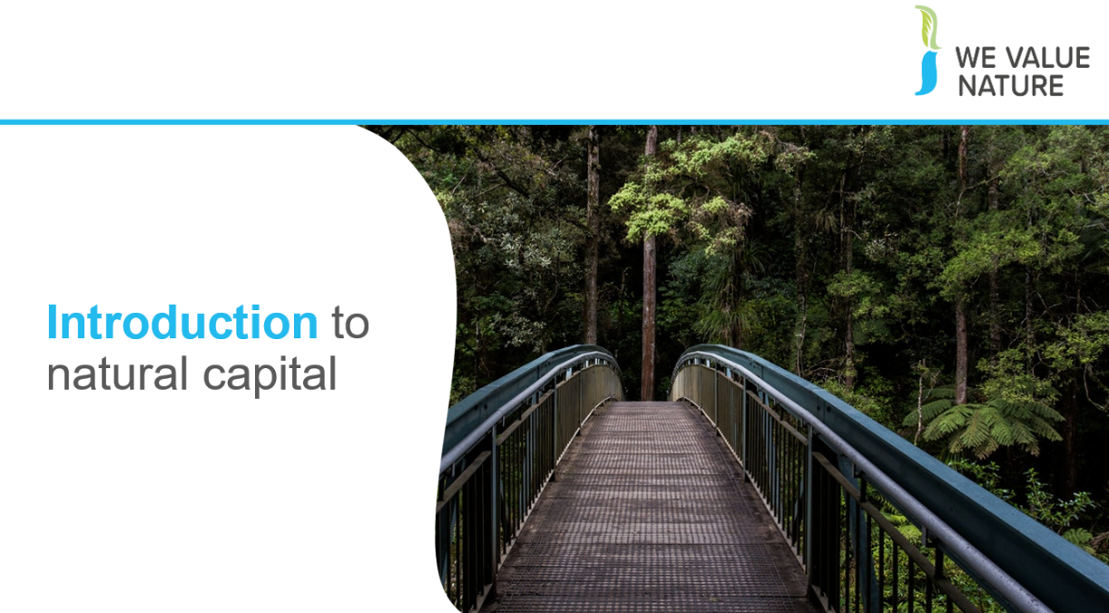

Introduce this first part of the training.
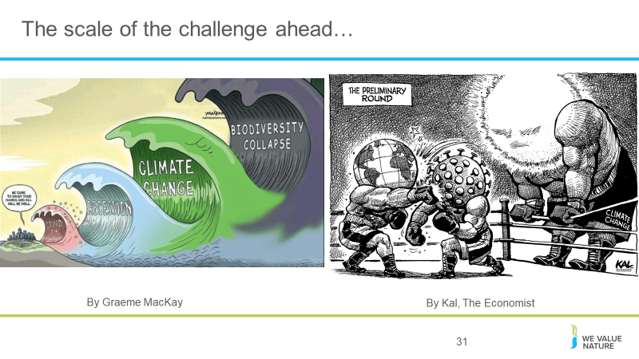
Nice comics to illustrate that the challenge ahead is yet to come.

If we think we were hit hardly by COVID19, we haven’t seen anything yet… The biggest challenges we are going to have to face are climate change and even more so, a biodiversity collapse which is underpinning all other issues – let’s not forget that at the heart of COVID-19 is a biodiversity issue
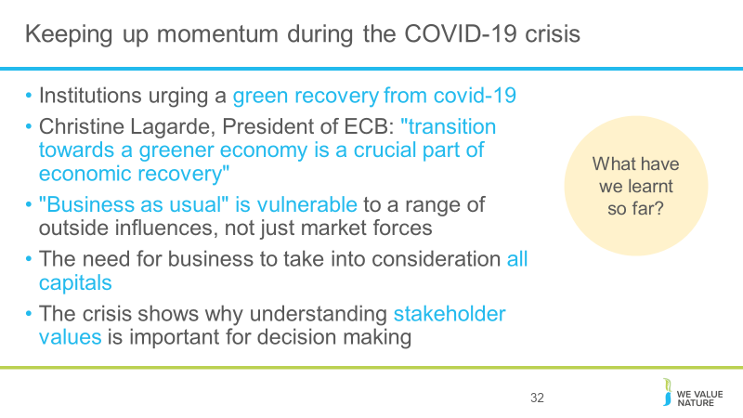
Briefly present natural capital/capitals thinking in relation to the current context on covid-19:
- Number of organisations have considered the impact and how to ensure sustainability remains on the agenda
- The crisis may help senior managers to realize that "business as usual" is vulnerable to a range of outside influences, not just market forces.
- The crisis has highlighted more than ever, the need for business to take into consideration all capitals
- The crisis has also further emphasized the need for business to shift from shareholder value to stakeholder focused business models – Stakeholder Capitalism
- The crisis shows why understanding stakeholder values into account for decision making is important i.e. understanding the wider implications of decisions

Institutions are actioning on the environment/urging a green recovery from the crisis in response to COVID 19 - an example of this is Christine Lagarde's introductory statement at the Hearing at the Committee on Economic and Monetary Affairs of the European Parliament:
- Christine Lagarde is pushing to include climate change considerations in a review the central bank is due to hold into the way it conducts monetary policy:
- "The transition towards a greener economy is a crucial part of economic recovery. We have the opportunity to step up the EU’s efforts to achieve its sustainability objectives by including climate change and sustainability considerations in the financial response to the COVID-19 pandemic.
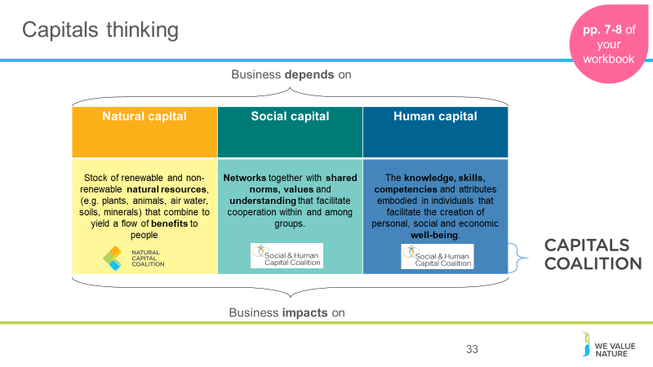
Briefly introduce the concept of capitals thinking and the importance of it while highlighting that in the context of this training, we will be focusing on natural capital

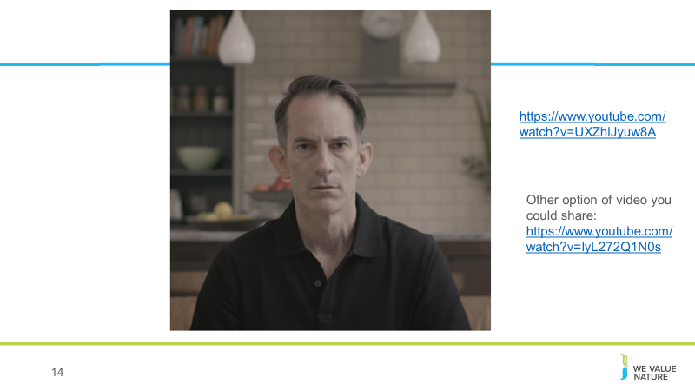
After showing video, open the floor to anyone that wishes to share something
Potential questions that can be asked to participants:
- Has anyone of you seen this video before? Show of hands. Direct them to where they can find the video: https://www.youtube.com/watch?v=UXZhlJyuw8A. The video was produces by WBCSD with the help of many of its members and with the aim to raise awareness among businesses on the importance to apply natural capital thinking into business.
- What did you think of the video?
- What feelings or perceptions were perhaps triggered when viewing the video?
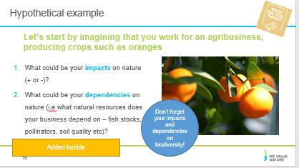
Give participants 5’ to reflect on both questions at their respective table and then offer each table to very briefly mention what ideas came out. Depending on how you have framed your training, you may wish to allow more time for this.
Reflect on responses:
- Reference of resources
- Scope of impacts – some examples referenced at product level others at supply chain level – direct operations or through supply chain
- Some may be directly related to the business. Others more indirect: water use through the process and noise/disturbances in extracting and manufacturing process, small particles
- Manufacturing process, customer phase – thinking about full suit
- How may depend on nature: if car manufacturing downstream from a forest for example, it depends on it to protect from flooding which if didn’t have that forest, factory could be at risk of being swamped
Potential answers:
Impacts: water use, soil degradation through overuse, (but also health: preventing too much rainwater runoff etc…), absorbing carbon, biodiversity (loss because of monoculture, or helping through providing habitats), use of fertilizer
Dependencies: water, fertile soil, appropriate temperature and climate,
Elements to be considered:
What stages of value chain are we considering, where is farm based, is it organic or mass production?
Recognise that biodiversity impacts and dependencies are also important, so ensure that the participants have also mentioned or thought about their impacts and dependencies on biodiversity, as well as on nature as a whole. E.g. Pollinators (bees) required pollinator-friendly habits in order to pollinate the crop (dependency) but a farms land clearance may be removing this habitat and therefore the bee population will decrease (impact). Alternative example: Ecotourism Tourism services, which encompasses aesthetic experiences and activities that promote health and well-being, are most successful when the habitat is particularly spectacular and hold a range of rare or signature species can be strongly impacted once reef health is degraded by boats and diving, fishing and waste management practices.

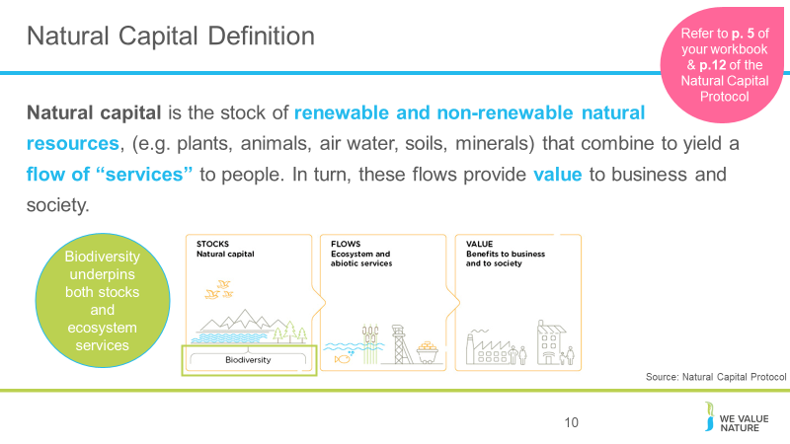
This is the definition according to the Natural Capital Protocol. Refer to p. 12 of Natural Capital Protocol.

The stocks refer to the natural resources available to us while the flows refer to the different benefits people receive from ecosystems such as:
- timber,
- fiber,
- pollination,
- water regulation,
- climate regulation,
- recreation,
- etc.
Abiotic services are benefits to people that do not depend on ecological processes but arise from fundamental geological processes e.g. – supply of minerals, metals and oil and gas, as well as geothermal heat, wind, tides, etc.

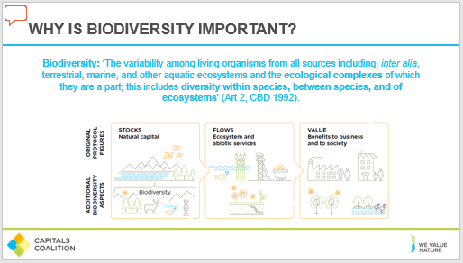
Biodiversity describes the variety of life and is the living component of what can be thought of as natural capital stocks. It plays an important role in the provision of the services we receive from nature. The presence of, and interactions between, natural capital stocks generate a flow of goods and services; these goods and services create value through the benefits they provide to business and society.
Biodiversity is an integral part of natural capital and underpins the goods and services that
natural capital generates. Biodiversity includes the variety of all living things, from genes through species and populations to habitats and ecosystems. Many of the flows of benefit from natural capital come directly from the interactions within and between biodiversity and non-living resources. The interactions that generate these benefits are vast, complex, and often poorly understood.

In the Protocol biodiversity (part of stocks) is considered to be critical to the health and also the stability of natural capital in so much that it provides resilience to shocks like:
- Floods
- Droughts
As well as supports fundamental processes such as:
- carbon and water cycles
- soil formation

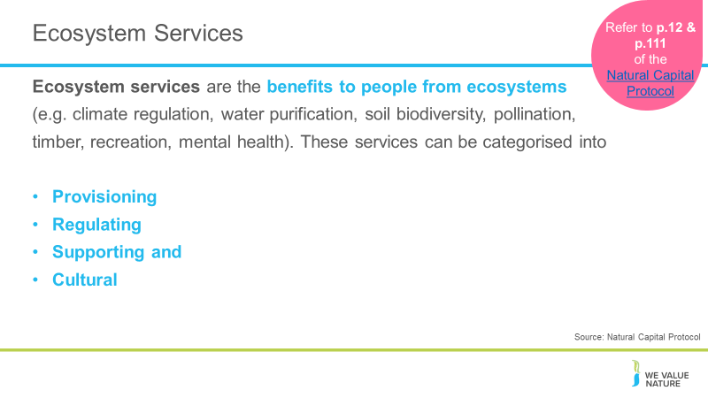

Presenter to explain ecosystem services using the notes below and referring to p. 12 /111 of the Natural Capital Protocol:
- Ecosystems services are the benefits to people from ecosystems, where an ecosystem is defined as the interaction between complex plants, animals and microorganisms and their non-living environment
- Examples of ecosystem services include timber, fiber, pollination, water regulation, climate regulation, recreation, mental health and others
- Ecosystem services can be classified into provisioning, regulating, cultural and supporting services
  - Provisioning: material outputs from nature (e.g. fiber)
  - Regulating: indirect benefits from nature generated through regulation of ecosystem processes (e.g. mitigation of climate change through carbon sequestration)
  - Cultural: non-material benefits from nature (e.g. recreational, spiritual, aesthetic)
  - Supporting: fundamental ecosystem processes that support the delivery of other ecosystem services (e.g. nutrient cycling)
- There are many classification schemes for ecosystem services including the CICES and the FEGS-CS which measure ecosystem outputs that are directly consumed or used by beneficiaries

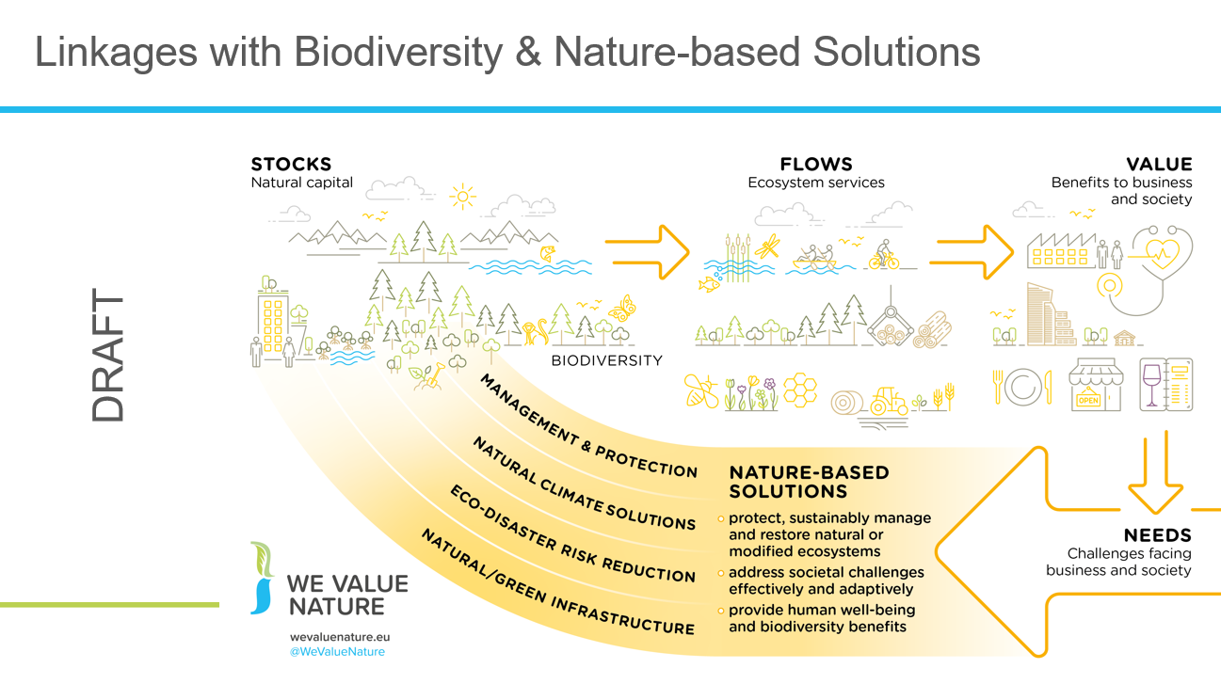

Explain that this infographic has been developed by WVN and is still a draft but thought we would share it as it is a helpful way to draw the links between natural capital and nature-based solutions. Can also ask participants that would be keen to get their thoughts/feedback on this by sharing in the chat.
Explain the infographic:
Demonstrates how NbS can enhance the stock of natural capital.
Business & society impact on stocks and consequently, on flows and values.
It’s the impacts and dependencies that generate business/societal needs and challenges. NbS can help address these and reduce impacts and dependencies through engineered solutions as well as management & protection of natural capital systems.
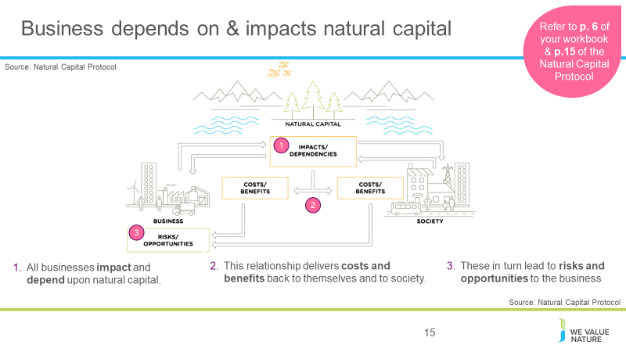

Natural capital and the benefits that flow from it sustain us all: individuals, families, companies, and society as a whole. At the same time, our individual or collective actions can build or degrade natural capital, depending on how we use it. Every business impacts and depends on natural capital to some degree and will experience risks and/or opportunities associated with those impacts and/or dependencies.

Biodiversity plays an important role in the provision of the services we receive from nature. The terms “capital” and “stocks” are used as metaphors to help describe the role of nature within the economy. The presence of, and interactions between, natural capital stocks generate a flow of goods and services; these goods and services create value through the benefits they provide to business and society. Biodiversity is an integral part of natural capital and underpins the goods and services that natural capital generates. It is important to note that biodiversity is not an asset, rather a descriptive feature of assets we call natural capital.

This figure is from the natural capital Protocol and is fundamental to the whole Protocol as it highlights how natural, social and economic issues are fundamentally interconnected and cannot be separated from one another. It also illustrates how natural capital underpins all the other capitals and without it we would not have social and human or financial capital.

1. All businesses impact and depend upon natural capital, and the biodiversity that underpins it
2. This relationship delivers costs and benefits back to themselves and to society.
3. These in turn lead to risks and risks and opportunities to the business

But this isn’t just theory and a nice diagram, these impacts and dependencies have the potential to affect businesses in a real way, and we’re seeing that right now.

What the examples show (from the previous slide) is that natural, social and economic issues are fundamentally interconnected and cannot be separated from one another. It also illustrates how natural capital underpins all the other capitals and without it we would not have social and human or financial capital.

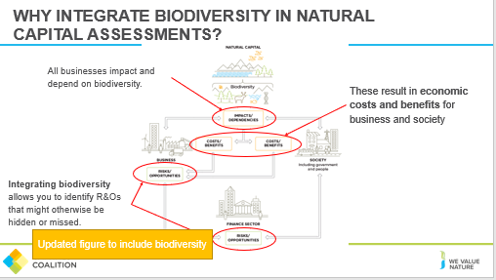
Biodiversity adds additional risks and opportunities that must be incorporated.
- All businesses impact and depend on biodiversity – not just natural capital .
- Impacts and dependencies on biodiversity result in economic costs and benefits for business and society. These generate risks to your business, but good management can also create opportunities, either directly, or indirectly.
- Integrating biodiversity values into a natural capital assessment allows you to identify risks and opportunities that might otherwise be hidden or missed.
- Because the current economic system assumes infinite availability of these resources, use and extraction are currently unsustainable, and provide a systemic risk to your business, and society as a whole.
- Failing to capture risks and opportunities can result in unexpected financial costs to a business

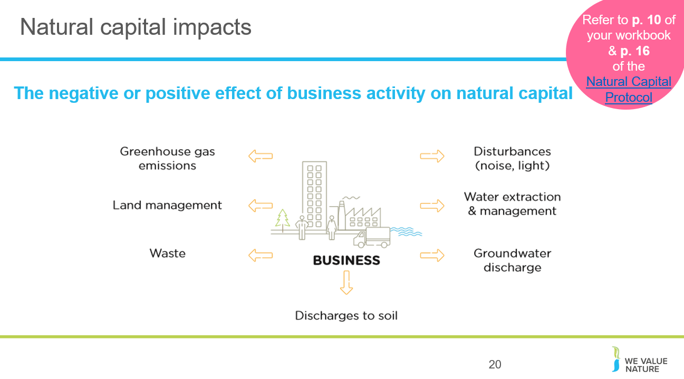

The Protocol defines a natural capital impact as: The negative or positive effect of business activity on natural capital. They can arise directly from business operations or indirectly from the use of products and services. As a result of your impact on natural capital you can generate impacts on your business as well as impacts on society.
ADDITIONAL BACKGROUND INFORMATION
Some examples:
We can see how natural capital impacts can pose different risks and opportunities for businesses.
- Pollution emissions e.g. transportation
- This may pose societal risks for businesses due to the health risks arising from the effect of air pollution on respiratory disease
- GHG emissions: On the other hand, this could pose a reputational and marketing opportunity due to new revenue streams offered in areas like carbon offsetting
- Land management e.g. forest management
- This may pose an operational risk by increasing natural hazard costs through degradation of natural ecosystems
- This may also pose an operational opportunity if businesses invest in sustainable and green land management, hence reducing costs by protecting against natural hazards
- Clearance of lands can reduce the connectivity of habitats and reduce the habitat intactness, preventing migration and access to food sources for species resulting in population decline.
- Waste e.g. post-consumer waste
- This may pose legal and regulatory risks if new laws or license fees are established, charging more for waste disposal
- This may also pose an operational opportunity for businesses if they minimise or add value to waste and recapture valuable materials otherwise discarded
- Discharges to soil e.g. fertilizers
- This may pose a financial risk if the business’ sales fall due to negative publicity about the business’ impacts on natural capital
- Groundwater discharge e.g. wastewater
- This may pose operational risks if social conflict over polluted water adds to security costs
- This may also pose societal opportunities if businesses use managed water catchments to improve water quality for local communities
- Water extraction and management e.g. factory equipment cleaning
- This may pose a financial opportunity if businesses alter the way in which they go about water extraction, thus attaining” green funds” or investor interest in sustainability
- Disturbances e.g. heavy machinery operation
- This may pose societal issues again as wider society is impacted negatively from heightened noise and light
- 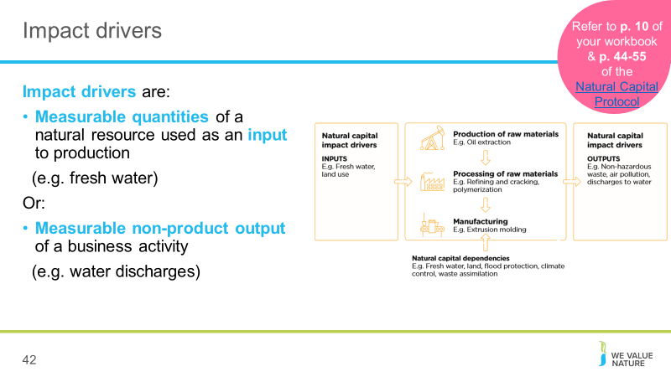
Presenter to walk through the slide, explaining the general steps of an impact pathway, using the notes below and referring to p. 44-55 of the Natural Capital Protocol:
- Business activities produce an impact driver (e.g. non-GHG air pollution)
- Impact drivers lead to changes in natural capital (e.g. reduced air quality)
- Changes in natural capital result in impacts (e.g. health problems)
Presenter to list some example impact drivers for either plastic cup manufacture or cotton t-shirt manufacture, using the notes below:
(1) Plastic cup manufacture example impact drivers:
Inputs: freshwater consumption
Outputs: emissions from GHGs and other air pollutants (in oil extraction and processing); water pollutants; plastic waste
(2) T-shirt manufacture example impact drivers (based on p. 26 of the Natural Capital Protocol)
Inputs: water use; terrestrial ecosystem use; freshwater ecosystem use
Outputs: GHG emissions; non-GHG air pollutants; water pollutants; soil pollutants
(3) In the coffee farm– clearing a measurable area of land is an important impact driver, as this can reduce species richness, and have a substantial impact on biodiversity, such as the reduction of pollinator supporting habitats leading to a reduced crop productivity.

Your business activities may have numerous impacts on biodiversity and natural capital, which can have positive or negative effects. As with other aspects of natural capital, your business impacts on biodiversity occur through impact drivers, which include:
1. Business use of natural resources as inputs to production processes, such as water use, terrestrial ecosystem use, or marine ecosystem use;
2. Non-product outputs resulting from business activities as well as the use and disposal of products that the business creates, such as air pollutants, solid waste, or disturbances.
Your business impacts on biodiversity may be direct, indirect, and/or cumulative. Indirect impacts are triggered in response to the presence of your business projects or operations, rather than being directly caused by them.

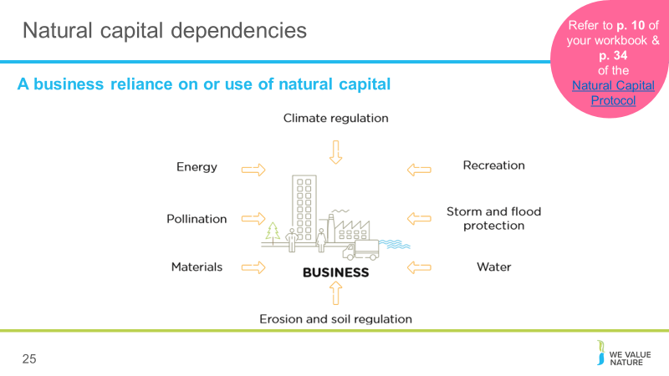

The protocol defines natural capital dependency as: A business reliance on or use of natural capital. This can occur in your direct operations or somewhere else in your value chain.
We can see how natural capital dependencies can also
pose different risks and opportunities for businesses. This is useful in establishing the value of natural capital dependencies in relation to other inputs and services that you rely on.
ADDITIONAL BACKGROUND INFORMATION
Some examples:
- Energy e.g. energy as a critical production input in a factory
- A reliance on energy may pose financial risks due to volatilities in the energy market which could impose higher costs on the business
- This could also open up financial opportunities if “green funds” become available for more renewable energy sources
- Pollination e.g. regulating service critical in agriculture
- This may pose an operational risk for agricultural sectors if pollination services start to vary
- Materials e.g. reliance on wood
- This may pose a societal risk if local communities start to experience reduced access to woodland or related ecosystem services as a result of business activities
- This may pose a societal opportunity if local communities start to benefit from forestry management
- Erosion and soil regulation e.g. essential for hydropower operations and beverage companies
- This may post legal and regulatory risk if businesses are faced with fines, penalties, compensation or legal cost from regulation efforts
- Water e.g. reliance on water to make cement
- This may pose reputational and marketing risk if loyalty of key suppliers of business service provides in the water industry falls
- Storm and flood protection e.g. local flood barriers
- Reliance on flood barriers could pose increasing risk as climate change makes flooding more likely in certain regions
- Investing in natural flood measures could provide wider benefits to local communities and thus benefit the business through reputation
- Recreation e.g. for tourist attraction
- If businesses rely on recreation such as tourist attractions to raise employee morale, they may be at risk of attracting and attaining their employees due to the volatility of the tourism industry – this could lead to higher recruitment and retention costs
- Climate regulation e.g. natural filtration of water
- This may provide an operational opportunity if businesses invest in green infrastructure like water filtration services, thus reducing overall costs
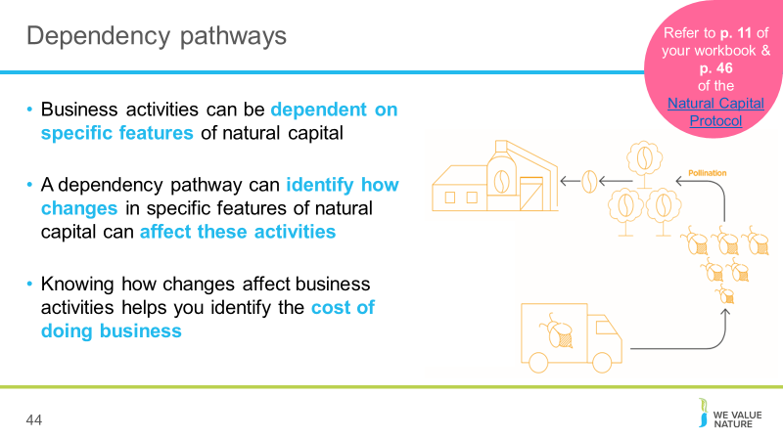
Presenter to explain dependency pathways, using the notes on the slide. Presenter to then walk through the coffee production/pollination example using the notes below and referring to p. 46 of the Natural Capital Protocol:
- Business activities at a coffee production plant have a dependency on the pollination of coffee plants.
- Changes in natural capital cause the bee population to decline due to:
- The business itself, e.g. overuse of pesticides
- Natural changes e.g. extreme weather events
- Human-induced changes, including due to the activity of other businesses, e.g. habitat change
- Changes in natural capital affect business dependency, so pollination services are important
Presenter to walk through the t-shirt manufacture example below, using the notes below and referring to p. 24 of the Natural Capital Protocol:
- At the agricultural level, water is needed to irrigate cotton plants, creating a dependency on water.
- Changes in the natural capital, in this case water availability, can change due to both external factors (e.g. climate change, other agriculture dependent on the same water source, other upstream water usage) and internal factors (e.g. over-abstraction of water for irrigation, water extraction to clean machinery).
- Because of these changes in natural capital, the company has to chose whether to accept a decreased cotton yield, adapt to a more resilient form of agriculture, or pay more for an alternative water supply.
.

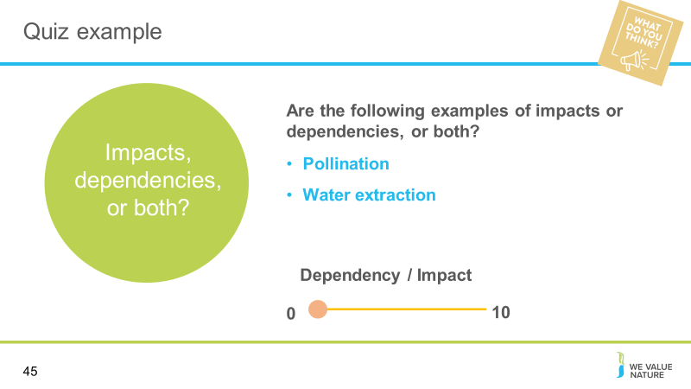
Presenter to read the question out on the slide.
Once poll is complete, presenter should explain that there are different answers:
- Impacts and dependencies are inter-related. Your assessment may cover your impacts, dependencies or both. This, in part, depends on business application and your objective. A complete assessment considers both impacts and dependencies to gain a full understanding of your company’s risk and opportunity related to natural capital.
- Soil regulation – fundamental ecological process related to maintaining soil health (e.g. nutrient cycling, soil formation)
  - Businesses can be dependent on soil regulation. For example in the agricultural industry, businesses may be dependent on nutrient cycling in the soil to grow crops.
  - At the same time, heavy use of soil by a business can degrade the quality of the soil. For example, if an agricultural company uses chemical fertilisers or pesticides on the soil which harm soil quality
  - Water extraction
  - Businesses can be dependent on water resources as critical production inputs in their business
  - At the same time, water use by a company will often mean less water or lower quality water available for other stakeholders
  - This shows how dependencies on natural capital can result in natural capital impacts – they are interrelated

For biodiversity Businesses may impact on biodiversity which in turn can affect dependencies, so it is important to consider both if you are doing a biodiversity-inclusive natural capital assessment.

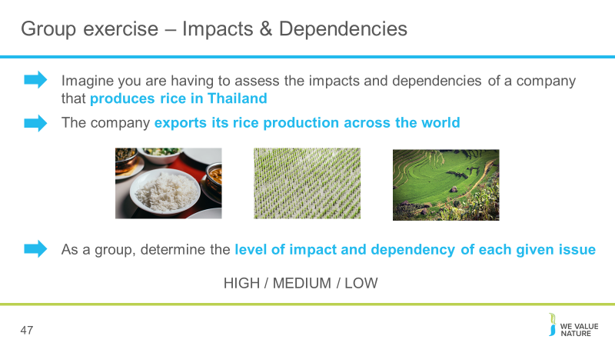
Presenter to flag that this is an advanced level of identifying impacts and dependencies. Presenter to explain the case study using the notes on the slide and referring to some of the added context below:
- This company is a leading rice producer and distributor, operating in several countries.
- The rice production process relies on water, soil quality and fertiliser and involves processing and packaging the rice.
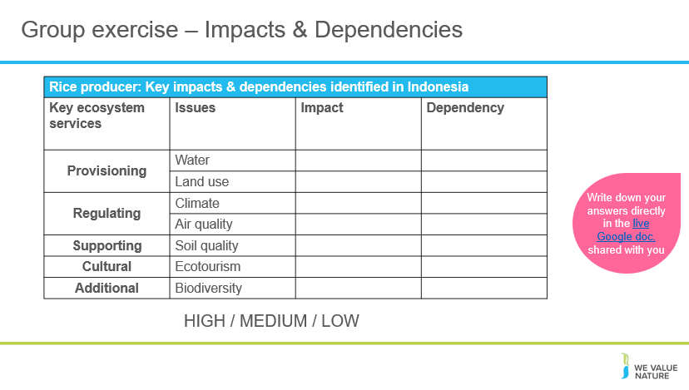
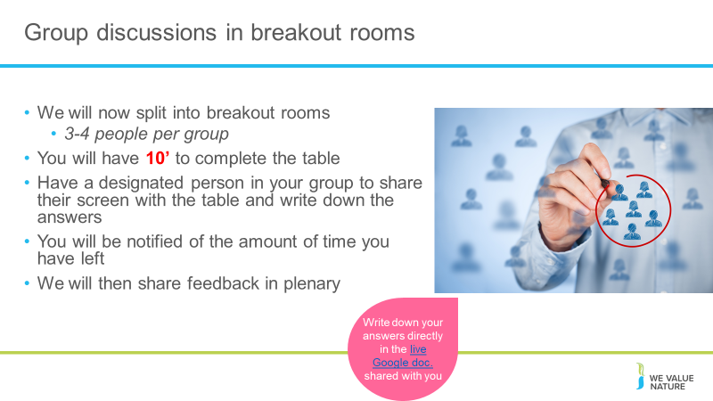
Explain how breakout rooms function and how long they will have to discuss.
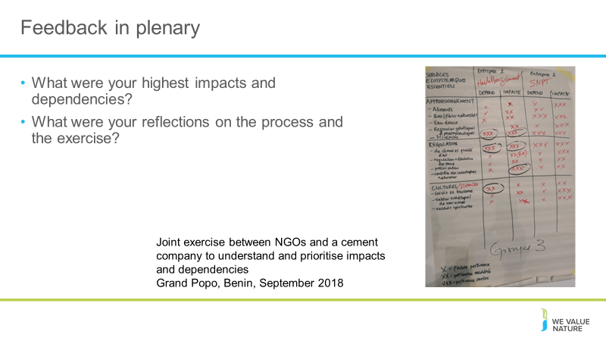
Try and encourage 1 person from each breakout room to present what they discussed.
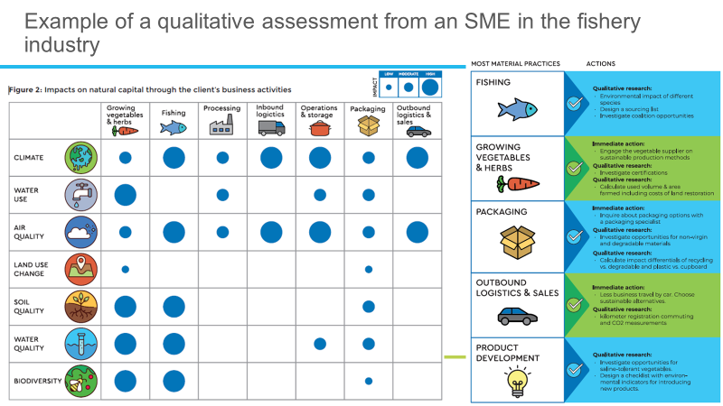
This is a great example of how you can conduct a qualitative assessment of your natural capital impacts and dependencies which can already translate into concrete actions to take in response to this. Here are just the impacts, but the same exercise was repeated for dependencies too.
To complete it, they discussed relative importance with different stakeholders and simply provided relative orders of magnitude, based on resources but also.
From this, they were able to identify most material elements of their practices and then prioritise which actions to take.
This exercise can be repeated in consultation with your own employees and stakeholders.
You don’t necessarily need to measure and value your impacts, this type of assessment can already be very informative without require a lot of time, expertise or budget. Again, it depends of what your objective is.
Stress that this example has a caveat that as an example for one company rather than the whole sector. Another company completing this might find they have different ratings based on different factors
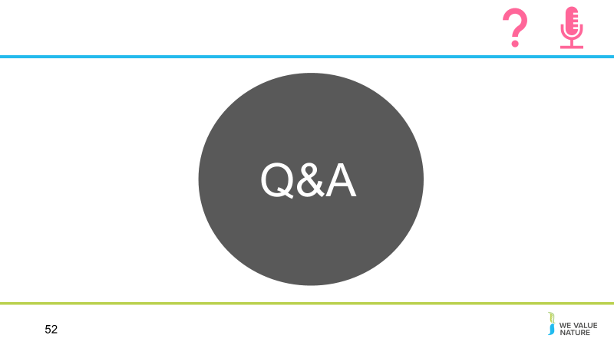

Why is natural capital important?
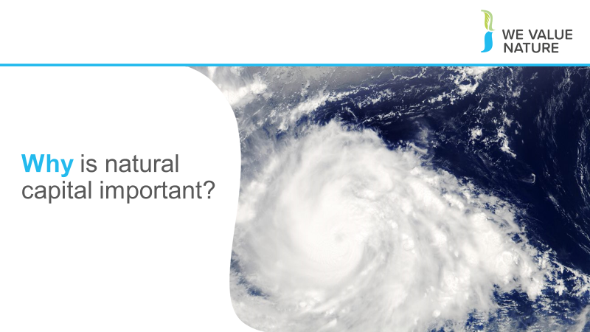
Introduce this next part and chapter of the training by linking with introduction part.

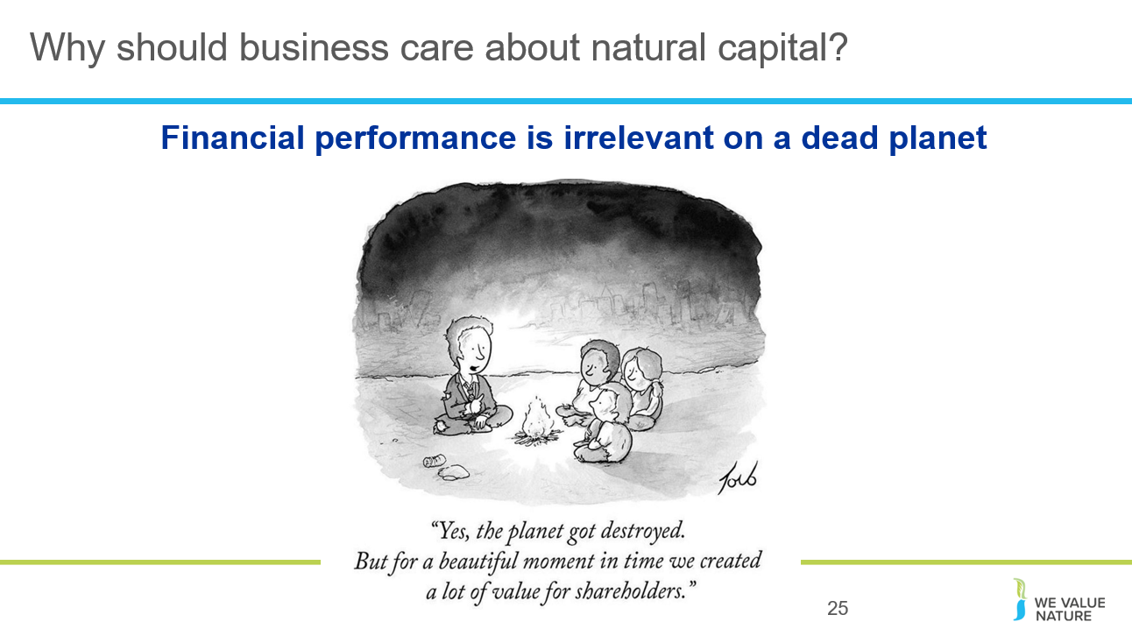

Business as usual is no longer possible.
Our ‘take-make-dispose’ way of consuming is no longer possible.
By destroying our natural world and its resources, we are destroying the critical foundations of our own survival.
We are going to see how business is part of the problem but also part of the solution.
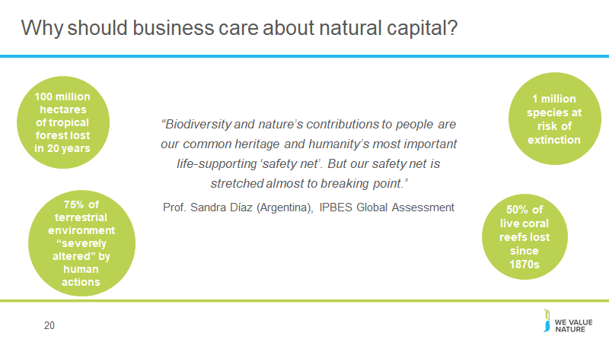
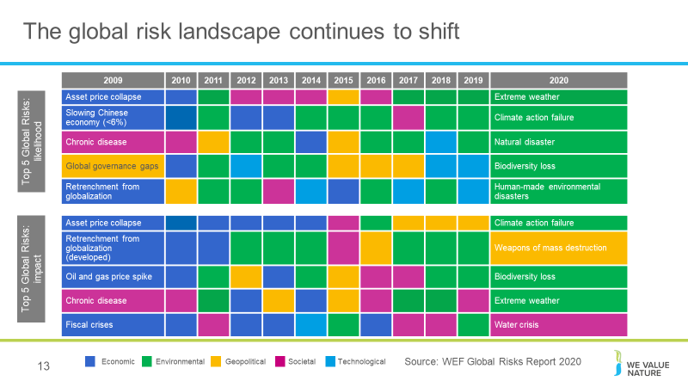
Read the quotes from the slides

This is from World Economic Forum’s global risks report.

We can see that there’s been a complete shift of risks from 10 years ago. You can see that nearly just 10 years ago, none of the top risks by likelihood or impact fell under the umbrella of “environmental”. Come back to today, and now, since 2020, nearly all of the top 5 risks in terms of likelihood are environmental and 3 of them are environmental in terms of impact.

Companies are increasingly facing natural capital related risks. More than ever, they are having to be able to understand, manage and mitigate their natural capital impacts and dependencies.

Behind this nice looking graph, there are many concrete examples of businesses being impacted by these risks and are in fact increasingly being impacted by them. We are also receiving more than ever invoices from nature. The latest example could be that of the devastating fires across Australia.
. 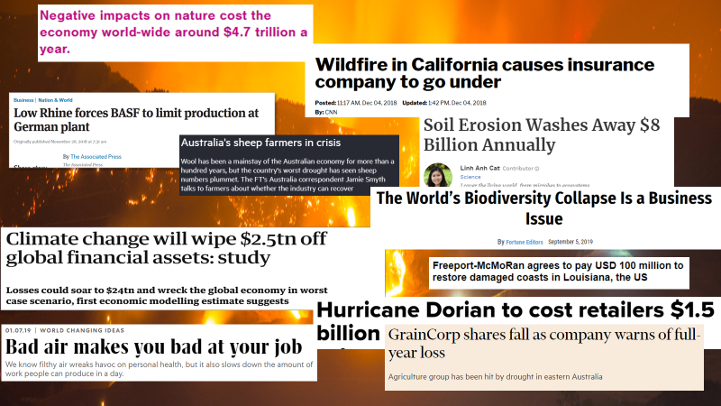
Real life examples:
- California fires: In 2019 California faced the deadliest and most destructive wildfire season ever recorded. The same year, a heat wave baked the entire Northern Hemisphere, killing dozens from Quebec to Japan.
Low Rhine levels:
- BASF: In 2018, BASF had to stop production of a component of polyurethanes at its main plant in Germany because low water levels in the Rhine river are impeding its ability to transport raw materials to the site. https://www.apnews.com/28755ad9694c4248b4e0c8fec6605b62
- Shell: the low levels of the Rhine meant than barges were unable to enter the harbor upon which Shell’s oil refinery depends on in Germany, therefore causing Shell to adjust production levels. https://uk.reuters.com/article/uk-refining-germany-shell/shell-adjusts-german-refineries-output-because-of-low-rhine-level-idUKKCN1NP1BX?il=0
- Pitch for nature: ‘negative impacts on nature cost the economy world-wide around $4.7 trillion a year.’ https://pitchfornature.org/
- Climate change will wipe $2.5tn off: according to estimates from economic modelling, clamate change could cut the value of the world’ financial assets by $2.5tn. The research also showed the financial sense in taking action to keep climate change under the 2C danger limit agreed by the world’s nations. In this scenario, the value of financial assets would fall by $315bn less, even when the costs of cutting emissions are included. https://www.theguardian.com/environment/2016/apr/04/climate-change-will-blow-a-25tn-hole-in-global-financial-assets-study-warns
- Soil erosion: A new study estimates $8 billion in global economic losses caused by soil erosion reducing crop yields and increasing water usage. On average, 24% of arable land globally is undergoing severe erosion, with a severely detrimental effect on global food production
- Australia’s sheep farmers in crisis due to severe drought that has caused the sheep population to plummet, leaving some farmers doubtful if the industry can survive at all.
- GrainCorp shares fall: after group warned it was likely to post a loss due to battling severe drought in Australia. GrainCorp’s stocks fell 10% on the news, leveling out at a 7% fall later in the day. It expected disruption to grain production due to drought
- Hurricane Dorian costs retailers 1.5billion dollars: Foot traffic at apparel stores is expected to fall 25%, while visits to outlet centers will decline 32%. Restaurant traffic is expected to decrease 14%, threatening the typical labor day boost retailers in the region normally see at this time of year. The storm also affected ports on the Carolinas coast when many retailers are expecting to get their shipments for Christmas season around this time, disrupting supply chains.
- Biodiversity loss is a business issue: speaking at the Forbes Global Sustainability Forum, executive secretary of UNCBD said so because destruction is driven by business, whilst the consequences will also have significant impacts on business
- Bad air: researchers at the national university of Singapore studied pollution levels and worker output at two textile factories in China and found that having to work in poor air conditions leads to a decrease in productivity over time
- Freeport-McMoRan: mining company agrees to pay USD 100million to Louisiana communities in response to the damage it has caused to the coast through drilling for oil. Freeport is one of 98 companies that have been sued in 46 lawsuits over the disappearing Louisiana coastline. The agreement is likely to light the way for future litigation and settlements with industry big players such as Shell, Exxon, Chevron etc…

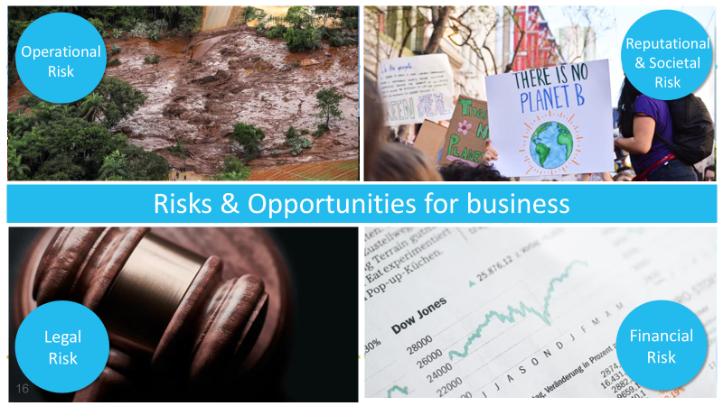
In years gone by, sustainability issues have sometimes taken business by surprise and companies have paid the cost. Companies are increasingly being impacted by the changing risk landscape discussed earlier.

The Protocol highlights key types / categories of risks and opportunities: (– refer to p. 18 of the Protocol).

Operational risk – Operational risk – Vale damn collapse - he direct economic impact of the disaster is "limited" according to Moody's, bearing in mind that the site accounts for less than 2% of the 390 million tonnes of iron ore produced by Vale each year. However, the rating agency expects the disaster "to raise environmental, administrative, criminal and civil liabilities, on top of serious reputational risk for the largest iron ore producer in the world”.
The first financial and legal consequences did not take long to emerge. A few days after the tragedy, Vale’s market value plummeted by 25% - a record drop. In addition, nearly €3 billion were seized from its accounts to manage compensation for the tragedy. Three of its engineers are currently being held on remand, along with two others from Tüv Süd, the German company that issued the dam stability certificate in September 2018.
https://www.novethic.com/csr/isr-rse/vale-s-dam-disaster-in-brazil-is-one-disaster-too-many-146904.html

Reputation risk – increased public & consumer awareness of environmental and social damages + consumers are increasingly demanding assurance that the products they buy are produced in way that protect our environment and respect human rights –link with SOCIETAL risks – health impacts on local communities, social license to operate
Legal risk – giant Texas oil company, Anadarko Petroleum, has agreed to pay $5.1 billion for a vast environmental clean-up - aimed at restoring thousands of sites polluted by toxins and compensating thousands of people with personal injury claims.
Financial risk – Underlying all of these risks & opportunities are financial ones! As we have seen, these risks imply important financial costs. Canadian gold mining company, Infinito Gold, lost over 50% of its share value as a result of the withdrawal of a mining concession in Costa Rica due to concerns about the potential impacts on agriculture, endangered species and forests. This led to a reference in the audit accounts to material uncertainties regarding the company’s ability to continue as a going concern
Source: KPMG, Flora and Fauna International, Acca, Is natural capital a material issue? (2012)
Biodiversity loss risk: Biodiversity loss comes at the nexus of many other business risks. E.g. through decreasing food security (which itself has economic ramifications), or increasing the likelihood of coastal flooding. Biodiversity loss can be felt through physical risks (increased cost of resources, disruption of operations due to natural disasters unmitigated by appropriate ecosystems), associated regulatory and legal risk, market risk from changing consumer preference as consumers become more aware & discerning RE biodiversity, and supply chain risks. Examples:
- “Deforestation in the Agno River basin in the Philippines has led to such extensive river and reservoir siltation that the 100-megawatt Binga hydroelectric facility can only operate intermittently”,
- Studies have shown that the total economic impact of Hurricane Katrina (approximately US$150 billion), was significantly higher than would have been the case if costal wetlands in the region had been preserved,
- In 2008, the Norwegian Pension Fund withdrew its £500 million stake in the mining giant Rio Tinto and excluded the company from its funds. The decision to withdraw was based on the activities of Rio Tinto’s mining operations in Indonesia.

But good news is that, where there is risk, there is opportunity to:
- Secure natural resources
- Save costs
- Manage future risks
- Engage stakeholders
Operational opportunity – EDF rainwater harvesting to manage water scarcity risks leading to reduction in water consumption, economical & energy savings
Reputation opportunity – IKEA to use only renewable and recycled materials by 2030
Legal opportunity – Union Carbide Corporation, subsidiary of The Dow Chemical Company: Seadrift, TX Wetlands for Wastewater Treatment Project description: 110-acre engineered wetland in lieu of an industrial wastewater treatment plant In 1995, the Seadrift water treatment facility was seeking a solution to consistently meet regulatory requirements for water discharge. An innovative GI solution consisting of a constructed wetland was installed and has been successfully operating upon startup and for the last 15 years.
Financial opportunity – But when these risks are taken into account, we saw how it can also lead to reduced financial costs, or improve access to finance. Companies like those you can see here have managed to secure substantial billion dollar loan facilities where the interest rate of repayments is linked to ESG performance (such as Danone). That is to say if the company has strong environmental and social performance they pay back less on the loan.
Biodiversity opportunity - Reduce risk of interruption to supply - For example, increasing wetlands in watersheds with diverse native vegetation increases the water storage capacity on which a hydro-electric dam relies, reducing the risk of interruptions caused by lack of water in the dry-season.

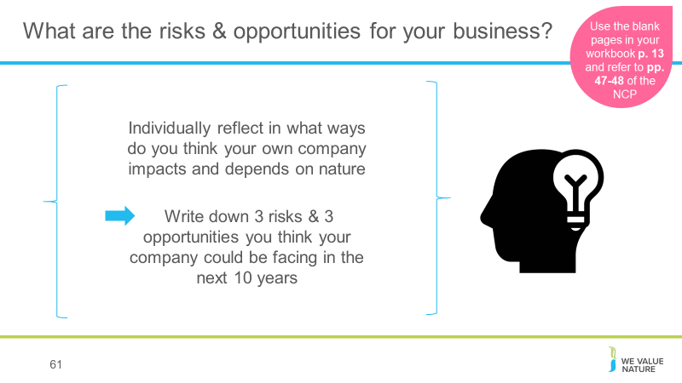
Give participants 5’ to reflect individually on both questions (again, depending on the time you have, you may want to spend more time on this).
For Q. 1: In the workbook, will have a prepared blank list - one for them to list impacts and one for them to list dependencies. Give also list of examples from NCP they can use – reference to pp. 47-48 and explanation of close link between impacts & dependencies. Include Nadine’s landscape image as additional support.
Business impacts and dependencies are closely linked. For example, a company may depend on water, while the quality of its water management practices will affect the scale of impacts generated through its use of water.
.
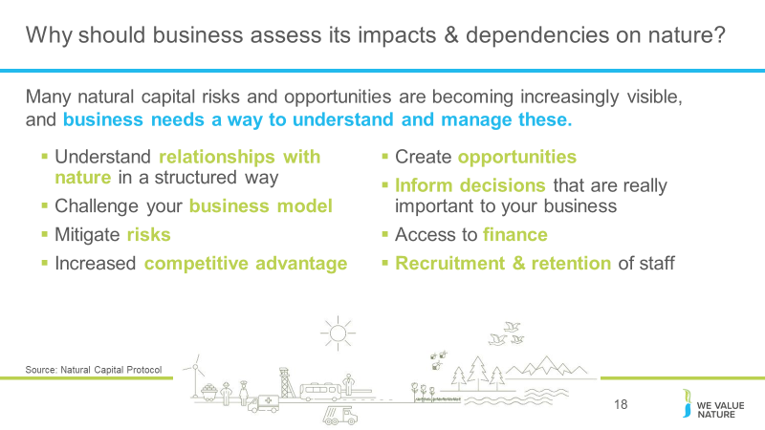
There are evidently a lot of pertinent risks around nature and the environment facing businesses today. Where does natural capital come into this - how can it help you manage these risks?
To assess natural capital is to assess your company’s impacts and dependencies on nature.
It provides information that will help you to understand your relationship with nature. By focusing on impacts and dependencies, natural capital provides structure to this understanding.
Once you have a better understanding of your relationship with nature, you can use this to challenge your business model, mitigate risks and create opportunities. Natural capital can also be a valuable tool for broadening the conversation to include all parts of your business, including the finance team.

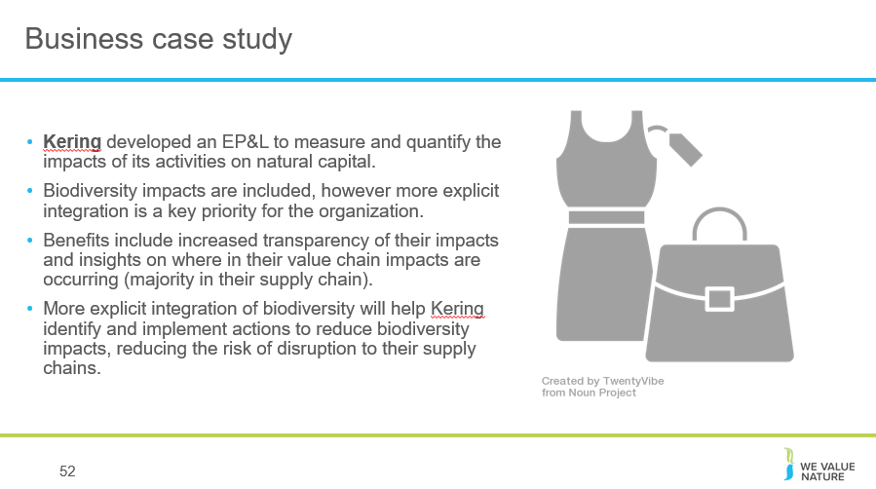Biodiversity loss is increasingly acknowledged as a material business risk, with organizations strengthening the way they integrate biodiversity in their decision-making processes.

e.g. Kering is an international luxury goods company. Biodiversity underpins natural capital, which supports the base of the supply chain for many of Kering’s products. Kering has developed an Environmental Profit and Loss (EP&L) accounting methodology to measure and quantify the impacts of its activities on natural capital, and released a dedicated biodiversity strategy in July 2020. Impacts on biodiversity are included in the EP&L methodology primarily through indicators of land use change.

More explicit integration of biodiversity impacts is a key priority for the organization. Given that it is not appropriate or possible to place an economic value on all aspects of biodiversity, Kering has investigated other biodiversity measures such as the Biodiversity Impact Metric (BIM) and is integrating elements of the BIM into the EP&L methodology to provide more detailed insight into biodiversity as part of land use impact measurement (CISL 2020; CISL 2016).
Application of the methodology has revealed that the majority of impacts lie at the beginning of their supply chain. By integrating biodiversity as part of the EP&L methodology – and refining it over time – Kering will be able to identify and implement actions to reduce biodiversity impacts, reducing the risk of disruption to their supply chains.

Acknowledge where we are in terms of learning objectives.
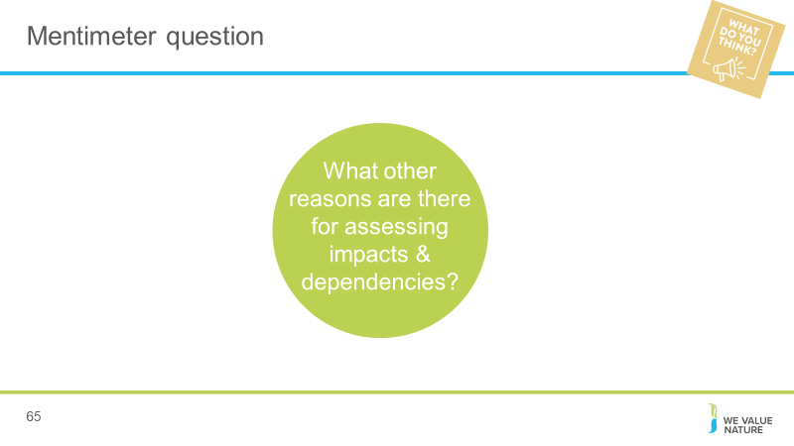

Risk Game
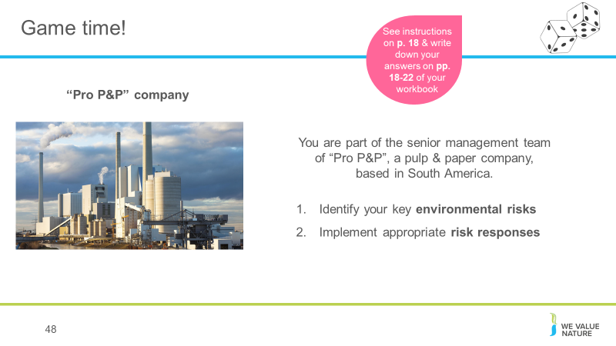

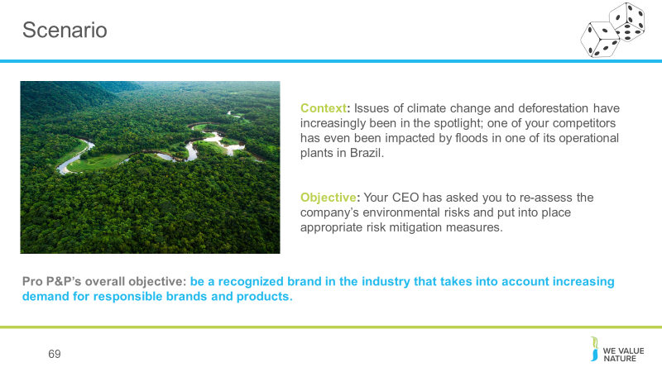
This case study is important to include biodiversity in for flooding mitigation and opportunities.
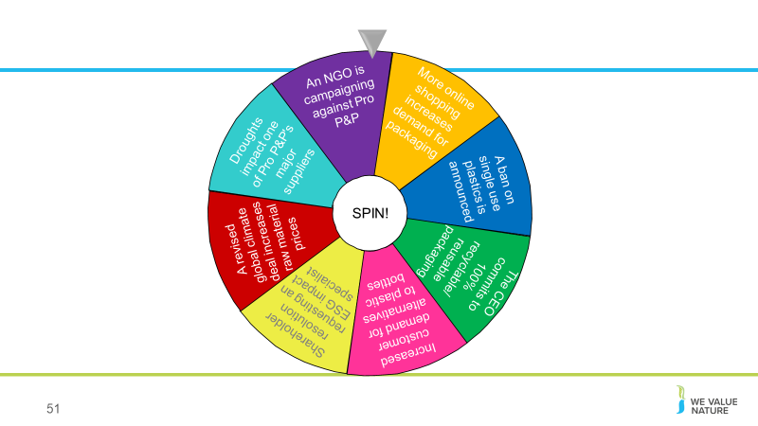
Spin the wheel to land on a risk event. Participants should follow the fuller instructions on the relevant card which will be on their table. Do this until either all 8 risk events have been selected, or until 5 or 6 have been selected (if playing a shorter version of the game). Make sure participants are tracking their share price on the supplied graph.
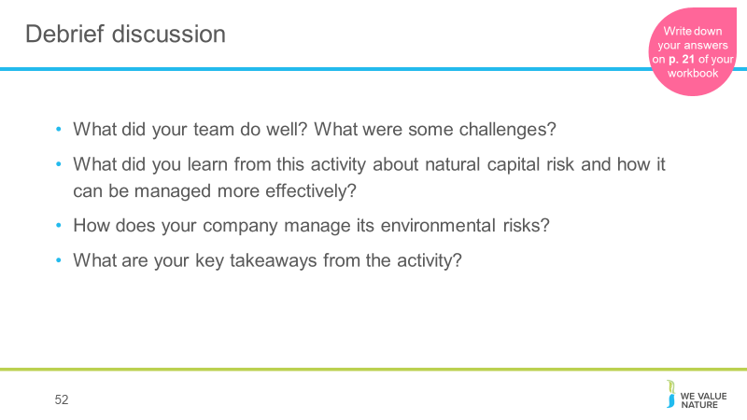
Debrief discussion in plenary for 15’.

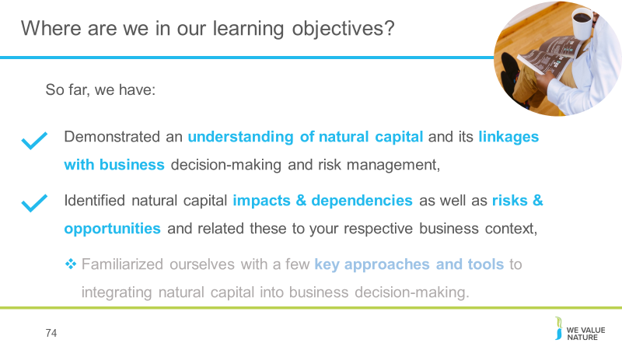
Briefly summarise what participants have learnt so far, and highlight what’s next.

How business can apply natural capital
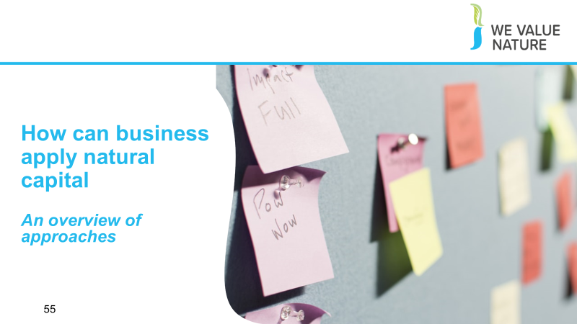
Re-connect to game and how through this, they have already thought of some tools and methods they could implement and perhaps even realized that some of these, they are already applying in their own company.
Before kick off this next session, give space for 1 person from each table to share some of the key barriers, challenges & solutions that came out from game

Briefly introduce this part of the training: After looking at why natural capital is important and why should business care about it, we are now going to look at what are some of the key approaches and tools to apply natural capital into decision-making.
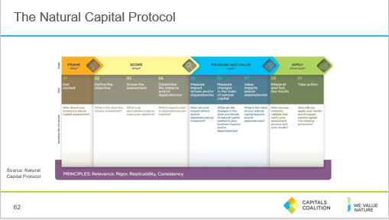
This section looks at the steps for Measuring and Valuing natural capital .

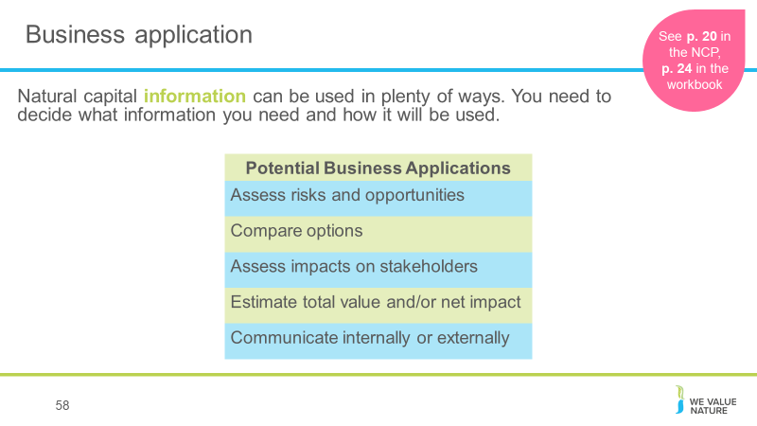
A natural capital assessment provides information. Whilst this can be valuable in its own right, and it’s okay to carry out an assessment just for fact-finding, this means there are also numerous ways to use this information for further purposes.
The NCP focuses on using natural capital for decision-making, measurement and valuation, but it can also be used for disclosure and communication, or to help formulate strategy.
The best way for your company to use natural capital information is highly individual – think back to the challenges and risks you identified earlier in the training and consider how exactly how more information could help you meet these challenges.

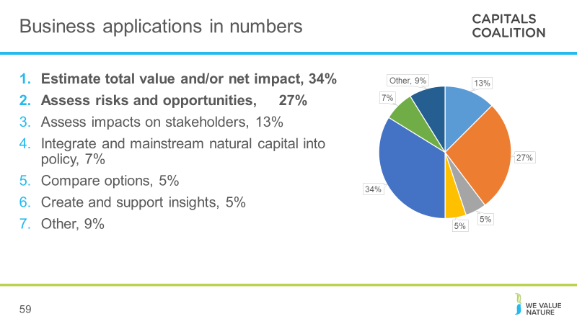
Data from the Capitals Coalition Case Study Database.
Give an overview of the pie chart presented on the slide. Explain that the main purpose for carrying out assessments are to estimate total value/or net impact of/on natural, or social and human, capital. The next greatest application is to assess risks and opportunities for the companies carrying out the assessment, and the third biggest reason is to assess company impacts on stakeholders.

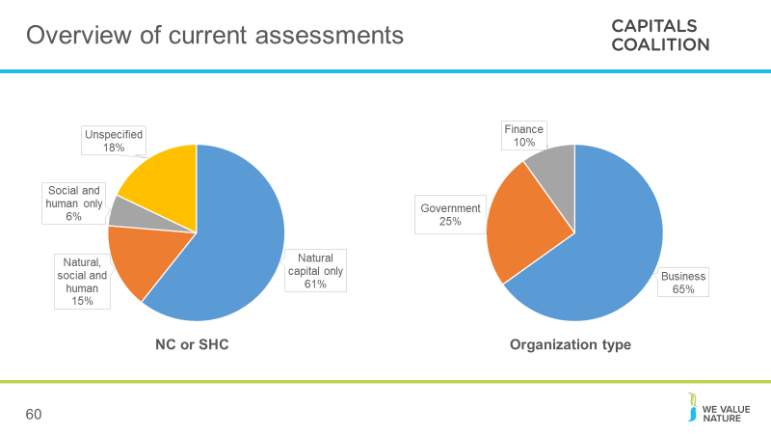

Data from the Capitals Coalition Case Study Database.

Give an overview of the pie charts presented on the slide. Explain that the majority of assessments carried out include only natural capital, and that very few assessments measure social and human capital as yet without also measuring natural capital. Presenter to explain that the majority of companies carrying out assessments are businesses, with governments carrying out ¼ of all assessments and finance carrying out the least.

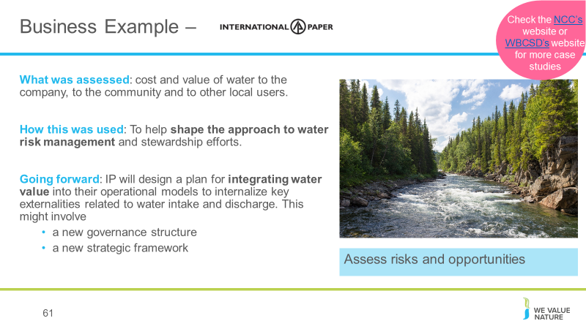
Source. Highlight that this is a business example which focuses on the application of “assessing risks and opportunities”.
International Paper (IP) is one of the world’s leading producers of fiber-based packaging, pulp and paper.
They conducted an assessment of its water use, looking at the costs and value of water to both the company and to the community and other uses of the water, therefore looking at both the impacts and dependencies and also considering not just the impact on the company but on society too. Finally, they assessed the company’s value-add per unit of water used. This information was then used to shape IP’s approach to water risk management and their stewardship efforts. Going forward, IP will design a plan for integrating water value into their operational models to internalize externalities.

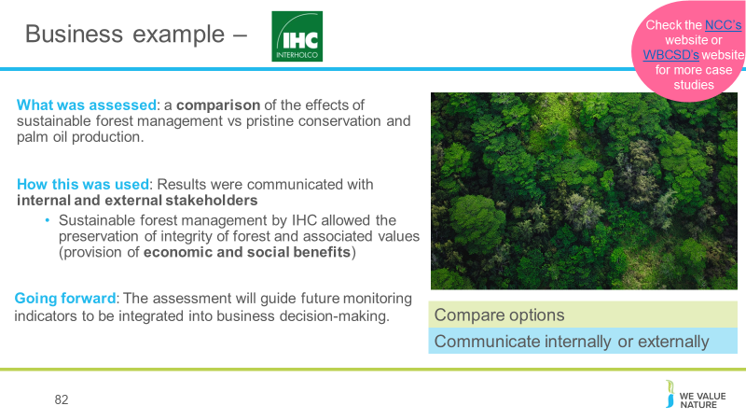
https://naturalcapitalcoalition.org/forest-products-sector-guide-case-study-for-interholco/
Interholco (IHC) specializes in forest management and wood production and is one of the largest producers of African tropical hardwood
IHC undertook a study comparing the effects on the forest of undertaking sustainable forest management in the Congo basin vs pristine conservation and palm oil production.
They found that SFM provided more economic value and comparable natural value as conservation. Palm oil theoretically provides 700x economic value than conservation and 40x more than SFM, but this is outweighed by significant co2 emissions associated with deforestation for palm oil and irreversible loss of ecosystem (showing benefit of taking NC approach).
Going forward: the assessment will be used to provide insight on impacts and dependencies, and guide future monitoring indicators to be integrated into business decision making. IHC may in future undertake specific NC assessment for new business development scenarios.
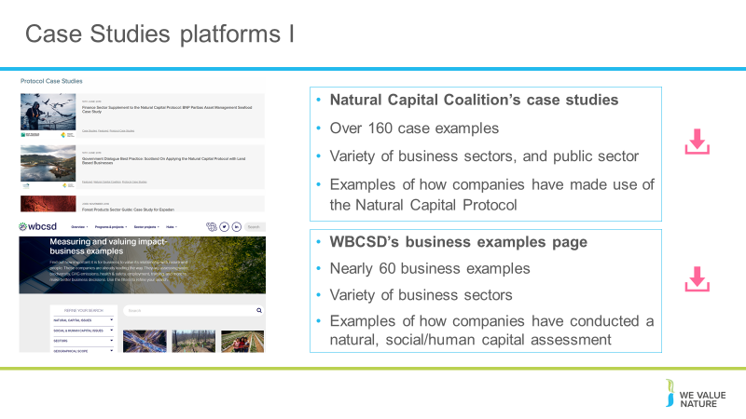
Run through other available case studies on the Natural Capital Coalitions, WBCSD
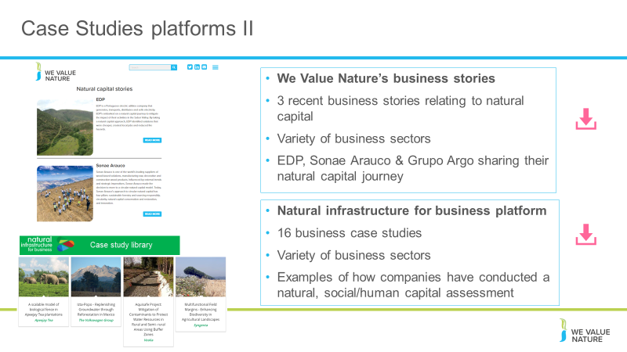
We Value Nature and Natural infrastructure websites.
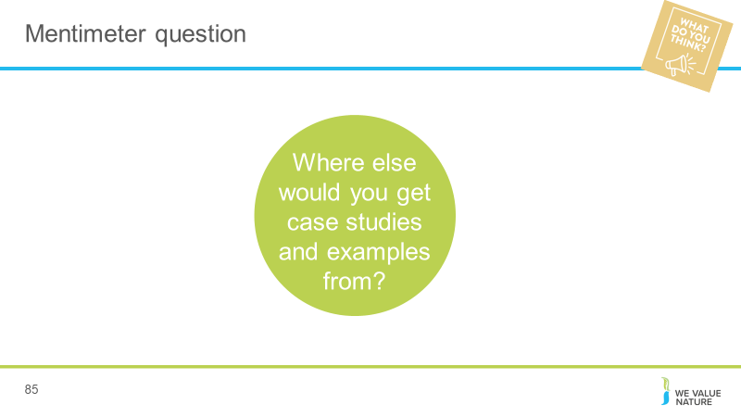
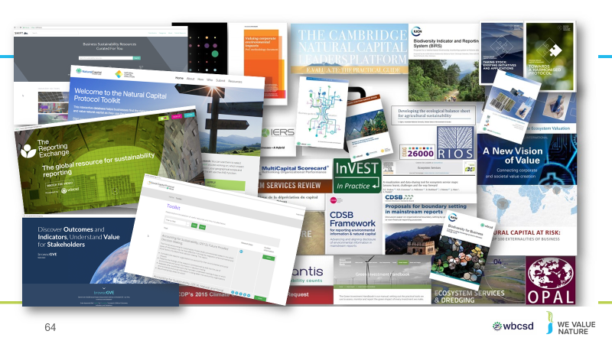
We can see from this slide, the wealth of intellectual content, tools and approaches that already exist in the natural capital field.
This certainly highlights the need for standardization, and a process into which all of these existing resources can input. As we have seen, the Natural Capital Protocol does NOT aim to recreate or invent any new methodologies – instead leverages what we already have.
This also shows that while there are many tools, methodologies and resources out there, this can add to the confusion hence the importance to have a good understanding of what it is you are trying to achieve, what kind of information you are trying to collect or decision you are trying to inform in order to chose the most appropriate tool / resource.
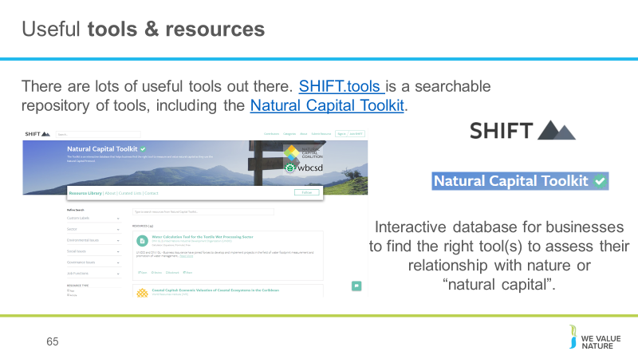
Briefly explain SHIFT platform, that it is a searchable repository of tools, including the Natural Capital Toolkit – can give further background on the reason why this toolkit was transferred onto the SHIFT platform – to encourage standardization & harmonization of tools.
This shows that there are many tools out there, many of which are freely accessible and readily available for companies to use and start assessing their natural capital impacts and dependencies.
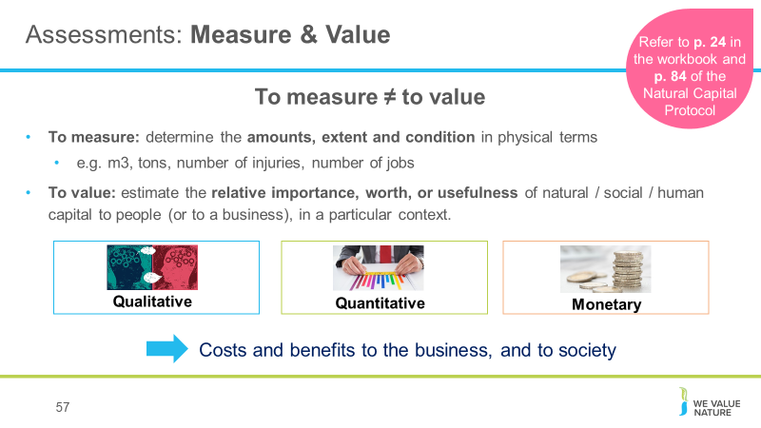

Differentiate between M&V.
There are different ways of valuing – could be qualitative, quantitative and monetary
Important to note that monetary values without any context (i.e. accompanying quantification) are less meaningful!
There are different ways of valuing – could be qualitative, quantitative and monetary
The method you chose depends on which natural capital impact drivers or dependencies you wish to assess, the chosen value perspective (e.g. business, societal, or both), the ultimate objective of your assessment, and the time and resources available.
Monetary valuation: some find it difficult to accept or interpret monetary valuation of certain benefits (e.g. spiritual values). In such situations, special efforts may be required to explain the advantages and also to acknowledge the limitations of monetary valuation.
Advocates of natural capital are sometimes accused of ‘putting a price on nature’ or ‘pricing the priceless’, but in fact our core assertion is that prices have failed to reflect the true value of the natural world, and that the economic systems that we are using are broken.
We use the common definitions of price and value: Where price is ‘the quantity of one thing that is exchanged or demanded in barter or sale for another/the amount of money given or set as consideration for the sale of a specified thing’ and value as ‘The regard that something is held to deserve; the importance, worth, or usefulness of something i.e. “your support is of great value”. If something is not for sale, we do not describe it as having a ‘price’, but we may nevertheless recognise the value that it holds, and make decisions on this basis.

Presenter to stress that in a biodiversity-inclusive natural capital is likely to only be done as estimates or minimum value because of the hidden and intrinsic values that biodiversity has. Any values derived should be viewed with caution along with other information that can assist the decision-making, rather than replace.
- When doing a biodiversity-inclusive natural capital assessment it is important to recognise that you may be double counting. Double-counting can be a concern when you value biodiversity and ecosystem services. This is because biodiversity delivers benefits in multiple ways. For example, in production of agricultural crops, biodiversity supports nutrient cycling and pollination. These ecosystem services (and other benefits from biodiversity) combine to provide one final benefit to a business—increased crop yields. If you value each ecosystem service individually you may count the role of biodiversity several times. To avoid double-counting, you can focus on final benefits, such as the crop yield, rather than intermediate or supporting services, such as nutrient cycling or pollination.

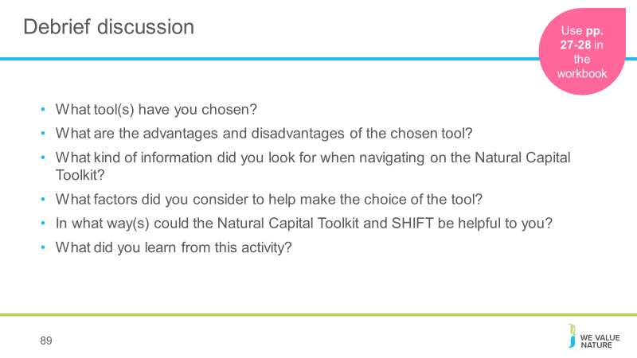
Conclusion of this exercise is that:
- There are no perfect answers!
- The choice of tool will depend on various factors:
  - What is the objective / what are you trying to achieve? / What decision are you trying to inform? – Is it to inform business strategy? Business management? Or operating decision?
  - What is the scope? Are you looking at product, corporate level?
  - What perspective are you looking at? Business? Societal? Both?
  - How much resources do you have available to conduct the assessment?
  - How much information / data do you already have?
  - Will you need external help?
  - Etc.

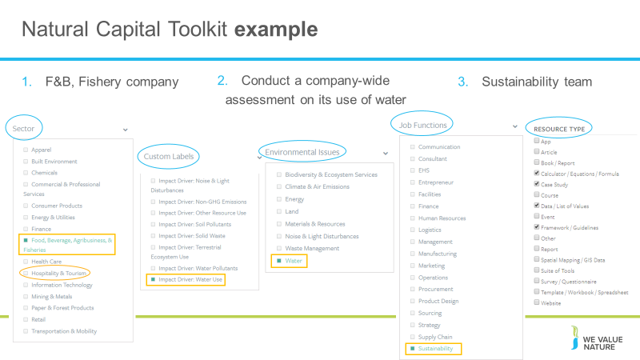
An example of how the platform works, providing a fictive scenario.
Conclusion is that: The choice of tool will depend on various factors:
- What is the objective / what are you trying to achieve? / What decision are you trying to inform?
- Is it to inform business strategy? Business management? Or operating decision?
- What is the scope? Are you looking at product, corporate level?
- What perspective are you looking at?
- How much resources do you have available to conduct the assessment?
- How much information / data do you already have?
- Etc.
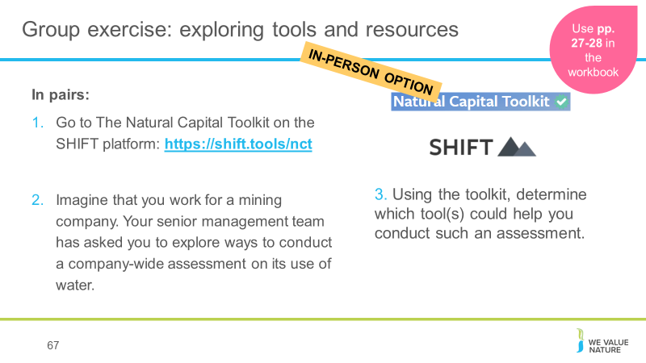
Now, we thought what better way to have participants familiarize themselves with these tools by doing an exercise that will have them explore some of them.
For this exercise, participants will need their laptops. They will be connection onto SHIFT, which is an extensive repository of tools and resources on how to undertake a natural capital assessment and valuation. Because it’s so huge, we’ve picked the natural capital toolkit to help narrow your search a bit. The natural capital toolkit was developed by the natural capital coalition and WBCSD.
This is a nice exercise to have them realize that there are many tools available and that the one they will choose will depend on many aspects.
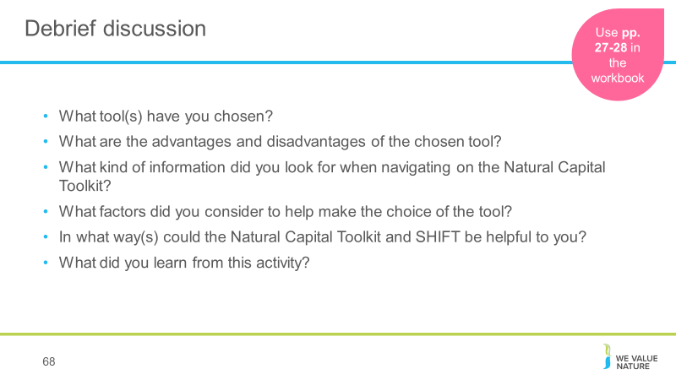
Conclusion of this exercise is that:
- There are no perfect answers!
- The choice of tool will depend on various factors:
  - What is the objective / what are you trying to achieve? / What decision are you trying to inform? – Is it to inform business strategy? Business management? Or operating decision?
  - What is the scope? Are you looking at product, corporate level?
  - What perspective are you looking at? Business? Societal? Both?
  - How much resources do you have available to conduct the assessment?
  - How much information / data do you already have?
  - Will you need external help?
  - Etc.

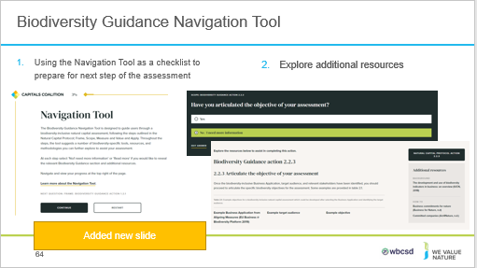

An overarching Biodiversity Guidance Navigation Tool is available for businesses to use. Using a series of questions, the Navigation Tool will guide you through the Frame, Scope, Measure and Value, and Apply Stages of the Protocol and Biodiversity Guidance in order to carry out a biodiversity-inclusive natural capital assessment.
The process is designed to be iterative and will require users to interact with all aspects of the Guidance
it's important to reiterate that it will be an online tool that is iterative and provides clickable buttons to navigate the Natural Capital Protocol. The report is to help outline the drafting of the online tool, but not a reference for the users to use.

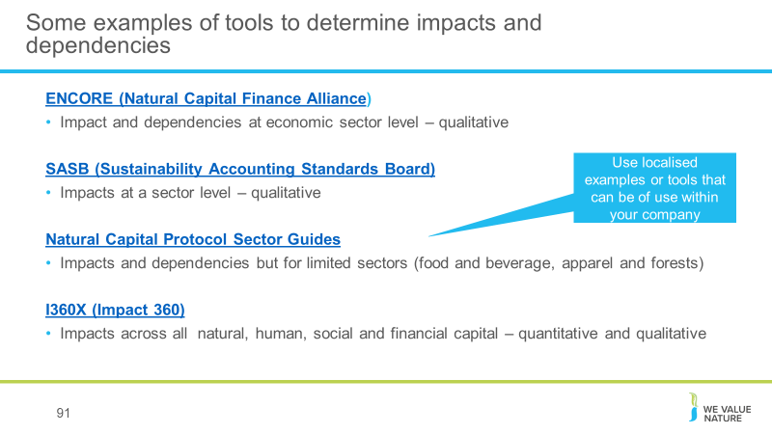
Quickly describes some of the other tool available
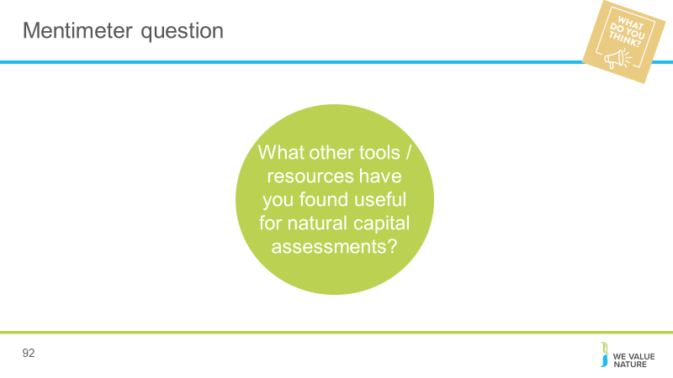

Case study presentation
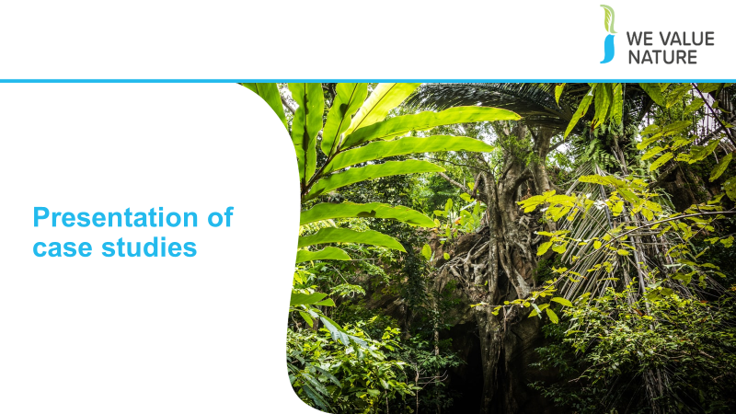
E.g.
3 speakers from 3 different companies will be invited to the training to share their experience in integrating natural capital into their business decision-making processes.
Speakers will be encouraged to share:
- Their experience
- The solutions put in place
- Challenges/barriers faced, how these were overcome and what would they do differently looking back
- Collaboration with stakeholders involved in the process – who was key in supporting the solution, making it happen and perhaps also discussion around communications, how do you have to communicate differently e.g. if trying to convince risk management vs
During presentation of case studies, participants will be encouraged to take note of:
- Challenges & barriers
- Solutions, activities
- Key stakeholders / enablers in the process
Encourage case studies speakers to also discuss how they would have done things differently.

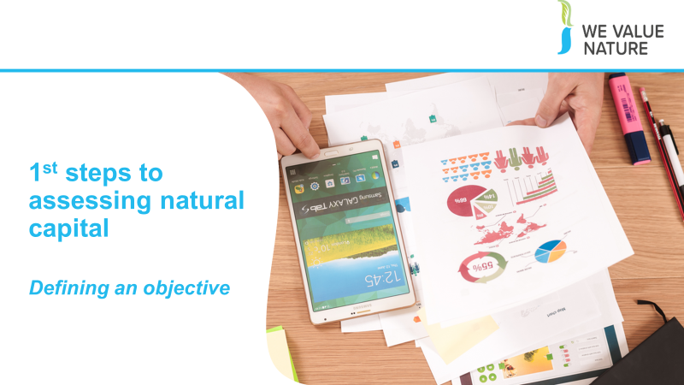

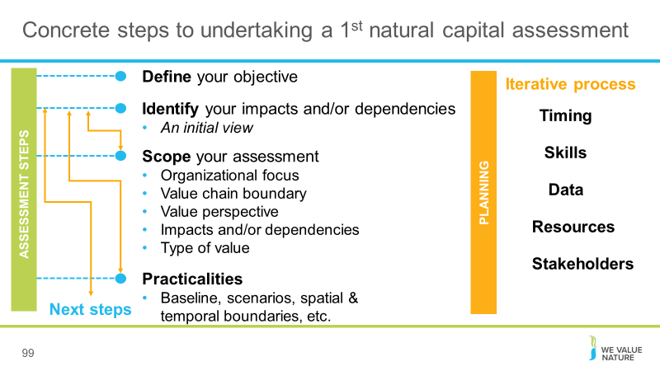
Presenter to explain the steps to undertaking a 1st natural capital assessment using the diagram on the slide. Presenter to explain that defining the objective can be quite difficult.
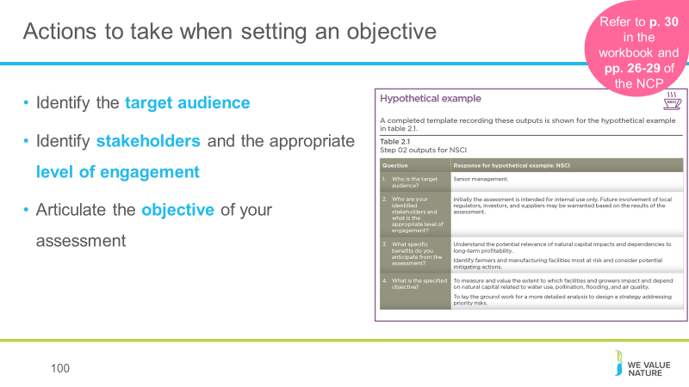

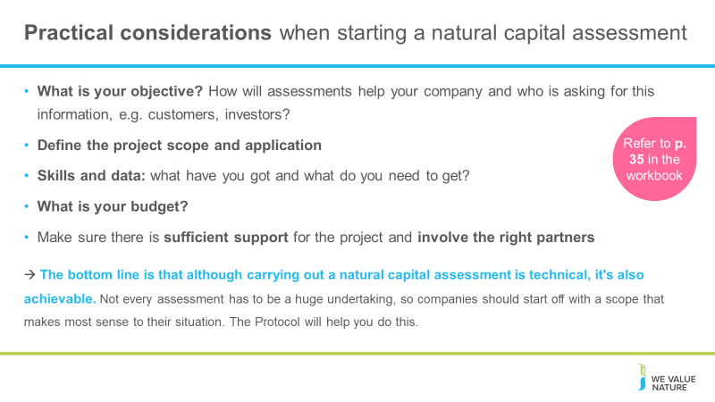
Most companies believe that the real value of using consultants is in the valuation itself, meaning the number-crunching analysis. This is because - unfortunately! - the Protocol isn't a calculator and it won't tell you which monetary values to use in any given situation. However, companies can start to conduct many other aspects of an assessment themselves by doing things like getting the project going, scoping the assessment and integrating natural capital considerations into internal processes.
It's usually much more efficient to build on existing data that's readily available in-house, and the Protocol provides guidance on gathering and using that data too.
For example, many companies have data on their own GHG emissions, water, waste, and some also have results of product Life Cycle Assessments - this existing information can provide a really good starting point for a natural capital assessment. How applicable it is will depend on the objectives and scope of the assessment though, so it's important to find the balance between getting perfect data (e.g. from monitoring in the field) and using proxies that are not as accurate but can be more practical and still lead to better decisions.
How much will it cost? It depends on what you're trying to do. It will depend on the scope of the assessment, what you're asking for and what data is already available.
Skills and data: what have you got and what do you need to get? companies can start to conduct many other aspects of an assessment themselves by doing things like getting the project going, scoping the assessment and integrating natural capital considerations into internal processes.
How can we secure the resources? In many cases, natural capital assessments can be a bottom-up effort. Trying to drive natural capital assessments from sustainability, environment or health and safety departments is sometimes difficult, but nevertheless, the Protocol provides guidance on integrating the assessment into the business itself. One way to facilitate engagement internally can be to show that "many companies are already doing natural capital assessments; they're just using different terminology and steps.
- The bottom line is that although carrying out a natural capital assessment is technical, it's also achievable. Not every assessment has to be a huge undertaking, so companies should start off with a scope that makes most sense to their situation. The Protocol will help you do this.
- Also to keep in mind:
- How will assessments help your company and who is asking for this information, e.g. customers, investors?
  - Decision-making
  - External reporting
  - Stakeholder engagement
  - What kind of information would help?
  - How good does the information have to be, e.g. financial grade?
  - Comparable?
  - Monetary (and what does it mean?)
- How much of a leader does your company want to be in this space?
  - Share to help converge on what is practical, e.g. case studies, learnings
  - Explicitly connect your approach with generally-accepted frameworks like Natural Capital and Social & Human Capital Protocols.

Wrapping up
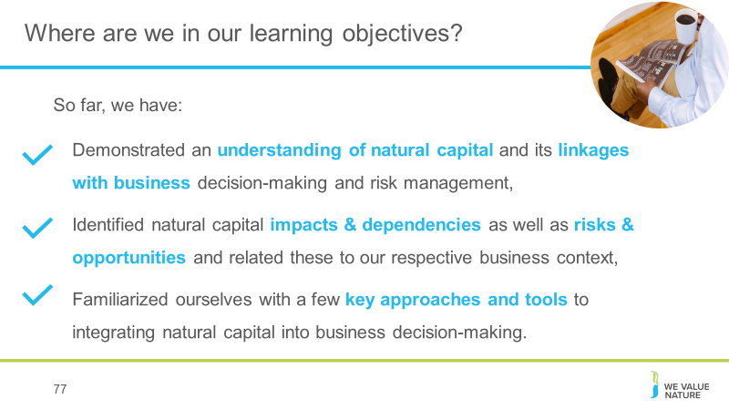

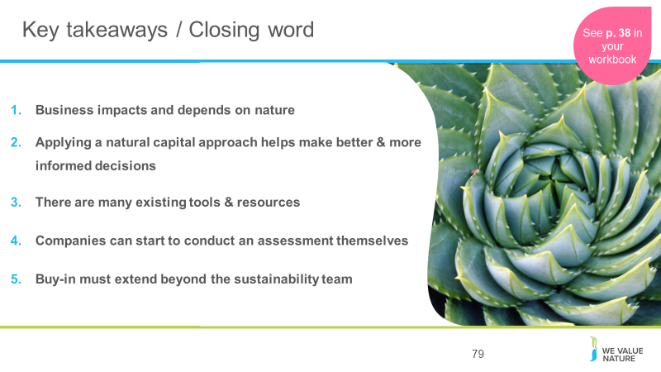
- Business impacts and depends on nature – the NCP provides the framework to identify and assess impacts and dependencies,
- Understanding, measuring and valuing natural capital (i.e. taking into account) will help business make better & more informed decisions,
- There are many existing tools & resources to measure and value impacts and dependencies. The one you chose depends on the information you are aiming to get or the decision you are trying to inform,
- Companies can start to conduct an assessment themselves by getting the project going, scoping the assessment and integrating natural capital considerations into internal processes,
- For natural capital to become strategically important, buy-in must extend beyond the sustainability team.
ADDITIONAL BACKGROUND
How much will an assessment cost?
Some of the Protocol pilot testers - like our members Nestlé and Roche - estimated they spent about USD $50,000 on consulting services for their assessments over a six-month period. Some companies spend less, others spend more.
Dow, Kering and Natura have invested significantly more over a longer term, for in-depth assessments that contribute to their multi-year strategic ambitions
The Protocol can help companies navigate these kinds of situations by making sure the services required align with the assessment's objective.
Skills & data needed:
It's usually much more efficient to build on existing data that's readily available in-house, and the Protocol provides guidance on gathering and using that data too.
For example, many companies have data on their own GHG emissions, water, waste, and some also have results of product Life Cycle Assessments - this existing information can provide a really good starting point for a natural capital assessment. How applicable it is will depend on the objectives and scope of the assessment though, so it's important to find the balance between getting perfect data (e.g. from monitoring in the field) and using proxies that are not as accurate but can be more practical and still lead to better decisions.
Internal buy-in:
In many cases, natural capital assessments can be a bottom-up effort. Trying to drive natural capital assessments from sustainability, environment or health and safety departments is sometimes difficult, but nevertheless, the Protocol provides guidance on integrating the assessment into the business itself.
One way to facilitate engagement internally can be to show that "many companies are already doing natural capital assessments; they're just using different terminology and steps.
To support this engagement, it is important to look beyond those benefits that can be valued through the natural capital assessment itself, and acknowledge how a natural capital approach can motivate organizational change in support of broader business goals." This means that there will be more leadership from the top to better measure, value and then integrate natural capital into business.
The bottom line is that although carrying out a natural capital assessment is technical, it's also achievable. Not every assessment has to be a huge undertaking, so companies should start off with a scope that makes most sense to their situation. The Protocol will help you do this.
Finally, we must make sure the information obtained from the assessment is included in core business decision-making. This will ensure you have the best possible impact on your business, and on the environment.
https://www.wbcsd.org/Programs/Redefining-Value/Business-Decision-Making/Measurement-Valuation/News/What-does-it-take-to-carry-out-a-natural-capital-assessment
Facilitation note: make sure to remind participants that they can do it, it’s not as complex as it may seem, and that WVN are here to help and have the resources!

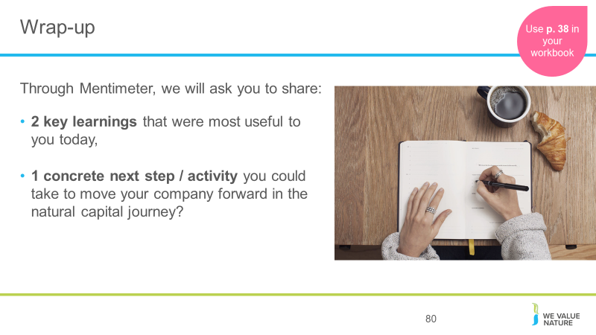
5’ for participants to write these down – can place their post-its on flipchart as they exist room (to save time).

