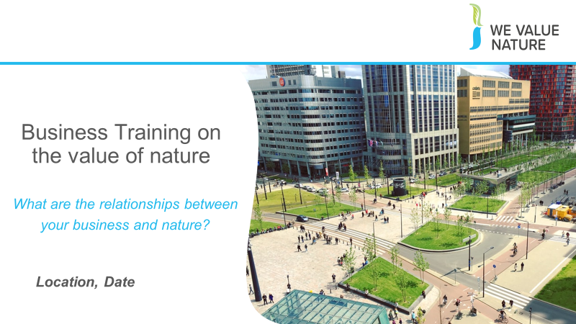
Speaking notes: business training on the value of nature

Welcome everyone in the room

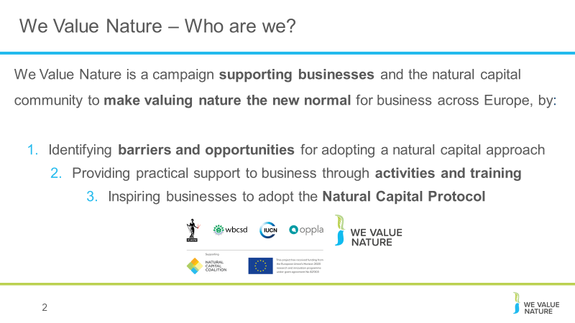
Introductions
2. Before kicking-off the training, introduce that this training is being given as part of the We Value Nature Campaign and explain what it is, its purpose, objectives and partners involved:
The We Value Nature Campaign is a €2 million EU-funded campaign supporting businesses and the natural capital community across Europe with the aim of making valuing nature the new normal for business. As we will have a chance to explore during today’s training, by valuing nature, businesses can make smarter decisions that benefit themselves, society and the planet as a whole.
The campaign is coordinated by the Institute of Chartered Accountants in England and Wales (ICAEW), World Business Council for Sustainable Development (WBCSD), The International Union for Conservation of Nature (IUCN) and Oppla. And it is supporting the Natural Capital Coalition, which has recently merged with the Social & Human Capital Coalition to become now the ‘Capitals Coalition’.
The campaign will aim to increase the uptake of the natural capital approach (including: natural capital assessment, natural capital accounting, nature-based solutions and green infrastructure) by identifying barriers and opportunities, providing practical support to business through activities (such as webinars, helpdesk calls, etc.) and training such as this one, as well as by inspiring businesses to adopt the NCP.

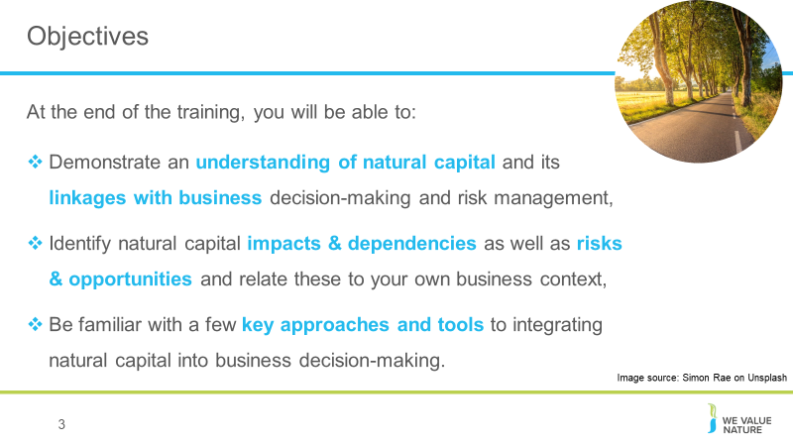
3. The objectives for today

4-6. Run through the agenda for the day, as well as security information (emergency exits etc…) and “house rules” re common courtesy, what is expected of participants during the training
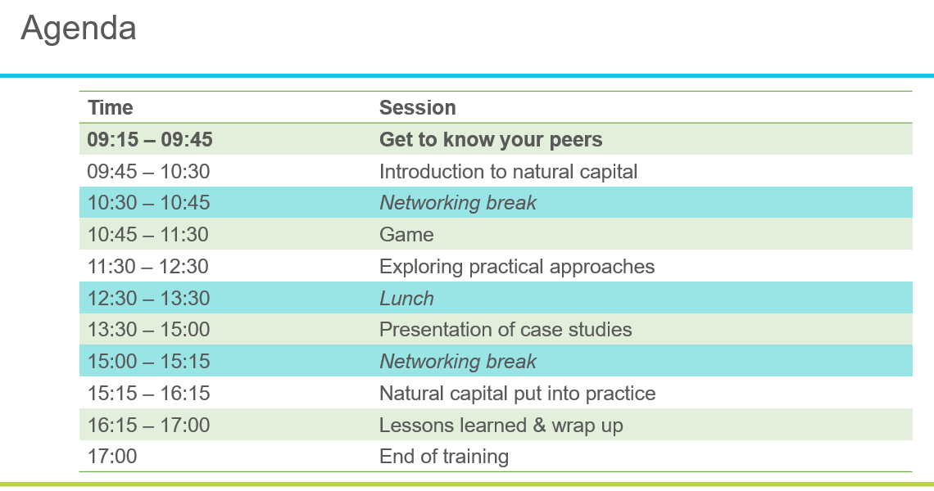

Explain the purpose of the workbook and mention that each have a copy of the NCP. Also mention that there are other useful guidance and reports out on table.

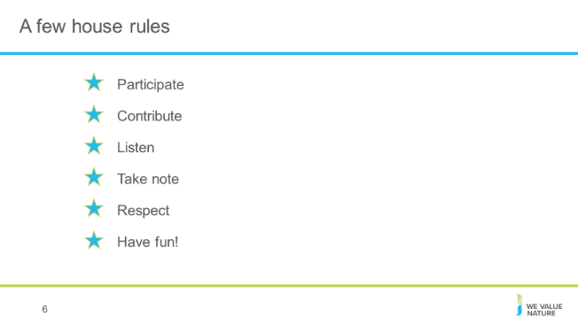
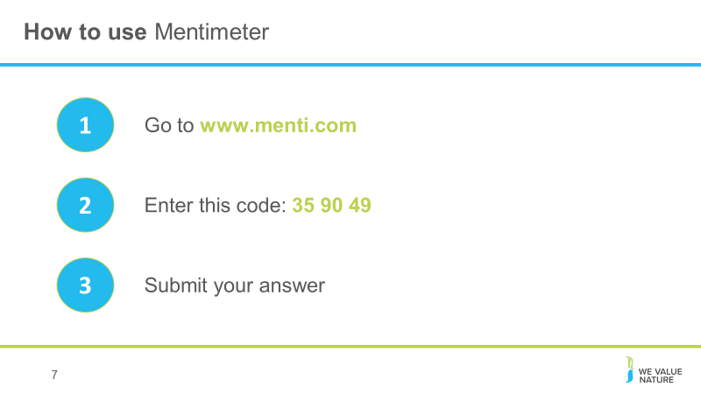
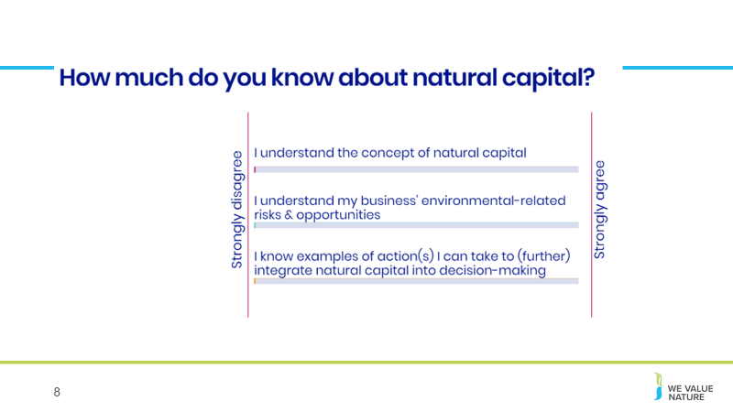
7. Introduce participants to mentimeter, invite them to follow instructions on slide now to have everything set up and ready. Explain that it will be used several times throughout the session.
8. Using mentimeter, get the participants to rate their knowledge of natural capital, explaining that it will help us and them understand how the training has helped.

9. Ask audience to each present themselves – name, role, company and expectations for today
Take note on flipchart of expectations.
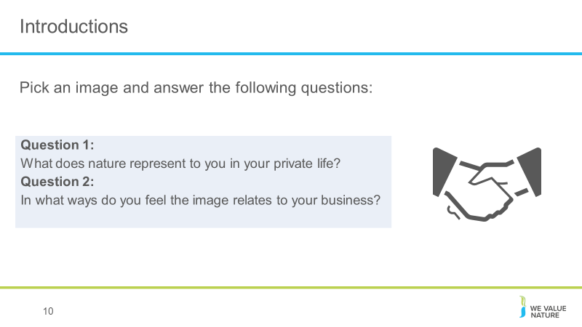

10. A variety of pictures illustrating nature in different ways will be placed on each table (e.g. bee, forests, mental health, etc.).
Invite each participant to pick a picture and discuss the questions at their table.

Hopefully this little ice-breaker would have shown that each one of us value nature to some extent or another whether in our private life or by recognizing the important role it plays for our business. And we certainly all have different entry points into this topic but the aim of today will be to show that whichever sector you represent, natural capital plays a key role and we can all integrate it some way or another into decision-making.

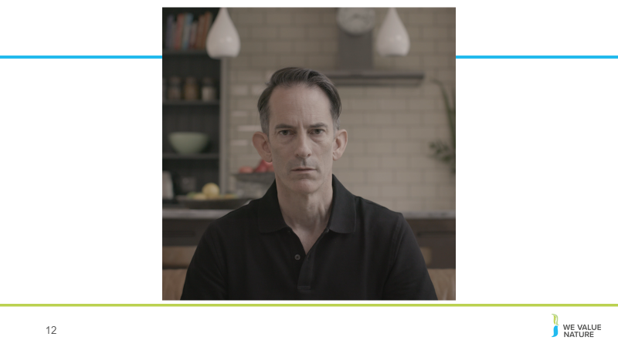
12. After showing video, open the floor to anyone that wishes to share something
Potential questions that can be asked to participants:
- Has anyone of you seen this video before? (Show of hands)
- What did you think of the video?
- What feelings or perceptions were perhaps triggered when viewing the video?

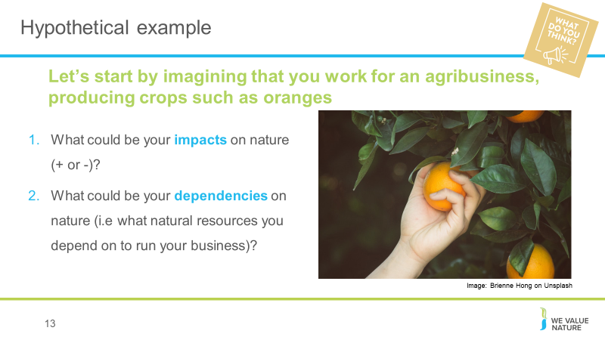
Hypothetical example
13. Give participants 5’ to reflect on both questions at their respective table and then offer each table to very briefly explain to the room what ideas came out.
Potential answers:
Impacts:
N: water use, soil degradation through overuse, biodiversity (loss because of monoculture)
P: preventing too much rainwater runoff, absorbing carbon, conservation, training & development, providing habitats,
Dependencies: water, fertile soil, appropriate temperature and climate, natural flood defenses, pollination.
Elements to be considered:
What stages of the value chain are we considering (just the farm itself, or the fertilizer and the seeds, the transport, the shops, end-use, etc…), where is farm based, is it organic or mass production?

Defining natural capital
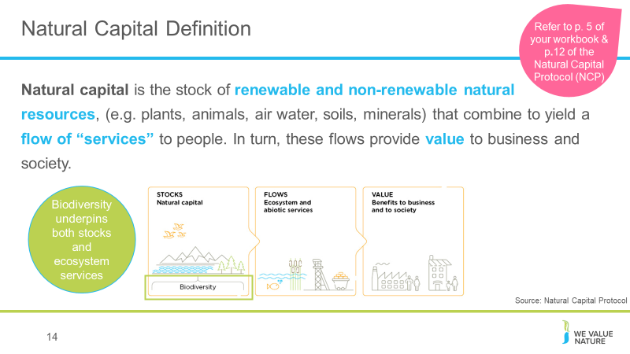
14. We have started thinking about natural resources an agricultural producer relies and impacts on but what do we mean when we talk about natural capital?
Well in fact, everything you have discussed through the previous example is natural capital is some form or another. Whether it is the assets/resources it represents (such as water and soil you have identified as needed for the farm) or the services it brings.

The environmental jargon is everywhere which can be confusing. What is important, is not to remember all the terminology used, but rather that these are all connected to the value of nature and that people have different entry points and priorities and will use one or another terminology based on that. But fundamentally, we are all speaking about the same things, just in different ways.

This is the definition according to the Natural Capital Protocol.

The stocks refer to the natural resources available to us while the flows refer to the different benefits people receive from ecosystems such as:
- timber,
- fiber,
- pollination,
- water regulation,
- climate regulation,
- Recreation,
- etc.
Ecosystems are part of natural capital! Biodiversity is both, part of natural capital and also underpins ecosystem services.
Natural capital is about the diverse natural resources people and businesses use every day – such as the water needed for the production/manufacturing of food and many other goods.
Natural capital is about the services people and businesses receive from nature every day – such as flood mitigation thanks to a forest upstream from the manufacturing plant for example
Natural capital is about the benefits that people and businesses receive every day from nature through the diverse services it provides – such as what you mentioned nature meant to you earlier this morning
Here’s another way to think of it: Imagine that nature is a trust fund, and humans and businesses are the beneficiaries. Humans and businesses live off the “interest” that the fund provides — the air, water, raw materials, carbon storage and its ability to regulate climate and mitigate floods, and so on. If humans and businesses keep dipping into the capital — by clearing too much forest, for example — we’re going to see diminishing returns from those dividends, to say nothing of their ability to continue to provide benefits over time.

ADDITIONAL BACKGROUND
Some background perspectives:
- Nature-based solutions in the Climate-policy-world (the new reports IPCC, Climate Adaptation) are coming from the perspective of climate mitigation/adaptation with a focus on eco-system services, protecting forests, mangroves, carbon sequestration, etc. Often slightly theoretical connotation
- Natural Climate Solutions are in fact a sub-set of Nature Based Solutions, and are a critical part of delivering a 1.5 degree trajectory for land use, as well as creating finance mechanisms at farm level which support livelihoods and practices
3) Nature is also emerging as a synonym for Biodiversity or even a new overarching word for ‘everything good for the planet’ (protecting earths resources & climate action).
4) To some ‘nature-based solutions’ may be the same as bio-based based solutions, referring to solutions of plant/bio based origin (non-fossil based), which result in lower carbon footprints (avoiding greenhouse gas emissions).

Abiotic services are benefits to people that do not depend on ecological processes but arise from fundamental geological processes e.g. – supply of minerals, metals and oil and gas, as well as geothermal heat, wind, tides, etc.
In the Protocol biodiversity (part of stocks) is considered to be critical to the health and also the stability of natural capital in so much that it provides resilience to shocks like:
- Floods
- Droughts
As well as supports fundamental processes such as:
- carbon and water cycles
- soil formation
Ecosystem services – key distinction between:
Supporting services: fundamental ecological processes that support the delivery of our ecosystem services
Regulating services: indirect benefits from nature generated through regulation of ecosystem processes e.g. – mitigation of climate change through carbon sequestration, water filtration by wetlands, erosion control and protection from storms.

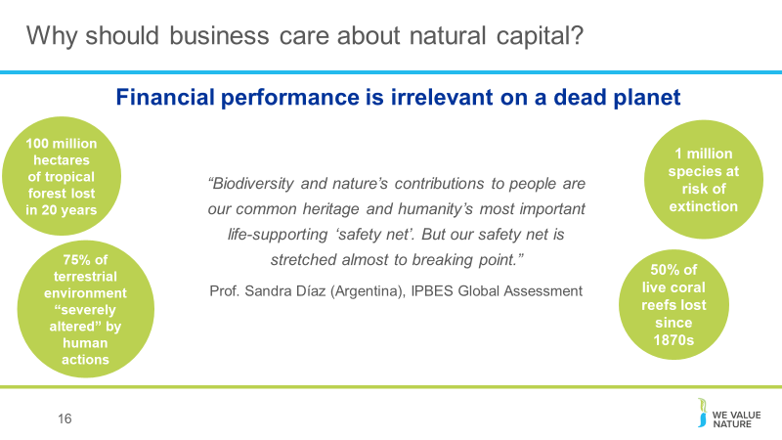
Why should business care?
16. Business as usual is no longer possible.
Our ‘take-make-dispose’ way of consuming is no longer possible.
By destroying our natural world and its resources, we are destroying the critical foundations of our own survival.
We are going to see how business is part of the problem but also part of the solution.
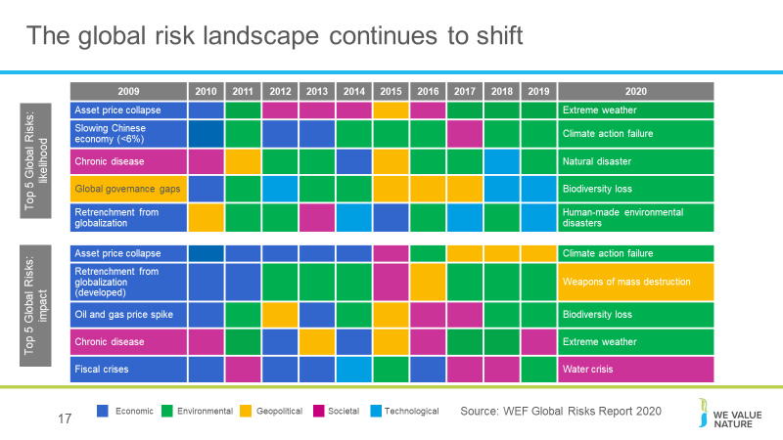
Stats all from IPBES media release re global assessment;
17. Just to flag some of the key challenges facing the world from a sustainable development perspective.
CLIMATE CHANGE
Perhaps one of the most high-profile which is now firmly on the world’s radar is climate change. In the last few years this has gone from being something that was part of our scientific forecasting and models to something which is being felt around the world. From wildfires in California to record levels of flooding in Asia the consequences are being felt by people and indeed businesses all over the world.
And we’re seeing reactions – for example the recent protests by school children across Europe.
Is and will become increasingly the issue of our time
ISSUES OF INTENSE RESOURCE USE & THROWAWAY SOCIETY
This is really an issue that is symptomatic of a wider, consumption led, throwaway society that has rapidly developed over the past few decades and that ultimately is unsustainable in the long term.
As global resource use and extraction has tripled in the past 40 years, global efforts to maximize reuse and recycle resources have not kept up with only 9% of materials being recycled.
This has environmental and social impacts in the form of things like ocean plastic but also means that we are effectively using resources at a rate much quicker than the earth can provide them in the long term.
GLOBAL FOOD SYSTEM CHALLENGES
Another set of issues that I wanted to highlight quickly are those relating to the global food system.
Responsible for 25% of global CO2 emissions. Still we have 800 million people globally who do not have access to enough food, but also 2 billion people who are overweight (a billion of whom chronically so)
25% of global land is highly degraded posing challenges to future agricultural production
And at present a third of all food that is produced never actually makes it a human mouth
So a series of challenges that we need to think very carefully about in relation tot the food value chain.
SOCIETAL-RELATED ISSUES
While we are facing mounting costs brought about by environmental burdens, we are also seeing our incumbent economic system taking a heavy toll on some quarters of society.
Although we have achieved significant progress in development over the past few decades challenges still remain.
- 700M people in extreme poverty
- 20 million in forced labor
- 150 million cases of child labor
And a marked rise in levels of inequality with 26 billionaires owning as much wealth as the poorest half of humanityand an increasingly disillusioned middle class which is contributing to the tide of political convulsions we’re seeing globally.
ADDITIONAL BACKGROUND:
Other challenge / issue to be kept in mind and that can briefly be highlighted include:
PLASTICS: the poster child of a throwaway society. Plastics is another issue that has received a lot of media and NGO attention lately. Clearly a topic that has captured public interest and emotions.
This is really an issue that is symptomatic of a wider, consumption led, throwaway society that has rapidly developed over the past few decades and that ultimately is unsustainable in the long term.
As global resource use and extraction has tripled in the past 40 years, global efforts to maximize reuse and recycle resources have not kept up with only 9% of materials being recycled.
This has environmental and social impacts in the form of things like ocean plastic but also means that we are effectively using resources at a rate much quicker than the earth can provide them in the long term.
Complete shift of risks from 10 years ago.
This shows that 3 of the top 5 global risks (in terms of likelihood) are environmental and 3 of the top 5 global risks (in terms of impact) are also environmental.
Companies will increasingly be facing natural capital-related risks. More than ever, they are having to better understand, manage and mitigate their natural capital impacts and dependencies.
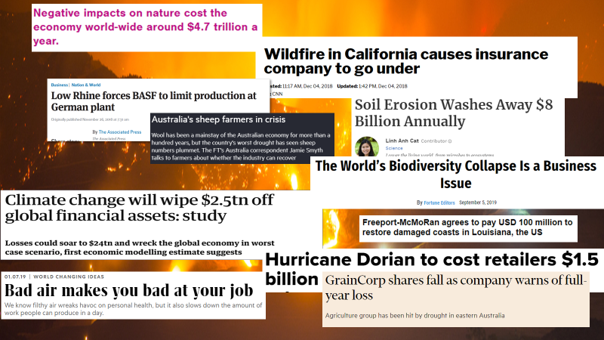
WEF’s Global Risks Report 2020 is published against a backdrop of worrying geopolitical and geo-economic tensions.
18. Real life examples:
- California fires: Last summer, California faced the deadliest and most destructive wildfire season ever recorded. The same year, a heat wave baked the entire Northern Hemisphere, killing dozens from Quebec to Japan.
- BASF: In 2018, BASF had to stop production of a component of polyurethanes at its main plant in Germany because low water levels in the Rhine river are impeding its ability to transport raw materials to the site.
- Pitch for nature: ‘negative impacts on nature cost the economy world-wide around $4.7 trillion a year.’
- Climate change will wipe $2.5tn off: according to estimates from economic modelling, clamate change could cut the value of the world’ financial assets by $2.5tn. The research also showed the financial sense in taking action to keep climate change under the 2C danger limit agreed by the world’s nations. In this scenario, the value of financial assets would fall by $315bn less, even when the costs of cutting emissions are included.
- Soil erosion: A new study estimates $8 billion in global economic losses caused by soil erosion reducing crop yields and increasing water usage. On average, 24% of arable land globally is undergoing severe erosion, with a severely detrimental effect on global food production.
- Australia’s sheep farmers in crisis due to severe drought that has caused the sheep population to plummet, leaving some farmers doubtful if the industry can survive at all.
- GrainCorp shares fall: after group warned it was likely to post a loss due to battling severe drought in Australia. GrainCorp’s stocks fell 10% on the news, leveling out at a 7% fall later in the day. It expected disruption to grain production due to drought.
- Hurricane Dorian costs retailers 1.5billion dollars: Foot traffic at apparel stores is expected to fall 25%, while visits to outlet centers will decline 32%. Restaurant traffic is expected to decrease 14%, threatening the typical labor day boost retailers in the region normally see at this time of year. The storm also affected ports on the Carolinas coast when many retailers are expecting to get their shipments for Christmas season around this time, disrupting supply chains.
- Biodiversity loss is a business issue: speaking at the Forbes Global Sustainability Forum, executive secretary of UNCBD said so because destruction is driven by business, whilst the consequences will also have significant impacts on business
- Bad air: researchers at the national university of Singapore studied pollution levels and worker output at two textile factories in China and found that having to work in poor air conditions leads to a decrease in productivity over time
- Freeport-McMoRan: mining company agrees to pay USD 100million to Louisiana communities in response to the damage it has caused to the coast through drilling for oil. Freeport is one of 98 companies that have been sued in 46 lawsuits over the disappearing Louisiana coastline. The agreement is likely to light the way for future litigation and settlements with industry big players such as Shell, Exxon, Chevron etc…
ADDITIONAL BACKGROUND:
Climate-related disasters have cost the world $650 billion over the last three years, and NA is shouldering most of the burden, according to a report from Morgan Stanley. 14 weather and climate disasters cost the nation $91 billion in 2018, Earth's fourth hottest year on record. A warmer planet could mean a big hit to G.D.P. in the coming decades.
IPCC report:
  - Consequences of 1°C of global warming through extreme weather, rising sea levels and diminishing Arctic sea ice
  - If the global temp. heats up by 1.5°C , Central and Eastern North America (Toronto, Ottawa and Montreal) will see highest levels of warming of extreme hot days.
  - Grasslands and wetlands that spread across Alberta, Saskatchewan and Manitoba down into the U.S. are breeding grounds for 50-80 percent of waterfowl in NA. Loss of biodiversity if the planet heats up by 2°C.
  - Heavy taxes or prices on carbon dioxide emissions —as high as $27,000 per ton by 2100 — would be required. Almost politically impossible move in the U.S., world’s largest economy and second-largest greenhouse gas emitter behind China.
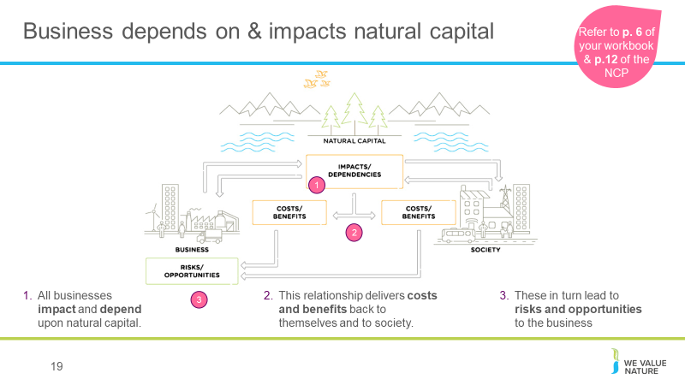
  - By 2050, use of coal as an electricity source would’ve to drop from nearly 40 percent today to 1-7 percent. Renewable energy such as wind and solar, which make up about 20 percent of the electricity mix today, would have to increase
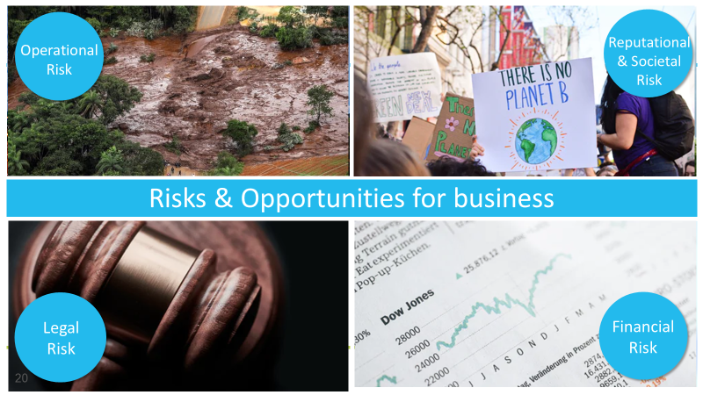
19. What the example shows is that natural, social and economic issues are fundamentally interconnected and cannot be separated from one another. It also illustrates how natural capital underpins all the other capitals and without it we would not have social and human or financial capital.
20. In years gone by, sustainability issues have sometimes taken business by surprise and companies have paid the cost. Companies are increasingly being impacted by the changing risk landscape discussed earlier.
Operational risk – Vale damn collapse
Reputation risk – increased public & consumer awareness of environmental and social damages + consumers are increasingly demanding assurance that the products they buy are produced in way that protect our environment and respect human rights – provide Volkswagen example here – link with SOCIETAL risks – health impacts on local communities, social license to operate
Legal risk – giant Texas oil company, Anadarko Petroleum, has agreed to pay $5.1 billion for a vast environmental cleanup - aimed at restoring thousands of sites polluted by toxins and compensating thousands of people with personal injury claims.
Financial risk – Underlying all of these risks & opportunities are financial ones! As we have seen, these risks imply important financial costs. Canadian gold mining company, Infinito Gold, lost over 50% of its share value as a result of the withdrawal of a mining concession in Costa Rica due to concerns about the potential impacts on agriculture, endangered species and forests. This led to a reference in the audit accounts to material uncertainties regarding the company’s ability to continue as a going concern
Source: KPMG, Flora and Fauna International, Acca, Is natural capital a material issue? (2012)
Biodiversity loss risk: Biodiversity loss comes at the nexus of many other business risks. E.g. through decreasing food security (which itself has economic ramifications), or increasing the likelihood of coastal flooding. Biodiversity loss can be felt through physical risks (increased cost of resources, disruption of operations due to natural disasters unmitigated by appropriate ecosystems), associated regulatory and legal risk, market risk from changing consumer preference as consumers become more aware & discerning RE biodiversity, and supply chain risks. Examples:
- “Deforestation in the Agno River basin in the Philippines has led to such extensive river and reservoir siltation that the 100-megawatt Binga hydroelectric facility can only operate intermittently”,
- Studies have shown that the total economic impact of Hurricane Katrina (approximately US$150 billion), was significantly higher than would have been the case if costal wetlands in the region had been preserved,
- In 2008, the Norwegian Pension Fund withdrew its £500 million stake in the mining giant Rio Tinto and excluded the company from its funds. The decision to withdraw was based on the activities of Rio Tinto’s mining operations in Indonesia.

But good news is that, where there is risk, there is opportunity to:
- Secure natural resources
- Save costs
- Manage future risks
- Engage stakeholders
Operational opportunity – EDF rainwater harvesting to manage water scarcity risks leading to reduction in water consumption, economical & energy savings
Reputation opportunity – IKEA to use only renewable and recycled materials by 2030
Legal opportunity – Union Carbide Corporation, subsidiary of The Dow Chemical Company: Seadrift, TX Wetlands for Wastewater Treatment Project description: 110-acre engineered wetland in lieu of an industrial wastewater treatment plant In 1995, the Seadrift water treatment facility was seeking a solution to consistently meet regulatory requirements for water discharge. An innovative GI solution consisting of a constructed wetland was installed and has been successfully operating upon startup and for the last 15 years.
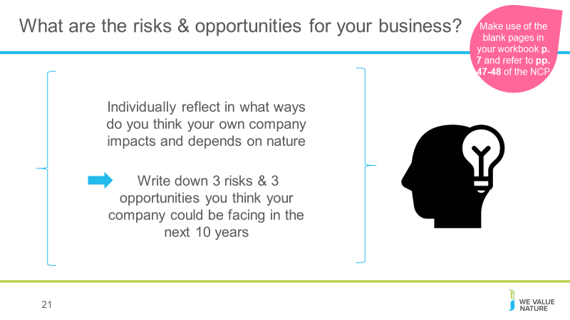
Financial opportunity – But when these risks are taken into account, we saw how it can also lead to reduced financial costs, or improve access to finance. Companies like those you can see here have managed to secure substantial billion dollar loan facilities where the interest rate of repayments is linked to ESG performance (such as Danone). That is to say if the company has strong environmental and social performance they pay back less on the loan.

21. Give participants 5’ to reflect individually on both questions. Highlight that workbook should be used, and draw pariticpants’ attention to the tables of impacts and dependencies they can use to help them.
Highlight that business impacts and dependencies are closely linked. For example, a company may depend on water, while the quality of its water management practices will affect the scale of impacts generated through its use of water.
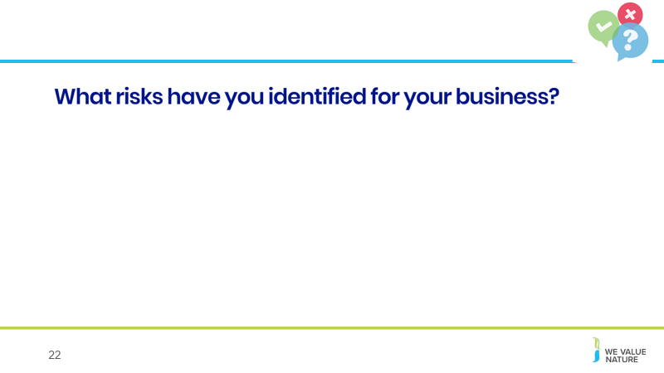
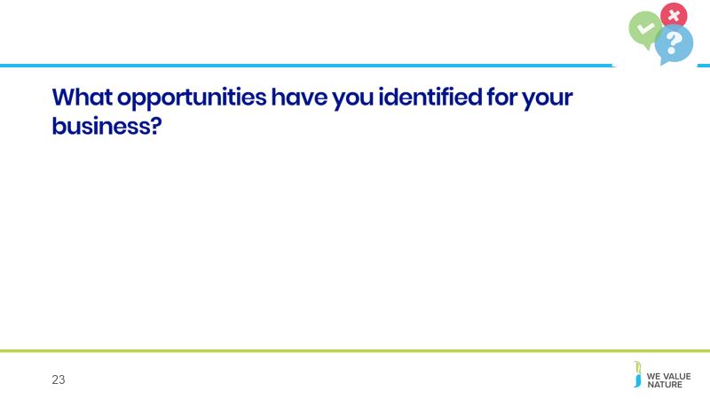
22, 23. You can use mentimeter or another polling website to share the results of the previous exercise with the room, reflecting on the results as they appear on the screen. Highlight the different types and nature of risks, and any commonalities that appear.
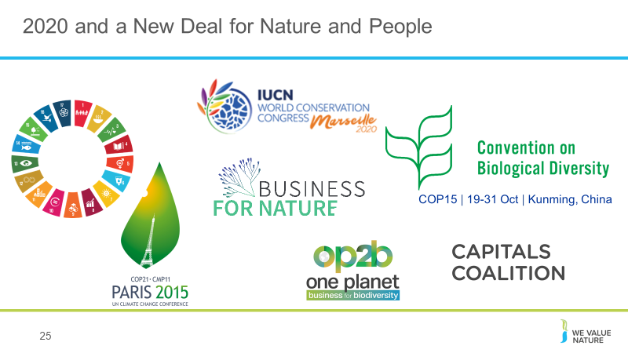
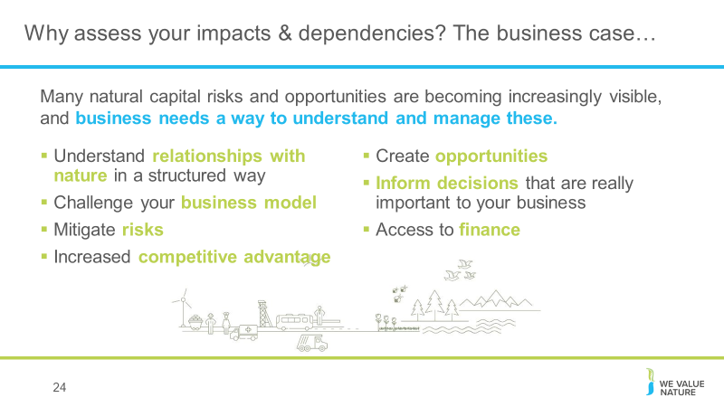
25. Strong call for a global agenda for action on nature and biodiversity; 2020 “super year” for nature. There are several crucial political decision milestones in 2020, providing key opportunities to address the frightening loss of nature. Protecting wildlife and reversing the decline of nature requires urgent global action.
ATTENTION!! Don’t assume that everyone will know these initiatives so also make sure to explain these and why business should care about them / keep an eye out.
While the IPBES Global assessment report warns that nature is declining globally at rates unprecedented in human history, it also tells us that it is not too late to make a difference, but only if we start now at every level from local to global, and through transformative change, that is, system-wide reorganization across technological, economic and social factors, including paradigms, goals and values.
2020 as a crucial year for securing international agreements for a New Deal for Nature and People, through a commitment by heads of state at the 75th United Nations General Assembly. World leaders are also expected to review the progress made on the UN Sustainable Development Goals, the Paris Agreement and, crucially, negotiate new 10-year targets for the UN Convention on Biological Diversity (CBD).
- Many of companies’ SDGs targets coming to an end in 2020
- Paris Agreement on Climate is due to begin.
- 15th CDB COP meeting in Beijing in 2020 - This is a very important conference, as targets for nature for the decade 2020 to 2030 are to be agreed.
- Unified business voice through Business for Nature coalition: it will champion radical collaboration to unite the vast network of business initiatives for nature in a somewhat similar way to the We Mean Business coalition did/does for climate. It will complement and drive business momentum for the Nature Action Agenda. A diverse, and powerful group of stakeholders including WBCSD, We Mean Business, the Consumer Goods Forum, the World Economic Forum, the Natural Capital Coalition and WWF have come together to initiate this coalition.
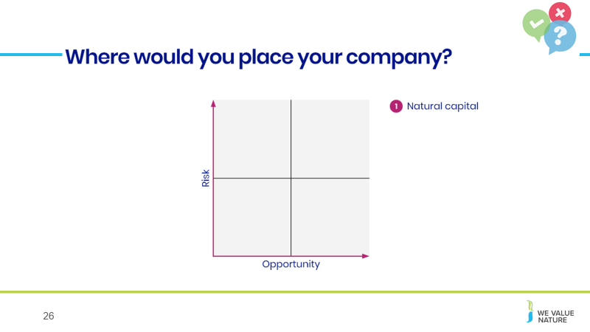
- (WBCSD leading business solutions)
26. Use mentimeter or another polling website to ask participants where they think their company stands on viewing natural capital as an opportunity or a risk.
Briefly reflect on the results as they appear and highlight any commonalities.

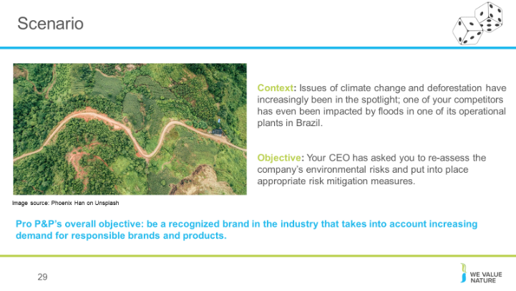
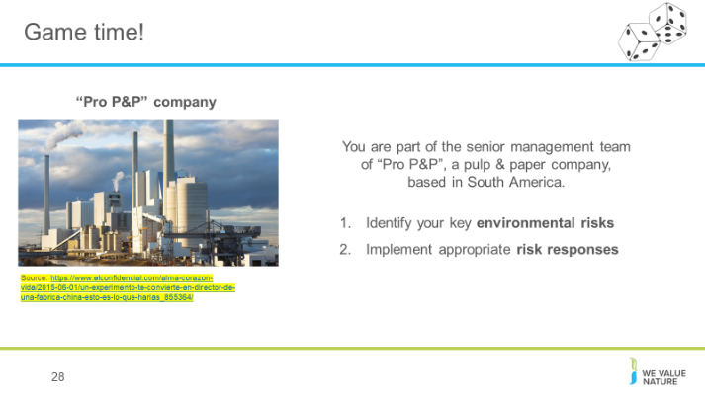
Risk game
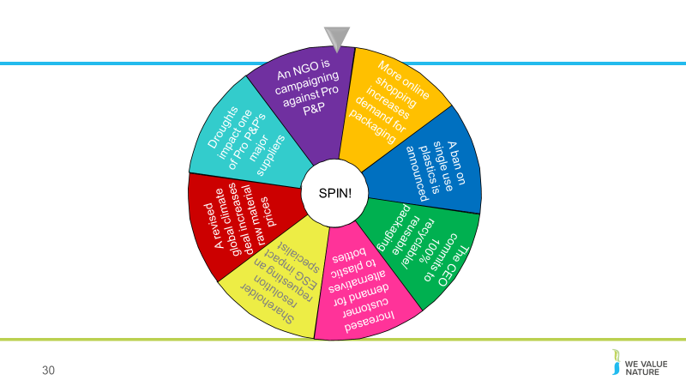
Spin the wheel to land on a risk event. Participants should follow the fuller instructions on the relevant card which will be on their table. Do this until either all 8 risk events have been selected, or until 5 or 6 have been selected (if playing a shorter version of the game). Make sure participants are tracking their share price on the supplied graph.
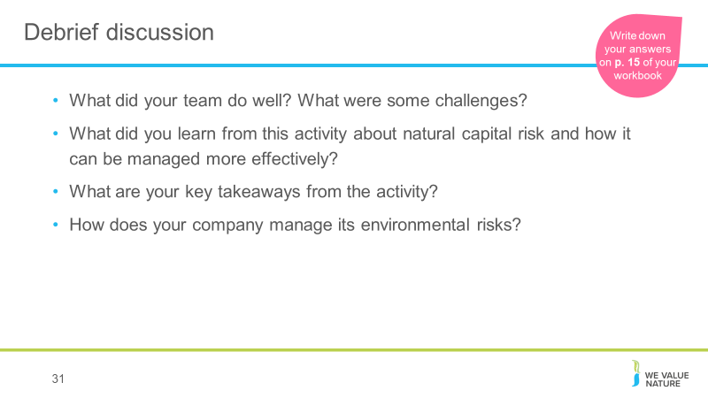
31. At the end of the game, leave 15’ for participants to reflect as a group on some key challenges, barriers and solutions that came up and have them think about how some of these may relate to their own business context. Encourage participants to use the provided space in their workbooks.

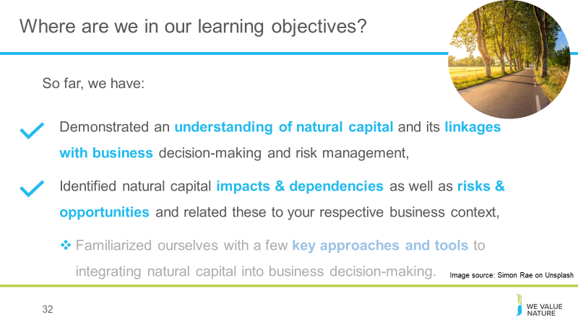
32. Briefly summarise what participants have learnt so far, and highlight what’s next.

Overview of tools & approaches

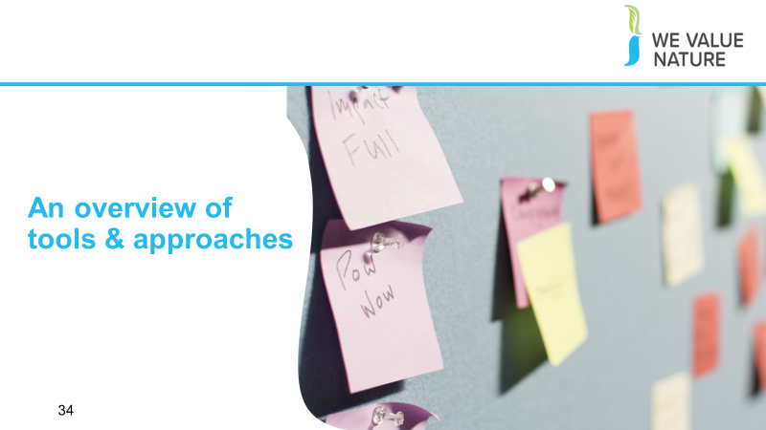
34. Re-connect to game and how through this, they have already thought of some tools and methods they could implement and perhaps even realized that some of these, they are already applying in their own company.
Before kicking off this next session, give space for 1 person from each table to share some of the key barriers, challenges & solutions that came out from game.

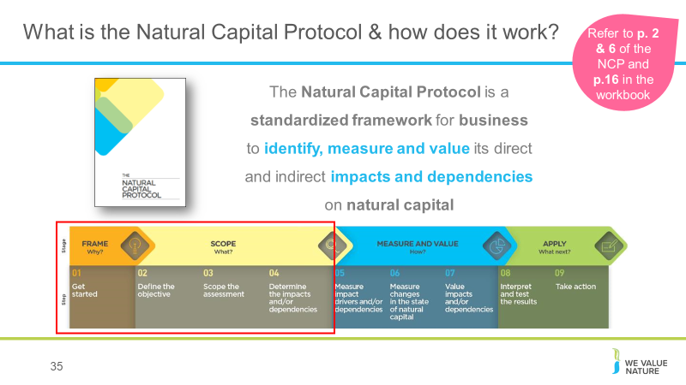
35. The Natural Capital Coalition is a collaborative space to harmonize approaches to natural capital
The network represents over 300 organizations across all parts of society and around the world
Purpose: To mainstream the inclusion of natural capital in decision making, harmonizing approaches and getting them to scale, quickly
The Protocol aims to support better decisions by taking into account how business interacts with natural capital in decision making. Until now, natural capital has for the most part and still is, being excluded from decisions.
So it is to be understood as a Framework that was really designed to help generate trusted, credible and actionable information that business managers need to inform decisions by identifying, measuring and valuing impacts and dependencies on natural capital.
The Protocol builds upon many approaches already used within business.
It acts as an overarching globally accepted framework to build and expand this information into robust natural capital assessments.
Important to note that the NCP as an overarching framework, won’t give you actual results and need to therefore use the Nat Cap toolkit to get tools.
Highlight that while we will briefly cover tools and approaches for stages of ‘Measure & Value’ – the aim of the training will mainly focus on first two stages of the Protocol and that going into measurement and valuation technical details, requires a separate training.
ADDITION
It builds on several approaches that already exist such as the Corporate Ecosystem Services Review and the Guide to Corporate Ecosystem Valuation.
The choice of tools will depend on business context, resources and needs
ADDITION: The problem is that when natural capital has been included, it has often been inconsistent, open to interpretations or limited
For most companies, interactions with nature do not yet affect their market value, the price of their products or the price they pay for materials they use, their cash flows or risk profile. If they do, they are not visualized on a their balance sheet or profit and loss statement.
➔ They remain externalities or issues without internal consequences
BUT there are different drivers that could lead to such externalities being internalized in the future such as increasing regulatory or legal action, market forces and changing operating environments, new actions from stakeholders, …
STRUCTURE of the Protocol:
4 overarching stages of frame (why), scope (what), measure and value (how) and apply (so what) and 09 logical steps. It should be easy to follow and should be suitable for any business across any sector or geography.
The stages and steps are iterative so expect that you may need to revisit a previous step.
Facilitation note: be sure to frame the NCP as an overarching, globally accepted framework, and also highlight that it does not provide specific tools with which to carry out an assessment – for that you need something like the NCP toolkit.

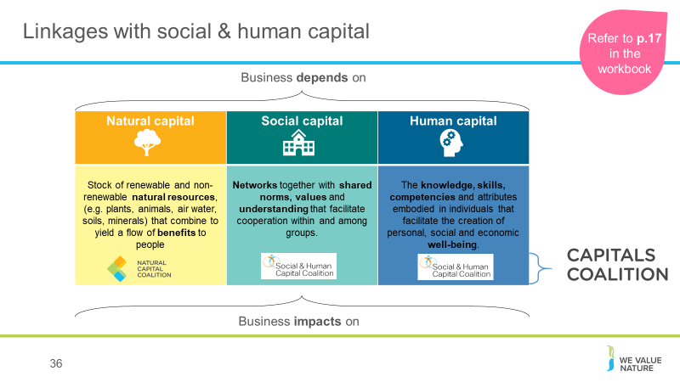
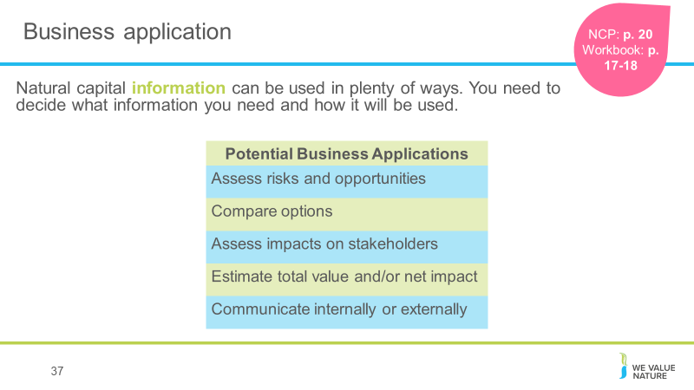
36. Draw attention to the fact that natural capital exists alongside human and social capital, which can also be measured and valued (for which the Social and Human Capital Coalition exists as a complement to the Natural Capital Coalition).
37. A natural capital assessment provides information. Whilst this can be valuable in its own right, and it’s okay to carry out an assessment just for fact-finding, this means there are also numerous ways to use this information for further purposes.
The NCP focuses on using natural capital for decision-making, measurement and valuation, but it can also be used for disclosure and communication, or to help formulate strategy.
The best way for your company to use natural capital information is highly individual – think back to the challenges and risks you identified earlier in the training and consider how exactly how more information could help you meet these challenges.

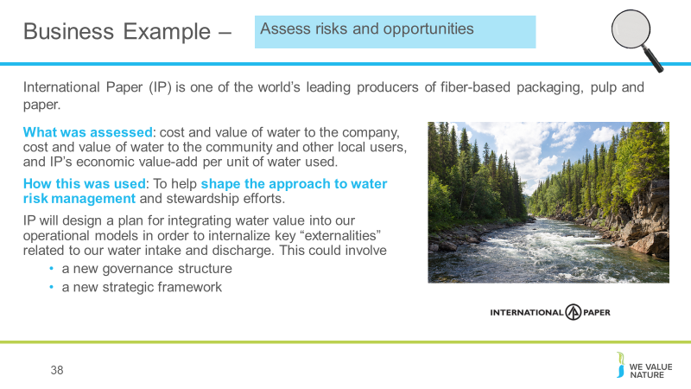
38. Source. Highlight that this is a business example which focuses on the application of “assessing risks and opportunities”.
International Paper (IP) is one of the world’s leading producers of fiber-based packaging, pulp and paper.
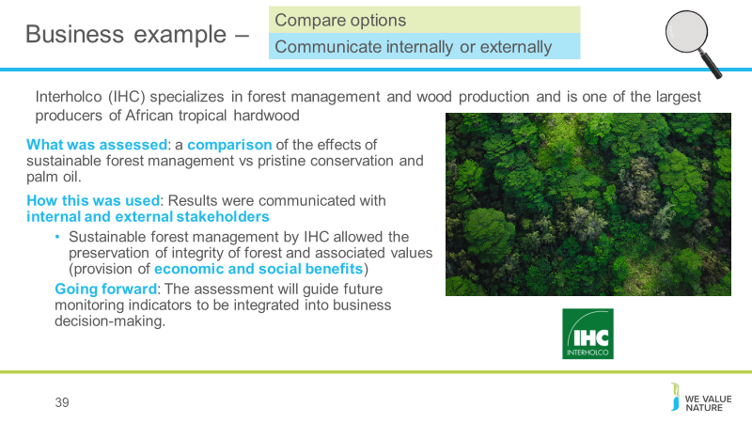
They conducted an assessment of its water use, looking at the costs and value of water to both the company and to the community and other uses of the water, therefore looking at both the impacts and dependencies and also considering not just the impact on the company but on society too. Finally, they assessed the company’s value-add per unit of water used. This information was then used to shape IP’s approach to water risk management and their stewardship efforts. Going forward, IP will design a plan for integrating water value into their operational models to internalize externalities.
39. Source. Interholco (IHC) specializes in forest management and wood production and is one of the largest producers of African tropical hardwood
IHC undertook a study comparing the effects on the forest of undertaking sustainable forest management in the congo basin vs pristine conservation and palm oil production.
They found that SFM provided more economic value and comparable natural value as conservation. Palm oil theoretically provides 700x economic value than conservation and 40x more than SFM, but this is outweighted by significant co2 emissions associated with deforestation for palm oil and irreversible loss of ecosystem (showing benefit of taking NC approach).
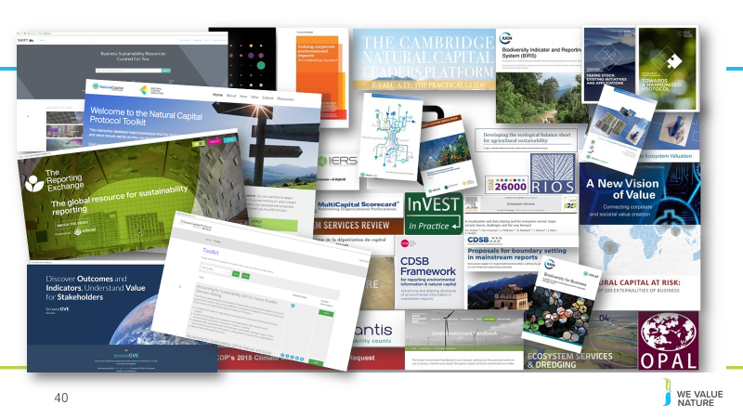
Going forward: the assessment will be used to provide insight on impacts and dependencies, and guide future monitoring indicators to be integrated into business decision making. IHC may in future undertake specific NC assessment for new business development scenarios.
40. We can see from this slide, the wealth of intellectual content, tools and approaches that already exist in the natural capital field.
This certainly highlights the need for standardization, and a process into which all of these existing resources can input. As we have seen, the Natural Capital Protocol does NOT aim to recreate or invent any new methodologies – instead leverages what we already have.

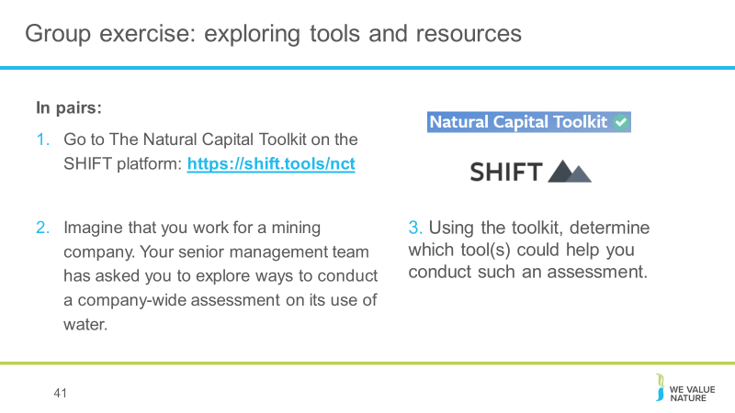
41. Now, we thought what better way to have you familiarize yourself with these tools by doing an exercise that will have you explore some of them.
For this exercise, you will need your laptops. You’ll be using SHIFT, which is an extensive repository of tools and resources on how to undertake a natural capital assessment and valuation. Because it’s so huge, we’ve picked the natural capital toolkit to help narrow your search a bit. This was developed by the natural capital coalition and WBCSD.
Facilitation note: This is a nice exercise to have them realize that there are many tools available and that the one they will choose will depend on many aspects.

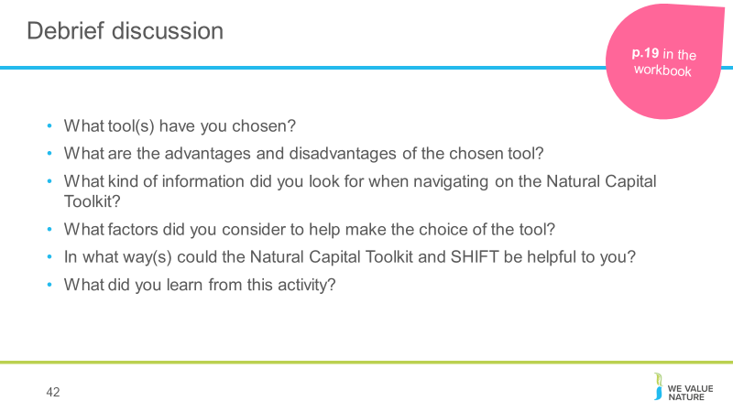
42. Conclusion of this exercise is that:
- There are no perfect answers!
- The choice of tool will depend on various factors:
  - What is the objective / what are you trying to achieve? / What decision are you trying to inform? – Is it to inform business strategy? Business management? Or operating decision?
  - What is the scope? Are you looking at product, corporate level?
  - What perspective are you looking at? Business? Societal? Both?
  - How much resources do you have available to conduct the assessment?
  - How much information / data do you already have?
  - Will you need external help?
  - Etc.

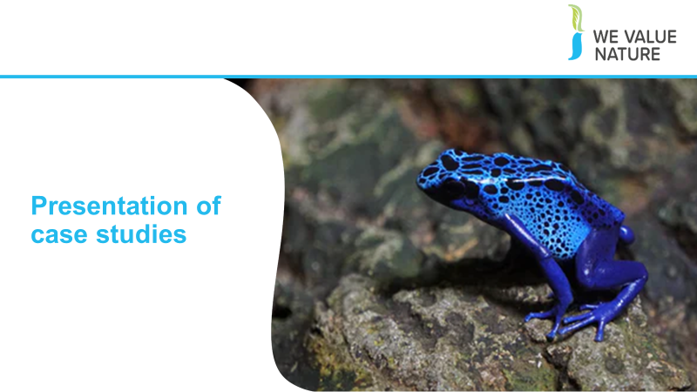
Case studies
3 speakers from 3 different companies will be invited to the training to share their experience in integrating natural capital into their business decision-making processes.
Speakers will be encouraged to share:
- Their experience
- The solutions put in place
- Challenges/barriers faced, how these were overcome and what would they do differently looking back
- Collaboration with stakeholders involved in the process – who was key in supporting the solution, making it happen and perhaps also discussion around communications, how do you have to communicate differently e.g. if trying to convince risk management vs
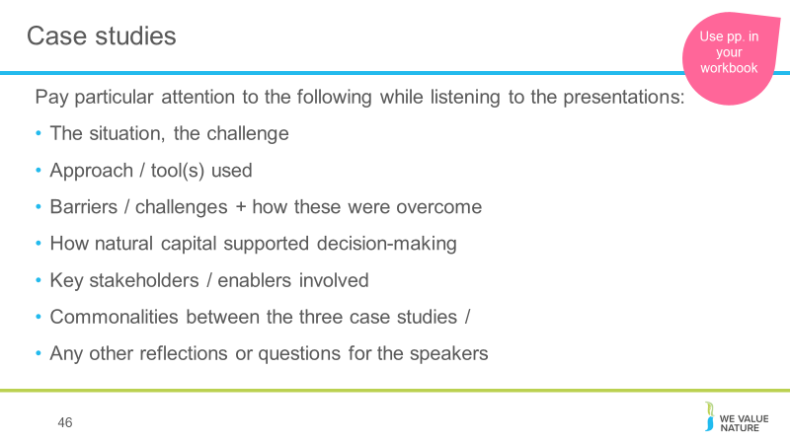
Encourage case studies speakers to also discuss how they would have done things differently.

46. Urge participants to pay particular attention to the points on the slide, and to take note of these things in the dedicated space in their workbook.

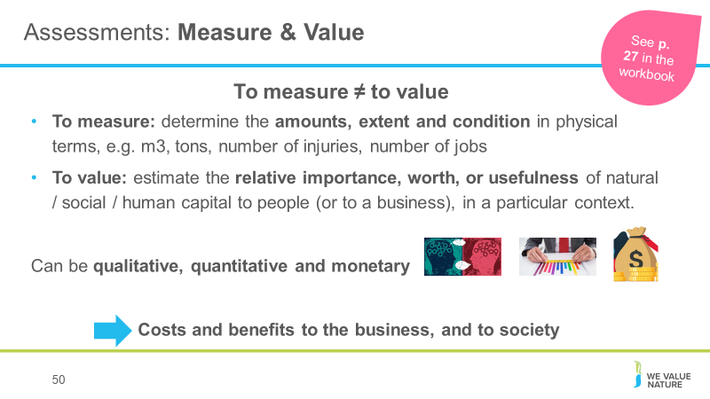
Natural capital put into practice
50. There are different ways of valuing – could be qualitative, quantitative and monetary
Important to note that monetary values without any context (i.e. accompanying quantification) are less meaningful!
The method you chose depends on which natural capital impact drivers or dependencies you wish to assess, the chosen value perspective (e.g. business, societal, or both), the ultimate objective of your assessment, and the time and resources available.
Monetary valuation: some find it difficult to accept or interpret monetary valuation of certain benefits (e.g. spiritual values). In such situations, special efforts may be required to explain the advantages and also to acknowledge the limitations of monetary valuation.
Advocates of natural capital are sometimes accused of ‘putting a price on nature’ or ‘pricing the priceless’, but in fact our core assertion is that prices have failed to reflect the true value of the natural world, and that the economic systems that we are using are broken.
We use the common definitions of price and value: Where price is ‘the quantity of one thing that is exchanged or demanded in barter or sale for another/the amount of money given or set as consideration for the sale of a specified thing’ and value as ‘The regard that something is held to deserve; the importance, worth, or usefulness of something i.e. “your support is of great value”. If something is not for sale, we do not describe it as having a ‘price’, but we may nevertheless recognise the value that it holds, and make decisions on this basis.

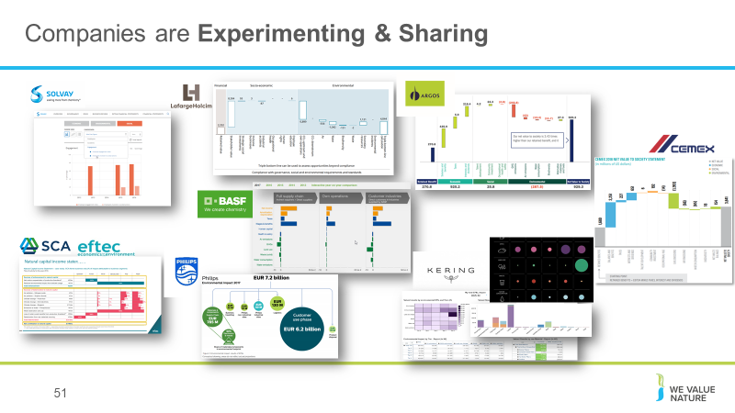
51. ATTENTION - Should talk through at least one of these with some information as to the use of the data and what it has helped the company to achieve!
Can ask after explaining this slide, what are participants’ corporate culture when it comes to this? What would their senior management team prefer?
SCA/eftec: produced a natural capital balance sheet showing value to business, value to society, total value, and how much of this is reported in financial accounts. Total assets in the financial accounts reported as 3250mn euros, whilst total natural capital assets value at much larger 12,369mn euros.
Use: as internal risk management tool, in internal & external communications and in government/regulatory relations. Production required an element of learning as SCA was a first-mover in this space.
Solvay: extra-financial statements which show economic, environmental and social indicators in similar form to a standard financial statement, with different units of measurement (i.e. not all monetary).
LafargeHolcim: Integrated profit & loss statement, an estimation of total value LH provides for society. Considers socio-economic and environmental factors alongside financial. The statement is the result of cross-functional collaboration. Use: in LT strategy to help LH building value for shareholders, people and planet. To help shape the mindset of decision makers in LH and enhance decision making process by looking at things from the bottom-up.
Argos: (will be explained by Cristina)
BASF: Value to society approach, considers impact categories along the entire supply chain and provides an absolute value of contribution in monetary terms. Can compare results between years since 2013. This approach in particular allows comparison between financial and non-financial impacts and maps impacts along different stages of the value chain, as well as providing a better understanding of interdependencies between economic, social and environmental issues.
Phillips: EP&L providing an environmental footprint for the whole value chain in monetary terms, using LCA methodology. However only looks at hidden environmental costs to society, not benefits.
Kering: EP&L (next slide)
Natura EP&L: in 2013, results have been used for carbon neutrality programme.
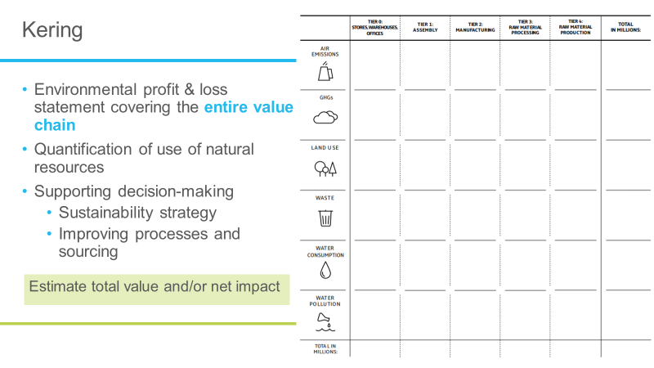
52. Quick deep dive on Kering: you may recognize some of these icons from the pre-training fashion game exercise we got you to complete.
Kering has been producing an EP&L for a number of years and their website has lots of useful information about the process, methodology, and why an EP&L can be useful. There’s a link to it under “useful resources” in your workbook so you can explore the website and the report.
They use their EP&L to measure and value their impact across the entire supply chain, and this information is then used to help support decision making, guiding its sustainability strategy, to improve its processes and help it choose the best sourcing strategies, the best technologies etc…
Good example of the potential business application number four – estimate total value or net/impact. We’ll return to the question of valuing later on after lunch.
See that their most significant impacts are generated in the supply chain (90%), and in particular, from the production and processing of raw materials. Their own operations represent only 7% of the impacts.
Accordingly, Kering shifted focus to finding innovative solutions and leveraging changes across the supply chain, as well as avoiding high impact sources due to an increased transparency via the EP&L.
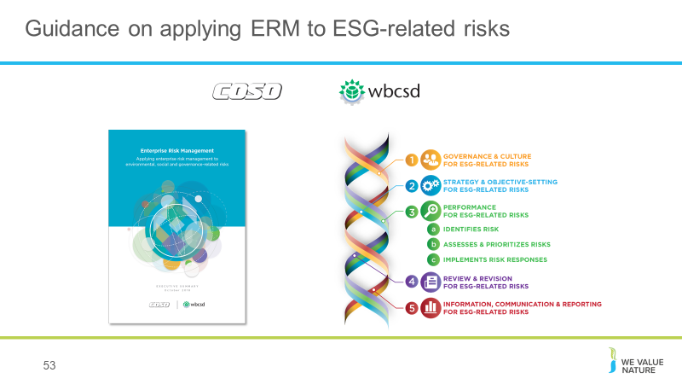
Case study here.

53. The COSO/WBCSD Enterprise Risk Management (ERM) framework provides guidance for applying ERM to Environmental, Social and Governance (ESG)-related risks. ESG issues, risks and opportunities can be absorbed into risk management practices to help decision-makers make better and more informed decisions.
Provide participants with printed copy of ERM framework OR its Executive summary!
Facilitation note: after showing slide, ask who of participants know if any of their company’s material issues are taken into account in their ERM processes. Also emphasise that this is a tool that will help them to communicate with risk management department – in a language that they will understand. + that NCP is referenced in this guidance.
COSO: Committee of Sponsoring Organizations of the Treadway Commission (COSO)
ADDITIONAL INFORMATION:
WBCSD provides opportunities for companies to participate in individual company workshops on how to implement the guidance, Applying Enterprise Risk Management for Environmental, Social and Governance risks.
The workshops are founded on the COSO / WBCSD guidance designed to help organisations to respond to the increasing prevalence and severity of ESG-related risks. There is more information in this flyer.
The workshop objectives are:
Understand the business case for sustainable development
Understand the business case for aligning ESG and ERM
Learn how to practically apply the guidance (Enterprise Risk Management to Environmental, Social and Governance-related Risks)
An opportunity to discuss and explore opportunities to improve integration
Dynamic Risk Assessment:
Looks at how companies can develop their risk assessment processes beyond the traditional impact vs. likelihood to look at both the velocity and connectivity of risks.
It will help companies to understand the weak links, new opportunities and those risks that are likely to have disastrous consequences.

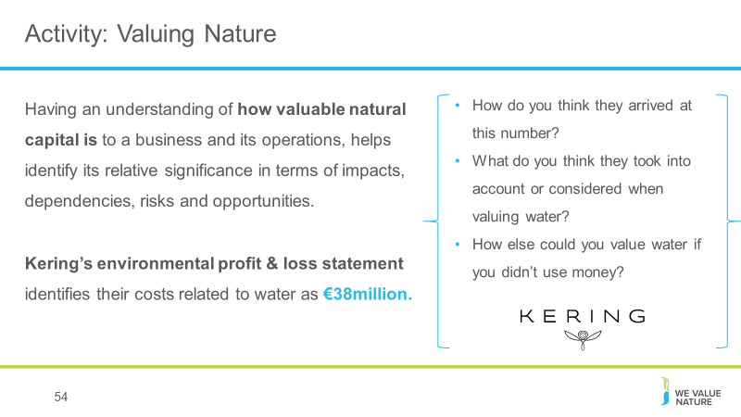
54. Give groups 15’ to discuss and then have one representative present in 1’ key elements that came out for all three points – take note on flipchart.
Potential answers:
- Cost to get water
- Amount that people are ready to pay for water
- Replacement cost
- Cost to treat water
- Potential regulatory cost of cleaning up polluted water
Potential reflections:
- Whether areas are water scarce
- What stages of value chain, geographies are considered? How far upstream/downstream of Kering’s own operations are considered?
Kering explanation of their valuation: this figure just represents the costs associated with Kering’s water consumption (they calculate water pollution costs differently). Kering has three steps in making their EP&L: quantifying environmental footprint, estimating likely environmental change as a result, valuing the change in wellbeing as a result of that. For water consumption the metrics for the above three steps are: water consumption in m^{3,} / increasing water scarcity / malnutrition and disease.
There are different ways of valuing – could be qualitative, quantitative or monetary
The method you chose depends on which natural capital impact drivers or dependencies you wish to assess, the chosen value perspective (e.g. business, societal, or both), the ultimate objective of your assessment, and the time and resources available.

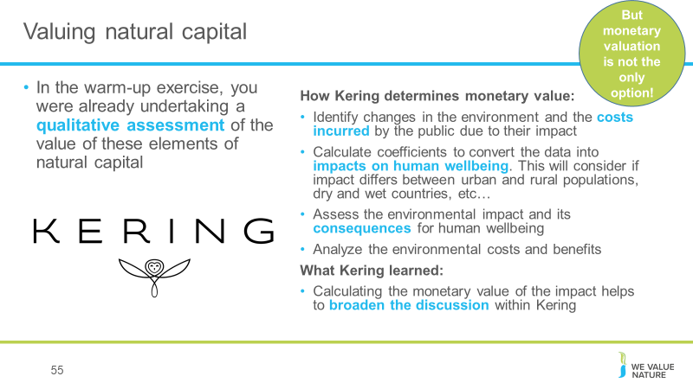
Participants may remember from the warm-up exercise, by assigning different levels of impact to different areas of the value chain for different issues, they were already undertaking a qualitative assessment of the value of these parts of natural capital. Here you can see extract from Kering’s methodology note on how they determine monetary value specifically.
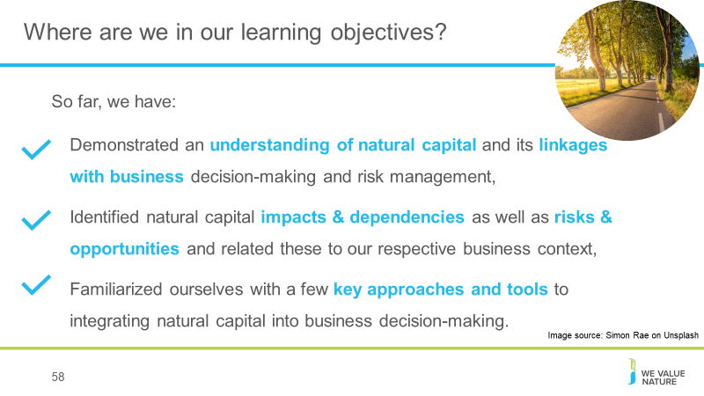
Remind participants that monetary valuation is not the only option.

58. Summarise how last section has contributed to this final learning objective.

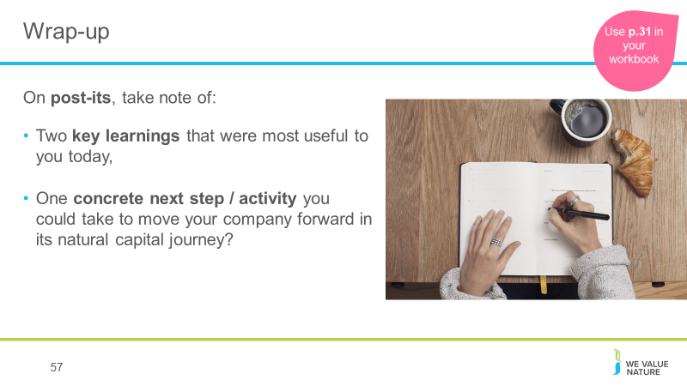
59. Make sure to get participants to fill out the feedback form at the same time, highlighting that it’s important to help improve the quality of training in the future and also tailor We Value Nature’s offering to business needs.

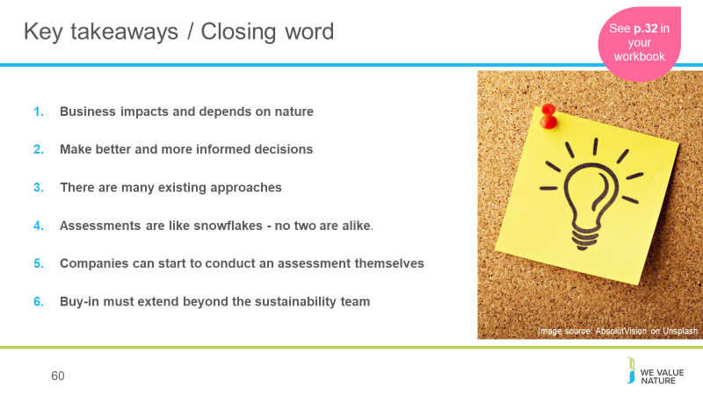
58. How much will an assessment cost?
Some of the Protocol pilot testers - like our members Nestlé and Roche - estimated they spent about USD $50,000 on consulting services for their assessments over a six-month period. Some companies spend less, others spend more.
Dow, Kering and Natura have invested significantly more over a longer term, for in-depth assessments that contribute to their multi-year strategic ambitions
The Protocol can help companies navigate these kinds of situations by making sure the services required align with the assessment's objective.
Skills & data needed:
It's usually much more efficient to build on existing data that's readily available in-house, and the Protocol provides guidance on gathering and using that data too.
For example, many companies have data on their own GHG emissions, water, waste, and some also have results of product Life Cycle Assessments - this existing information can provide a really good starting point for a natural capital assessment. How applicable it is will depend on the objectives and scope of the assessment though, so it's important to find the balance between getting perfect data (e.g. from monitoring in the field) and using proxies that are not as accurate but can be more practical and still lead to better decisions.
Internal buy-in:
In many cases, natural capital assessments can be a bottom-up effort. Trying to drive natural capital assessments from sustainability, environment or health and safety departments is sometimes difficult, but nevertheless, the Protocol provides guidance on integrating the assessment into the business itself.
One way to facilitate engagement internally can be to show that "many companies are already doing natural capital assessments; they're just using different terminology and steps.
To support this engagement, it is important to look beyond those benefits that can be valued through the natural capital assessment itself, and acknowledge how a natural capital approach can motivate organizational change in support of broader business goals." This means that there will be more leadership from the top to better measure, value and then integrate natural capital into business.
The bottom line is that although carrying out a natural capital assessment is technical, it's also achievable. Not every assessment has to be a huge undertaking, so companies should start off with a scope that makes most sense to their situation. The Protocol will help you do this.
Finally, we must make sure the information obtained from the assessment is included in core business decision-making. This will ensure you have the best possible impact on your business, and on the environment.
Facilitation note: make sure to remind participants that they can do it, it’s not as complex as it may seem, and that WVN are here to help and have the resources!
