Participant workbook
Business Training on natural capital
Location | Date

This workbook was developed by on behalf of the We Value Nature Campaign.

Authors: Katia Bonga, Francesca Jaworska

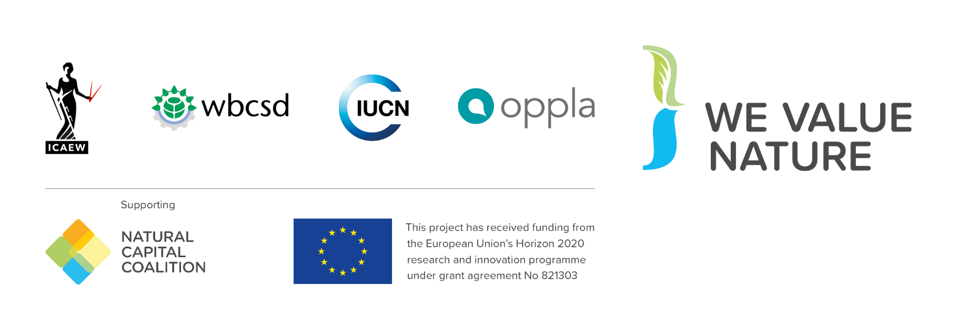
Contents
How to use this workbook 4
1. Introduction to natural capital 5
1.1 What is natural capital 5
2. Why is natural capital important? 6
2.1 Dependencies and impacts 6
3. How can you apply natural capital? 8
3.1 Natural Capital Protocol 8
3.2 Integrating natural capital into business decision-making 9
3.3 Natural Capital Toolkit 11
Notes: exploring tools and resources 11
4. Wrap-up 12
4.1 Reflection: next steps 12
4.2 Key takeaways 13
5. Useful resources and further reading 14
Multimedia resources 15
Notes 16

How to use this workbook
This workbook is intended to complement the training you will be receiving today. It includes copies of the key definitions and diagrams included in the slides, as well as some additional ones you may find useful. There is also space for you to write personal reflections and key learnings for each section, as well as pages at the back for your own notes. You can refer back to these in the future as you progress on your natural capital journey.

1. Introduction to natural capital

1.1 What is natural capital

Natural Capital Protocol definition
Natural Capital is the stock of renewable and non-renewable natural resources that combine to yield a flow of “services” to people. In turn, these flows provide value to business and society.
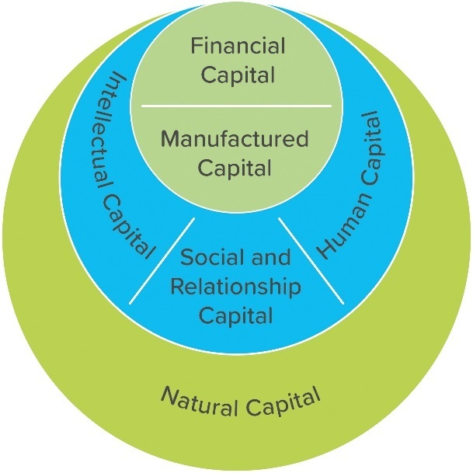
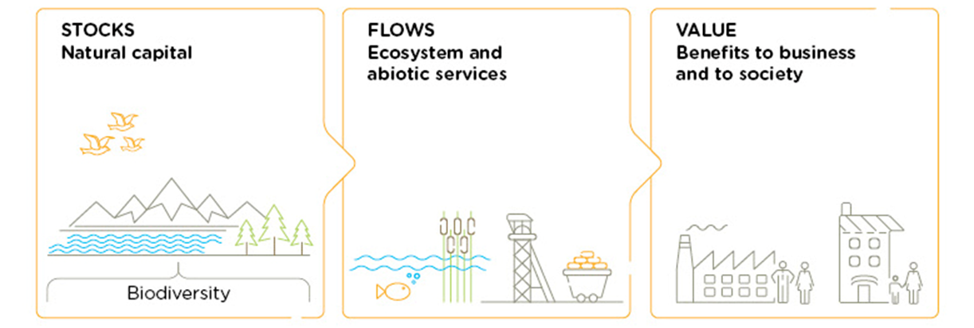
Figure 2: IIRC Capitals Background Paper 2013, p.3
Natural Capital underpins all the other kinds of capital we also talk about. Without natural capital, human, social, and financial capital would not exist. Yet we also need to use other kinds of capital in order to realise some of the value of natural capital, for example extracting minerals.
Figure 1: Natural Capital Protocol, p. 12

2. Why is natural capital important?

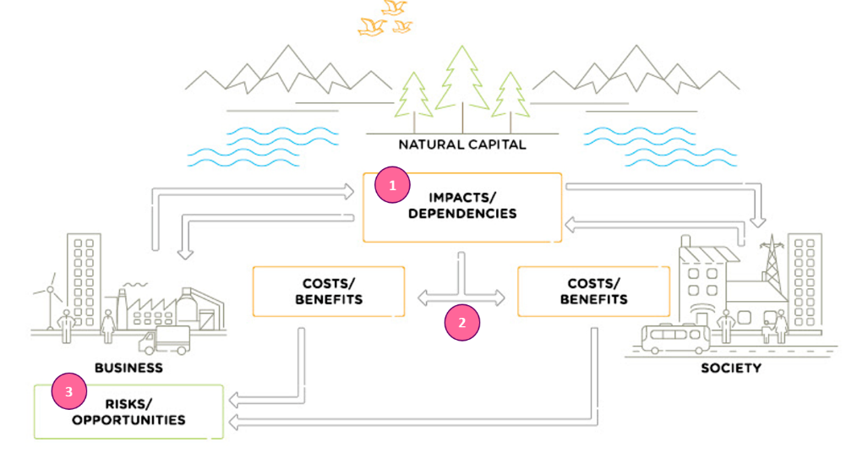
2.1 Dependencies and impacts
My key learning(s)
- All businesses impact and depend upon natural capital.

- This relationship delivers costs and benefits back to themselves and to society.

- These in turn lead to risks and opportunities to the business
Figure 3: Natural Capital Protocol, p. 15
2.2 Why should business assess its impacts & dependencies on nature?
Many natural capital risks and opportunities are becoming increasingly visible, and business needs a way to understand and manage these.

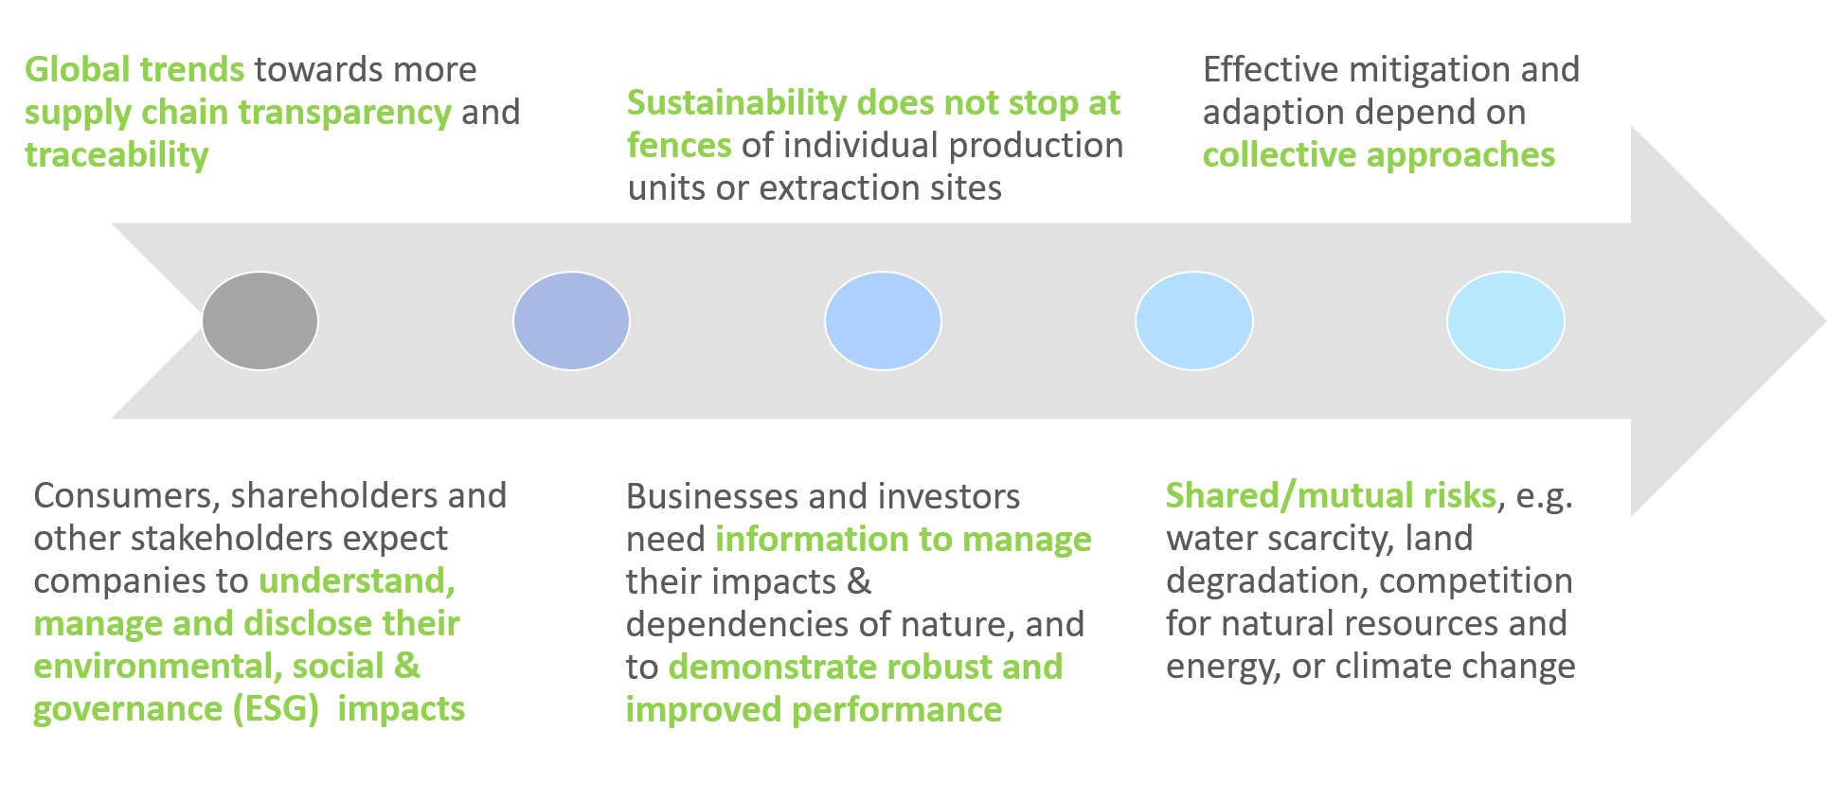
My key learning(s)
- Understand relationships with nature in a structured way
- Challenge your business model
- Mitigate risks
- Increased competitive advantage
- Create opportunities
- Inform decisions that are really important to your business
- Access to finance
- Recruitment & retention of staff

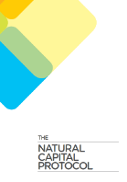
3. How can you apply natural capital?

3.1 Natural Capital Protocol
The Natural Capital Protocol is a standardized framework for business to identify, measure and value its direct and indirect impacts and dependencies on natural capital.
It has been developed by the Natural Capital Coalition as a generally accepted framework built on existing approaches.

You can use the NatCap Checker to self-assess the credibility and rigor of your assessments.

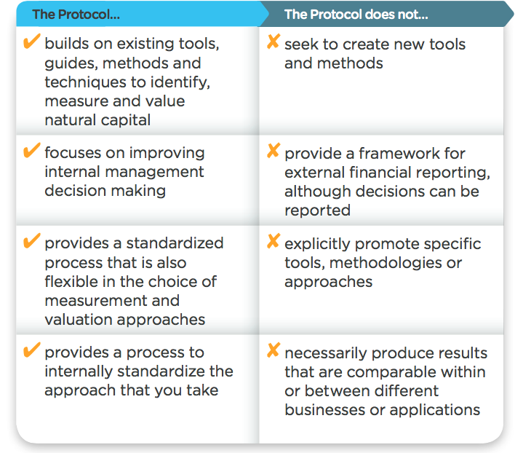

Figure 8: Natural Capital Coalition

3.2 Integrating natural capital into business decision-making
Assess risks and opportunities
Compare options
Assess impacts on stakeholders
Estimate total value and/or net impact
Communicate internally or externally
Potential Business Applications

You will find a series of case studies on the Natural Capital Coalition’s website and the World Business Council’s website.

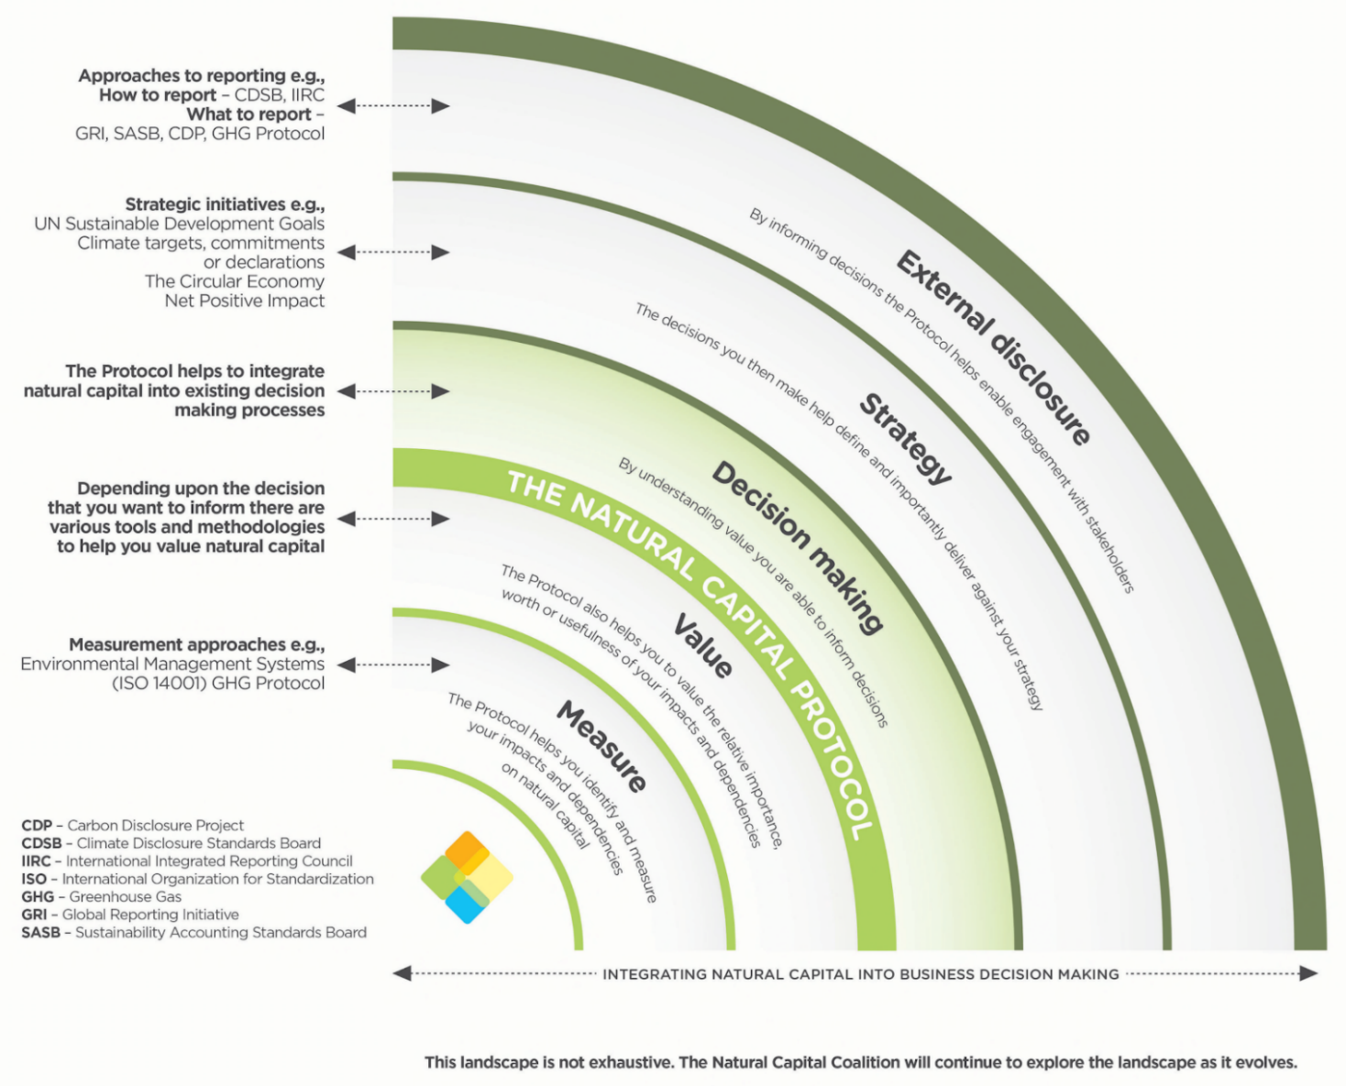
My key learning(s)
Figure 9: Natural Capital Coalition

3.3 Natural Capital Toolkit
You can find the Natural Capital Toolkit at https://shift.tools/nct

Notes: exploring tools and resources

4. Wrap-up

4.1 Reflection: next steps
- One concrete next step / activity you could take to move your company forward in its natural capital journey?

- One key learning from today

4.2 Key takeaways
- Business impacts and depends on nature – the NCP provides the framework to identify and assess impacts and dependencies,
- Understanding, measuring and valuing natural capital (i.e. taking into account) will help business make better decisions,
- There are many existing tools & resources to measure and value impacts and dependencies. The one you chose depends on the information you are aiming to get or the decision you are trying to inform,
- Companies can start to conduct an assessment themselves by getting the project going, scoping the assessment and integrating natural capital considerations into internal processes,
- For natural capital to become strategically important, buy-in must extend beyond the sustainability team.

5. Useful resources and further reading

General reading
- Biodiversity & Business Risk: A Global Risks Network Briefing (WEF & PwC)
- Business for Nature – a global coalition calling for action to reverse nature loss
- Is natural capital a material issue? (ACCA, Flora & Fauna International, KPMG)
- IPBES report (summary) - a 2019 report highlighting the extent of human impact on biodiversity, ecosystems and the natural world
- Natural Capital Committee terminology
- WBCSD Business Examples

Blogs
- Natural capital assessments: how far are you willing to stick your neck out and why (WBCSD)
- What does it take to carry out a natural capital assessment? (WBCSD)
- Why We Must Move From Measuring Only Impacts to Also Measuring Dependencies on the Natural World (Natural Capital Coalition)

Reporting
- Capitals Background Paper (International Integrated Reporting Council)
- Framework for reporting environmental information and natural capital (Climate Disclosure Standards Board)
- Environmental Profit & Loss Statement (Kering) - this is just one example of an EP&L, but Kering provides a comprehensive explanation of how and why they did it.
- GHG Protocol
- Global Reporting Initiative

Assessing & measuring

Guidance:
- Natural Capital Protocol
- Natural Capital Protocol Sector Guides & Supplements (for apparel, food & beverage, and forest products)
- E.VALU.A.TE: The practical guide (The Cambridge Natural Capital Leaders Platform)
- Valuing Corporate Environmental Impacts (PwC Methodology)
- Demystifying Valuation (Valuing Nature)

Tools:
- ENCORE (Exploring Natural Capital Opportunities, Risks and Exposure)
- Integrated Biodiversity Assessment Tool
- Natural Capital Toolkit
- NatCap Checker - A self-assessment tool to help evaluate how credible and fit for purpose your assessments are, therefore giving stakeholders a level of confidence they can place in the process, results and decisions taken based on the assessment.

Multimedia resources
There are many informative videos about natural capital out there. A few that we particularly recommend are:
Pitch4Nature
Natural Capital Protocol training videos
ThinkNature Nature Based Solutions game
WBCSD Natural Capital a short film series

Contact
Keep in touch! You can contact Katia at bonga@wbcsd.org for specific questions or further information on We Value Nature trainings.
For queries about the We Value Nature campaign, email info@wevaluenature.eu
or sign-up to our mailing list on wevaluenature.eu to stay up to date.

Notes
Use this page for your own notes throughout the training

