Warm-up exercise: fashion game
Instructions:
The grid below shows some of the different stages of the value chain of a luxury fashion company (along the top), alongside some of their key environmental impacts (on the left).
Map the dots below into each of the squares to show what you think the size of the impact that occurs at each stage of the value chain. There is no limit on the number of times you can use each size of dot.
High impact
Medium impact
Low impact
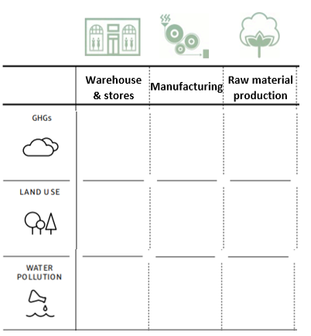
Reflection:
What other stages of the value chain could be considered?

If you did this exercise for your company what would it look like?

Why do you think an exercise like this might be useful for a business?

